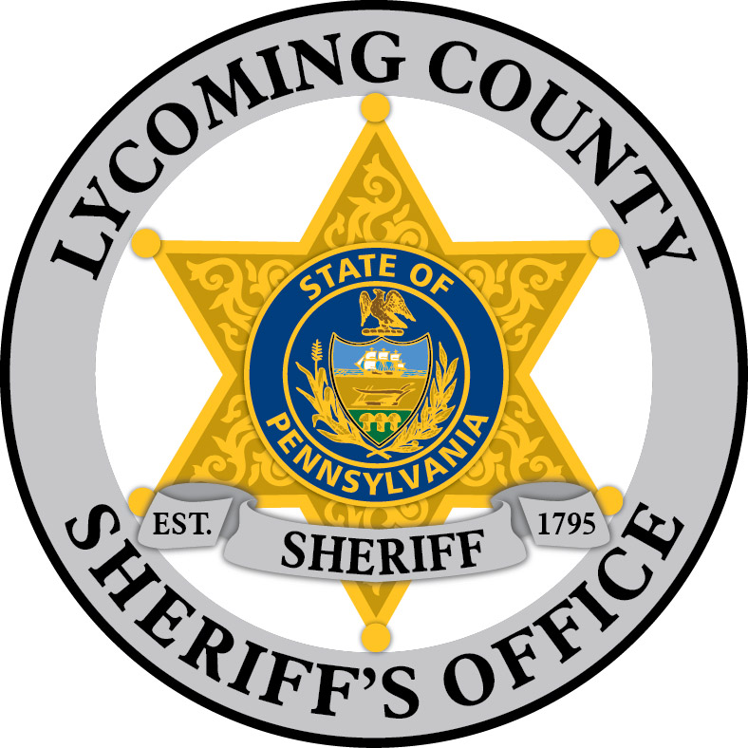

COUNTY OF LYCOMING
Mark Lusk, Sheriff
Lycoming County Courthouse
48 West Third Street
Williamsport, Pa 17701-6536
Phone: (570) 327-2280
Fax: (570) 327-2366
www.lyco.org

Eric Spiegel Chief Deputy
espiegel@lyco.org

Michele M. McDermott Admin. Specialist
mmcdermott@lyco.org

Legal Descriptions for Real Estate Sales

The Lycoming County Sheriff’s Office has an email address sherifflegalinfo@lyco.org solely for real estate legal descriptions. This email was created to allow electronic versions of legal descriptions to be emailed directly to the real estate division. It is now required when filing a Writ of Execution, that an electronic version of the long legal description be received by our office via email.

The legal description must be an electronic document (Microsoft Word *.doc or *docx). The description cannot be a scanned image.*.rtf and *.docm files are NOT acceptable and will be rejected in our system

If the legal descriptions are not emailed by the deadline for filing, sales WILL NOT be processed. The description must be clear and legible. The description must also contain the docket number and tax parcel number(s). Please put the primary defendant’s name and sale date in the subject line of the email.

A short legal description can still be provided to our office for advertisement in the newspaper and legal journal.

If you have a question, please call 570-327-2220. Our email is to be used for legal descriptions only, not questions.

Thank you in advance for your compliance with this guideline,

Sheriff R. Mark Lusk

Updated 7/2022 KSM

