Eric Spiegel Chief Deputy
espiegel@lyco.org

Michele M. McDermott Admin. Specialist
mmcdermott@lyco.org

COUNTY OF LYCOMING
Mark Lusk, Sheriff
Lycoming County Courthouse
48 West Third Street
Williamsport, Pa 17701-6536
Phone: (570) 327-2280
Fax: (570) 327-2366
www.lyco.org

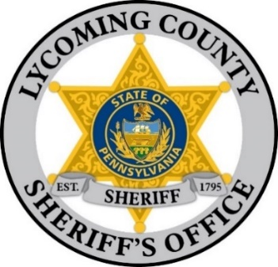

TERMS AND CONDITIONS FOR THE SALE OF REAL ESTATE

The first bid made on each property put up for sale shall be a sum sufficient to pay all the Sheriff’s costs, including the advertising, water rents, and delinquent taxes. The successful bidder is solely responsible for obtaining current year tax information as to what is owed by contacting the municipal tax collector. The first bid may also include municipal liens if provided to Sheriff’s office.

***BUYER BEWARE***

A successful third-party bidder is required to pay a 25% deposit of purchase price and 2% poundage of the first $250,000.00 and 1/2% on any amount over.

The deposit must be paid to the Sheriff immediately after the conclusion of Sheriff’s sales by the successful bidders on each property. Deposit can be paid with certified check or personal check made payable to the Sheriff of Lycoming County.

The balance of the purchase price and poundage must be paid within ten (10) days of the sale without any further demand. In default, thereof, the property may be sold again at the risk of the defaulting bidder and in case any deficiency on such resale the defaulting bidder shall make good the same to any persons injured.

The deposit paid by any bidder who fails to comply with the above conditions shall be forfeited. Bidders are responsible to research the title to the property being sold prior to sale.

The Sheriff shall not be liable for loss or damage to the premises sold resulting from any cause whatsoever, and makes no representation or warranty regarding the condition of the premises. The properties are sold AS IS.

Thank you for your compliance,

Sheriff Mark Lusk

Rev.05/04/22 DG

