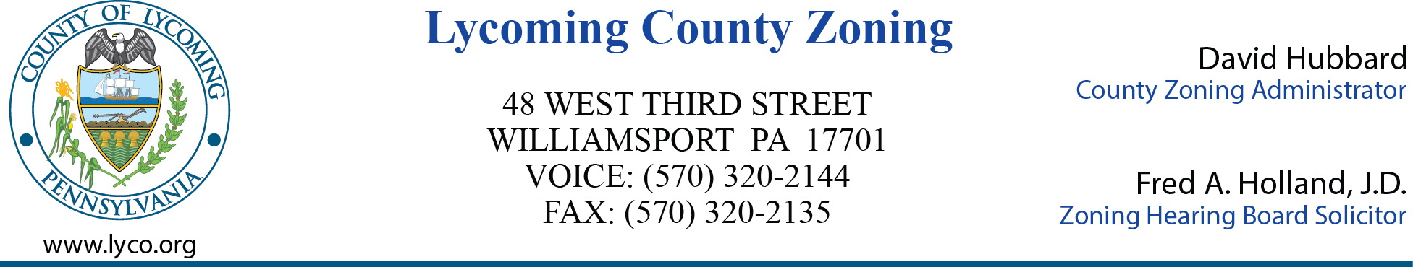

**LYCOMING COUNTY ZONING HEARING BOARD MEETING MINUTES**

**THIRD STREET PLAZA**

**33 W. THIRD STREET**

**3RD FLOOR COMMISSIONERS BOARD ROOM**

**WEDNESDAY, APRIL 23, 2025**

**6:00 P.M.**

1. **CALL TO ORDER**

Chairman Bill Klein called the meeting to order at 6:00 p.m.

1. **ROLL CALL (Members & Alternates)**

MEMBERS PRESENT: Bill Klein, Leslie Whitehill, Dan Clark, Stephan Brady, George (Herman) Logue, Howard Fry, III (alternate).

1. **MINUTES OF PREVIOUS MEETING**

The March 26, 2025 meeting minutes were approved as presented. Stephan Brady motioned to approve, George Logue second the motion. Motion carried.

1. **ACTION ITEMS**
2. David Hubbard announced the nominations for the officers of the Lycoming County Zoning Hearing Board for the year 2025. Nominations were as follows:

Stephan Brady – Vice Chairman

George (Herman) Logue – Secretary

Bill Klein- Chairman

Jennifer Bates – Recording Secretary

There were no other nominations for any of the offices.

1. By Law update. The proposed By Law updated is located in Article 5.1 under meetings, changing the location of the Regular Meetings of the Zoning Hearing Board to Lycoming County Third Street Plaza, 33 West Third Street, Williamsport, 3rd Floor Commissioners Board Room. George (Herman) Logue motioned to approve, Leslie Whitehill second the motion. Motion carried.
2. Fred Holland discussed the Board wanting to have transcripts of the hearings taking place and feels it appropriate to order the transcripts now as opposed to waiting until the conclusion of the hearings. Stephen Brady motioned to approve, Leslie Whitehill second the motion. Motion carried.
3. **NEW BUSINESS**
4. Continuation – ZHB Case 2025-002

Solar Renewable Energy, LLC

Jordan Township

Special Exception

This case has been continued until the next Zoning Hearing Board Meeting being held Wednesday May 28, 2025 at 6:00 p.m.

1. **ADJOURNMENT**

The meeting was adjourned at 9:17 p.m.

Respectfully submitted,

_______________________ ____________________

Jennifer Bates, Recording Secretary Bill Klein, Chairman

DATE: _________________ DATE: _______________