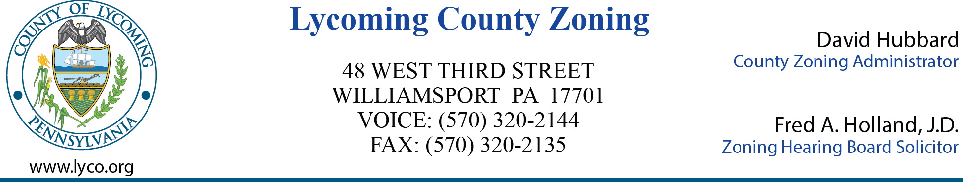

**MEETING AGENDA**

**LYCOMING COUNTY ZONING HEARING BOARD**

**Third Street Plaza – 3rd Floor Commissioners Board Room**

**Wednesday, May 28, 2025**

**6:00 p.m.**

1. **CALL MEETING TO ORDER**
2. **ROLL CALL**
3. **MINUTES OF PREVIOUS MEETING – April 23, 2025**
4. **NEW BUSINESS**
5. **Continuation – ZHB Case 2025-002**

**Solar Renewable Energy, LLC**

**Jordan Township**

**Special Exception**

1. **ADJOURNMENT**