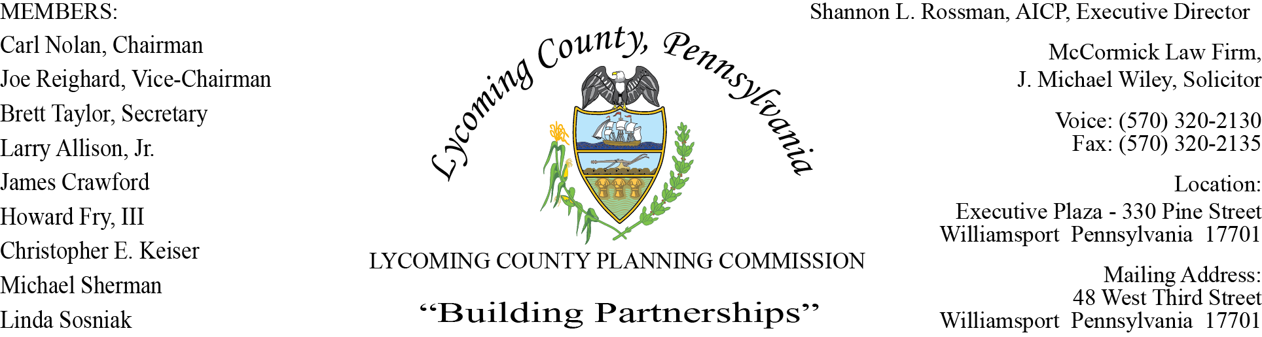

LYCOMING COUNTY PLANNING COMMISSION MEETING
Executive Plaza Building
September 17, 2020
6:00pm

MEMBERS PRESENT: Brett Taylor, Joe Reighard, Howard Fry, III, Jim Crawford, Linda Sosniak, Larry Allison, Jr.,

MEMBERS PRESENT VIA CONFERENCE CALL: Chris Keiser

MEMBERS ABSENT: Michael Sherman, Carl Nolan
OTHERS PRESENT VIA CONFERENCE CALL:

OTHERS PRESENT: Shannon Rossman, PCD, John Lavelle, PCD, Tiffany Krajewski, PCD, Heather George PCD, J. Michael Wiley, Solicitor, David Williams, Superior Land Services

- CALL TO ORDER

Joe Reighard, Vice - Chairman, called the meeting to order at 6:00pm.

- MINUTES OF REGULAR MEETING

Larry Allison, J. made motion to accept the minutes of August 20, Brett Taylor second motion. Motion carried.

- PUBLIC ON AGENDA ITEMS ONLY

- OLD & FUTURE BUSINESS

Shannon shared with the committee that the Planning Department is working on the Covid CARES Act funds for the Commissioner’s. Applications will be accepted for Small Business, Non-Profit, Alternative Learning, Fire EMS, School District.

- SUBDIVISION & LAND DEVELOPMENT PLANS

- Multi-Lot Presentations

- Harry L. Landon Irrevocable Trust
Cogan House Township
Multi-Lot Subdivision

Joshua Billings presented information pertaining to proposed Subdivision for two lots for agricultural/forestry use with residual. The plan proposes the subdivision of 132.39 acre parcel into two single lots. This plan meets the requirements for consideration of LCPC final subdivision plan approval.

Brett Taylor made motion to approve, Larry Allison, Jr second motion, motion carried.

- Land Development

- Cummings Township Municipal Building
Cummings Township
Institutional Land Development

Joshua Billings presented Cummings Township land development for Municipal Maintenance Building & Salt Storage Garage. The development proposed is on an existing 1.90 acre parcel containing an existing building being converted into their main Municipal Building. The LCPC board approved the slope modification as requested but denied the request to modify the driveway width from 20 ft. to 18 ft due to the total width needed for the potential of municipal trucks entering and exiting the site at the same time. Joshua recommended final approval with conditions.

- The developer shall finalize the land development plans with any required revisions from the LCPC, LCPC staff, County Conservations District and PennDOT; including a note describing the Subdivision & Land Development modifications if concurred with by the Planning Commission review engineer and Planning Director.
- After the Planning Commission approval, the approved land development plans, the applicant signed approval letter, must be recorded within 90 days of the date when all conditions are met. Applicant has 6 months from the conditioned approval date to satisfy all conditions. Extension of the 6 months is at Staff’s discretion.
- The development driveway width shall be widened to 20 ft to meet the required
Nonresidential driveway width requirement in the ordinance.

Larry Allison, Jr made motion to approve with conditions, Brett Taylor second with conditions.

- Brown Agricultural Support Building
Moreland Township
Agriculture Support Land Development

Joshua Billings presented to the committee the proposed land development, which is located on the existing Wagner Farm along Stan Warn Road in Moreland Township. The proposed land development is on a 195-acre Tree farm and will consist of an 11,520 sq ft building to move the tree farm business into, Joshua recommended final approval with conditions:

- Upon Staff’s and LCPC Consulting Engineer concurrence of a Cost Estimate to complete the required Land Development improvements, an Improvement Guarantee Agreement with Financial Guarantee must be established within 60 days of final land development approval.
- The developer shall finalize the land development plans with any required revisions from the LCPC, LCPC Staff and the County Conservation District NPDES approval letter.
- The developer must contact LCPC Staff for final land development and stormwater basin inspection.
- After the Planning Commission approval, the approved land development plans, the applicant signed approval letter, must be recorded within 90 days of the date when conditions 1-3 are met. Applicant has 6 months from the conditioned approval date to satisfy all conditions. Extension of the 6 months is at Staff’s discretion.

Larry Allison, Jr made motion to approve with conditions, Howard Fry III second with conditions. Motion carried.

C. Single-Lot Ratifications

Joshua presented two Subdivision Single-Lot Ratification for Nippenose Valley Happenings
LTD, LLC and Nathaniel & Heidi Snyder.

Joe Reighard made motion to approve, Larry Allison, Jr second motion. Motion carried.

- ACTION ITEMS - None

- COMMITTEE REPORTS/DISCUSSION

- Fall Zoning Ordinance Amendments

Tiffany handed out proposed amendments and text amendment criteria for the County Zoning Ordinance. Amendments to add Solar Energy Systems, Event Venues, Personal Storage Structures, Mobile Compressor Stations, as well as a few minor amendments to the county zoning ordinance and subdivision and land development ordinance are proposed. Staff will be asking the LCPC to recommend the amendments for approval by the Commissioners in the near future.

- DISCUSSION ITEMS

A. Zoning Fee Schedule Update

Tiffany reviewed the three proposed versions of the fee schedule, reminding the committee to review the versions so that this can be moved forward to get approval by the Commissioners.

- ADJOURNMENT

Brett Taylor made a motion to adjourn, Jim Crawford seconded. Motion carried.

Meeting adjourned at 7:56pm.

Respectfully submitted,

_________________________ _________________________
Shannon L. Rossman, Director Brett Taylor, Secretary

DATE: ____________ DATE: _____________

