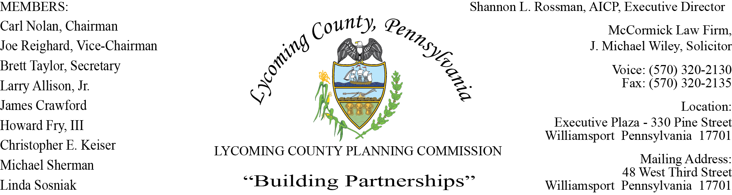

LYCOMING COUNTY PLANNING COMMISSION MEETING
Executive Plaza Building
October 15, 2020
6:00pm

MEMBERS PRESENT: Chris Keiser, Joe Reighard,

MEMBERS PRESENT VIA CONFERENCE CALL: Carl Nolan, Linda Sosniak, Howard Fry, III,

MEMBERS ABSENT: Brett Taylor, Larry Allison, Jr., Jim Crawford, Mike Sherman
OTHERS PRESENT VIA CONFERENCE CALL:

OTHERS PRESENT: Shannon Rossman, PCD, Tiffany Krajewski, PCD, Joshua Billings, PCD, Eve Adrian, PCD, Heather George PCD, J. Michael Wiley, Solicitor, Mike Ruther, Sun-Gazette, Joseph Stender, Geisinger, Bob Markowski, Geisinger

- CALL TO ORDER

Carl Nolan, Chairman, called the meeting to order at 6:01pm.

- MINUTES OF REGULAR MEETING

Joe Reighard made motion to accept the minutes of September 17, Howard Fry, III second motion. Motion carried.

- PUBLIC ON AGENDA ITEMS ONLY – None

- OLD & FUTURE BUSINESS

A question was raised by Joe Reighard in regards to Land Development that occurred on a property 10 years ago. The question is, if the original owners sell the property in 7 years later, do the land development requirements apply to the new landowner, an example would be of landscaping. Mike Wiley’s response to the question was yes, it runs with the land. After further questions, Mike Wiley suggested that questions be asked outside of the meeting so he can give a legal opinion to a specific issue.

Tiffany spoke in regards to the Zoning Fee update that was sent earlier in the month. The results to the Zoning Continuance fee are: two people chose option 1, 3 chose option 2, option 3 had 4. At this time, this will go before the Commissioners with possibilities to complete in November.

Tiffany notified the committee that the Land Development staff would like to plan a meeting with Muncy Township and Codes Inspection Inc to discuss the process of communication to ensure everyone is on the same page when it comes to development. In addition, there will be a meeting on November 17 at 6pm in the Commissioners Board Room with County land use partners to review both sides of the partnership, which will include land use ordinance changes, zoning questions and amendments, processes, etc.

- SUBDIVISION & LAND DEVELOPMENT PLANS

- Multi-Lot Presentations - None

- Land Development

- Liddic Et Al., Cingular Wireless
Telecommunications Land Development
Mifflin Township

Joshua Billings presented to the board a proposed new land development for a cell tower for Cingular Wireless partnered with AT&T, in Mifflin Township west of Salladasburg Borough. The 280 ft lattice tower is on a 100 ft x 100 ft leasehold within a fenced area. The Mifflin Township Supervisors reviewed the land development plan and had no comment. The recommendation from the staff is to grant final approval with conditions:

- Upon Staff’s and LCPC Consulting Engineer concurrence of a Cost Estimate to complete the required land development/stormwater management improvements, an Improvement Guarantee Agreement with Financial Surety must be established within 60 days of final land development approval. Extension of the 60 days is at Staff’s discretion (to be provided prior to signing and recording of the final land development plan).
- The developer shall finalize the land development plans with any required revisions from the LCPC, LCPC consulting engineer and the County Conservation District. (to be provided prior to signing and recording of the final land development plan)
- The developer must provide a copy of the Conservation District approval letter for the erosion and sedimentation control plan.
- The Developer must contact LCPC Staff for an intermediate and final land development and stormwater inspection to insure the proper installation of the TrueGrid permeable pavement system.
- After the Planning Commission approval, the approved land development plans, the applicant signed approval letter, must be recorded within 90 days of the date when conditions 1-2 are met. Applicant has 6 months from the conditioned approval date to satisfy all conditions. Extension of the 6 months is at Staff’s discretion.

C. Single-Lot Ratifications

Joshua asked the committee if they had any questions on the three Subdivision Single-Lot
Ratification for the following townships: Jordan Township, Limestone Township and Muncy
Township. There being no questions from the Committee a motion was made.

Chris Keiser made motion to approve, Joe Reighard second motion. Motion carried.

- ACTION ITEMS

- Geisinger Developers Agreement
Chris Keiser requised himself

Joshua reviewed the Developers Agreement while noting the agreement is to memorialize the
approvals already given to Geisinger for the Acute Care Hospital. This agreement will help to
clarify approvals, permits issued and yet required. Parties involved in this agreement are
LCPC, Muncy Township and Geisinger Medical Center.
One of the conditions for approval was to establish improvement guarantee agreement
for everything onsite, except the building. This does not cover offsite agreements that might
require HOP.
There were two zoning approvals given, one being zoning permit for grading along with a
zoning permit for the site for the building and use. Also noting there was a NPDES permit
approval, which is a requirements to move dirt. The temporary HOP permit along with other
permits and land development approval allowed Geisinger to move forward on site. This
Developers Agreement clarifies what is allowed in the Subdivision Land Development and
Zoning Ordinance.

Chris Keiser noted a Construction HOP only allows to build the small construction access. At the
March meeting the HOP was yet to be approved and Construction HOP was granted by District 3,
knowing Geisinger was doing work subject to risk.

Shannon noted the Developer’s Agreement was written to clarify to the public and township that
Geisinger cannot get their Occupancy Permit and Zoning Occupancy finalization, final reviews
and inspections until all the conditions of the agreement and land development are satisfied.

Joe Reighard made motion to approve, Howard Fry, III second motion. Motion carried.

- COMMITTEE REPORTS/DISCUSSION - None

- DISCUSSION ITEMS

- New Staff Introductions

Shannon introduced Eve Adrian as the Natural Resource Planner. Eve spoke of her work experience while mentioning that she received her Master’s degree in Community and Regional Planning. Eve has local roots and it happy to be back home.

- Subdivision & Land Development Ordinance Amendment

Tiffany stated she emailed an ordinance amendment that was created in response to the Developer’s Agreement. The purpose of the amendment is to tighten up the language for the section of Subdivision Land Development, Article 3 recording final plans. Currently the ordinance states, “The final plans shall be filed with Lycoming County Register and Recorder before proceeding with the sale of lots or Zoning Occupancy certificate of building and structures”. The language will be changed to “The final plans shall be filed with the Lycoming County Register and Recorder before proceeding to the sale of the lots or construction of buildings and structures, unless the developer has completed a Developer Agreement and Improvement Guarantee Agreement between the Developer and the County and approved by the LCPC and the Municipality.” The Developer’s Agreement will be used as a template that may change from case to case depending on the development.
Eventually the agreements will be available on the website as templates, after Mike Wiley reviews.

- PUBLIC COMMENTS - None

- ADJOURNMENT

Joe Reighard made a motion to adjourn, Chris Keiser seconded motion. Motion carried.

Meeting adjourned at 6:46pm.

Respectfully submitted,

_________________________ _________________________
Shannon L. Rossman, Director Brett Taylor, Secretary

DATE: ____________ DATE: _____________

