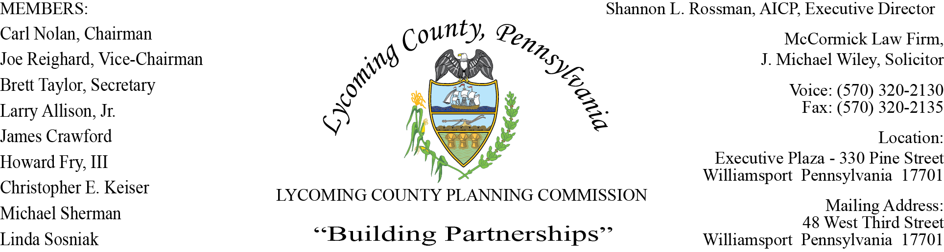

LYCOMING COUNTY PLANNING COMMISSION MEETING
Executive Plaza Building
November 19, 2020
6:00pm

MEMBERS PRESENT: Chris Keiser, Joe Reighard, Brett Taylor

MEMBERS PRESENT VIA CONFERENCE CALL: Carl Nolan, Linda Sosniak, Howard Fry, III, Jim Crawford

MEMBERS ABSENT: Larry Allison, Jr., Mike Sherman
OTHERS PRESENT VIA CONFERENCE CALL: John Lavelle

OTHERS PRESENT: Shannon Rossman, PCD, Tiffany Krajewski, PCD, Joshua Billings, PCD, Brandon Ball, PCD, Heather George, PCD, J. Michael Wiley, Solicitor, Mike Ruther, Sun-Gazette, Josh Phillips, Tom Schneck Muncy Township Spv.

- CALL TO ORDER

Carl Nolan, Chairman, called the meeting to order at 6:00pm.

- MINUTES OF REGULAR MEETING

Joe Reighard made motion to accept the October 15 minutes, Linda Sosniak second motion. Motion carried.

- PUBLIC ON AGENDA ITEMS ONLY – None

- OLD & FUTURE BUSINESS

- New Staff Introduction

Shannon introduced new staff to the committee. Brandon Ball is the new Community & Economic Development Planner, who replaced Chris Musto. Brandon has been working on the COVID CARES Act applications, he will also be involved with applications for HUD, Homes in Need anything relating to CDBG funds. Additionally new to the department is Chris Hodges, Zoning and Subdivision Officer. Chris will be reviewing Zoning Permits and Subdivision Land Development Plans.

- CARES Act Update

Shannon updated members in regards to CARES ACT noting there were 166 approved for the small business grant with two additions. Checks dispersed thus far totaled between 30 to 40, as documentation is approved, it goes to the Commissioners and Controllers for the check to be cut. Checks cannot be released until there is enough documentation to cover the amount awarded. Shannon noted they are working with the commissioners, to potentially announce a contingent round for small businesses. There were 43 Non-profits that were approved for funding, with checks ready to be distributed on December 17, 2020.

- Old Business Report

Joshua informed members they are preparing a list of developments that have been approved by the Planning Commission over the last year. This will help to track the approval conditions as well as the status of the development if under construction or if they had a final inspection, etc. This will help to keep the Planning Commission members informed of any updates. Joshua will have this list available for the next Planning Commission meeting.

- Tentative meeting schedule for 2021

Shannon spoke of the meeting dates for 2021 noting the dates will be advertised in the newspaper.

- SUBDIVISION & LAND DEVELOPMENT PLANS

- Multi-Lot Presentations - None

- Land Development

- Joshua & Amy Phillips
Single-Family Home Land Development
Muncy Township

Joshua presented to the board a proposed new land development for a second residence on the Phillips property located in Muncy Township. The proposed second residence will be approximately 90 ft x 90 ft, 8100 sq ft., two-story with attached garage on 55 acres. The Zoning Ordinance permits a certain number of homes to be allowed on the property based upon the Zoning District. The Subdivision Land Development Ordinances requires the applicant to go through a major land review process, due to the size being over 2500 sq ft. There is an existing home, barn and driveway that fronts SR 220 highway. Joshua recommended after the Planning Commission approval, the approved plan, and the approval letter must be recorded within 90 days of approval date.

Tom Schneck, Chairmen of the Board of Supervisors for Muncy Township spoke to members on the proposed development. A statement from the board for Muncy Township endorses the project, they feel it is a plus for the community. Mr Phillips and his family have invested well over 5 million dollars in Muncy Township over the last couple of years, repurposing and expanding local businesses, bringing jobs. The recommendations from Muncy Township Planning Commission and Supervisors is to approve and endorse the project. Joshua stated he attended the Muncy Township meeting on November 11 and then forwarded “no comment”.

Brett Taylor made motion to approve, Chris Keiser second motion. Motion carried.

C. Single-Lot Ratifications

Joshua briefly reviewed two Subdivision Single-Lot Ratification for the following townships:
Moreland Township and Shrewsbury Township.

Joe Reighard made motion to approve, Brett Taylor second motion. Motion carried.

- ACTION ITEMS - None

- COMMITTEE REPORTS/DISCUSSION - None

- DISCUSSION ITEMS

- WATS MPO Technical Committee Member

Sal Vitko spoke to the committee notifying them that LCPC has a seat on the WATS MPO Technical Committee. The current representative, Joe Reighard is one of the members on the committee. The Technical Committee reviews all transportation issues, programs and projects in Lycoming County. Once the Committee reviews they give recommendations to WATS Coordinating Committee, along with other coordinating committees in WATS. WATS MPO Technical Committee currently has the following voting members, PennDot Program Center, Engineering District 3, Planning Director, LCPC member, RVT Representative, City of Williamsport Engineer and Williamsport Airport. Additionally there are four non-voting members consisting of FHWA, PA DCED, Federal Trans Administration and Fullington Trailways. Sal stated WATS MPO suggests having an alternate for every seat on the committee in the event the representative cannot attend. Shannon suggested to the committee that LCPC select an alternate with recommendation to be made at the December meeting.

- PUBLIC COMMENTS - None

- ADJOURNMENT

Brett Taylor made a motion to adjourn, Joe Reighard seconded motion. Motion carried.
Meeting adjourned at 6:23pm.

Respectfully submitted,

_________________________ _________________________
Shannon L. Rossman, Director Brett Taylor, Secretary

DATE: ____________ DATE: _____________

