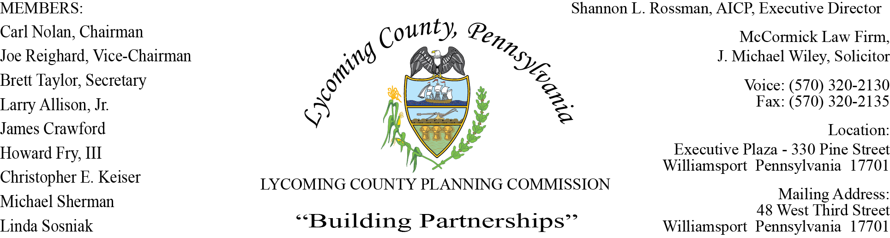

LYCOMING COUNTY PLANNING COMMISSION MEETING
Executive Plaza Building
May 20, 2021
6:00pm

MEMBERS PRESENT: Joe Reighard, Jason Bogle, Brett Taylor, Linda Sosniak, Chase Kelch,
Howard Fry III,

MEMBERS ABSENT: Carl Nolan, Larry Allison Jr, James Crawford
MEMBERS PRESENT VIA CONFERENCE CALL:
OTHERS PRESENT VIA CONFERENCE CALL:

OTHERS PRESENT: Shannon Rossman, PCD, John Lavelle, PCD, Tiffany Krajewski, PCD,
Heather George, PCD, J. Michael Wiley, Solicitor, Mike Ruther, Sun-Gazette,
Commissioner Mussare

- CALL TO ORDER

Joe Reighard, Chairman, called the meeting to order at 6:04pm.

- MINUTES OF REGULAR MEETING

Joe Reighard asked for motion to accept the April 15, 2021 meeting minutes.
Brett Taylor motion to approve, Linda Sosniak, second to approve. Motion carried.

- PUBLIC COMMENT ON AGENDA ITEMS ONLY – None

- OLD & FUTURE BUSINESS

- Personnel update

Shannon updated members on the positions within the PCD Department. Mark Haas, came to PCD from Sullivan County, he is the Subdivision & Land Development Administrator. Kelsey Green is the new Hazard Reduction Planner, she interned within the department a couple times and has worked on the Levee projects in different capacities. Tiffany Krajewski has accepted the position of Community & Economic Planner position, currently they are advertising for her position as Development Services Supervisor.

Tiffany spoke to members referring back to last months discussion on Event Venue amendments, the language is still being researched.
Tiffany notified members that the language on the agenda for “Single-Lot Ratification” is proposed to change to “Minor Plan Ratification”. A Major Plans report is also in the works this will help to keep members informed as to where they are in the approval process.

Tiffany updated members on the VIWY, Starbucks plans. The developer is moving forward with the approach known as phase I and phase II, this is due to the other side of Starbuck where they have no signed guarantees.

- SUBDIVISION & LAND DEVELOPMENT PLANS

- Multi-Lot Presentations - None

- Land Development

- Marshall Bros/HEP Booster Station
Jackson Township
Natural Gas Land Development

Mark Haas presented a proposed land development plan from Marshall Bros/Howard Energy Partners in Jackson Township. The plan proposed is for a booster station on a 3.54 acre lot on a 101.4 acre parcel located in the Agricultural Zoning District.

Access to the Booster Station will be provided by a proposed 25 ft driveway off an existing natural gas well pad access road. There will be a 380 ft access road going to the booster station. The driveway will meet the requirements of the Subdivision and Land Development Ordinance.

The Zoning Administrator has reviewed the zoning for the Booster Station and has determined that the development will need to address landscaping requirements prior to approval.

Jackson Township Supervisors will review the land development plan at their meeting June2, 2021.

Jim Townsley spoke on behalf of Howard Energy Partners Tioga Gathering, LLC. He presented to members revised plans pertaining to the trees and noted they could match the ordinance and do what was required while putting in some extra trees. They are putting a barrier around the fans to eliminate the sound more.

Approval conditions:
- Upon Staff’s and LCPC Consulting Engineer concurrence of a Cost Estimate to complete the required Land Development improvements, An Improvement Guarantee Agreement with Financial Guarantee must be established within 60 days of final land development approval. Extension of the 60 days is at Staff’s discretion (to be provided prior to signing and recording of the final land development plan)
- The applicant shall provide final plans with required plan revisions identified in the review letter dated 5/12/21 and any revisions required by other agencies involved in the development prior to signing of the Final Land Development Plan.
- Any comments received from Jackson Township shall be addressed as needed prior to signing and recording of the final land development plan.
- The applicant shall provide a copy of the ESCGP-3 permit approval to Planning Staff prior to signing and recording of the final land development plan.
- The applicant shall receive zoning permit approval prior to signing and recording of the final land development plan.
- After the Planning Commission approval, the approved land development plans, the applicant signed approval letter, must be recorded within 90 days of the date when all conditions are met. Applicant has 6 months from the conditioned approval date to satisfy all conditions. Extension of the 6 months is at Staff’s discretion.

Howard Fry, III made motion to approve with conditions, Brett Taylor second motion. Motion carried.

- Single-Lot Ratifications

Mark Haas explained to members the Waiver Request of Brian and Amy Tilburg. They had two lots but wanted to build on their existing lot. Where they found their perc approval encroached into the 50 ft right of way which didn’t leave them enough space to build a house. They requested a 33 ft right of way to give them more flexibility to construct their house which was approved.

There were no questions from members on the five single-lot ratifications.

Jason Bogle made motion to approve, Linda Sosniak, second motion. Motion carried.

- ACTION ITEMS

- COMMITTEE REPORTS/DISCUSSION

- MONTHLY REPORTING

Shannon expressed to members these are standard monthly reports if they have any questions to contact the individual staff.

- DISCUSSION ITEMS

A. Community Development Block Grant (CDBG) Update

Jenny Picciano updated members on the Community Development Block Grant Program. The
county receives an annual allocation thru CDBG which is generated at the federal level and
distributed through the PA Department of Community and Economic Development (DCED). The
grant amount is based upon population, at this time the grant is in the amount of $291,230.00, to
be used for county wide projects. The funding is to address community development issues
within the county that can be related to housing, infrastructures, roads, bridges, home
repair. PCD and SEDA-COG will compile a list of projects that will be evaluated using certain
criteria to be presented to the Commissioner’s for inclusion in the County’s final application to
DCED.

There is a kick off workshop on June 9 at 6:00pm in the First Floor Commissioners; Board
Room, Executive Plaza (330 Pine Street). All municipalities were mailed a packet of
information.

- PUBLIC COMMENTS - None

- ADJOURNMENT

Joe Reighard asked for a motion to adjourn, Brett Taylor, motion to adjourn, Chase Kelch second motion. Motion carried.
Meeting adjourned at 6:53 pm.

Respectfully submitted,

_________________________ _________________________
Shannon L. Rossman, Director Carl Nolan, Secretary

DATE: ____________ DATE: _____________

