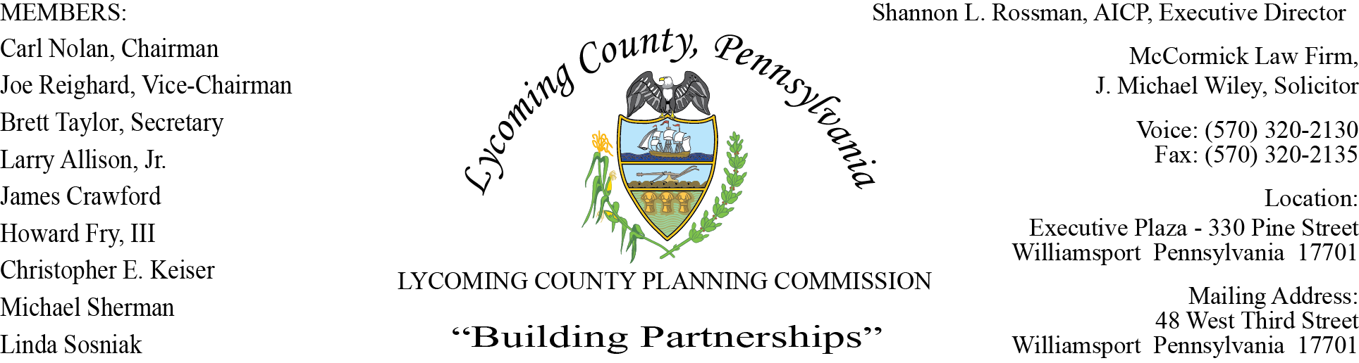

LYCOMING COUNTY PLANNING COMMISSION MEETING
Executive Plaza Building
July 16, 2020
6:05pm

MEMBERS PRESENT: Joe Reighard, Brett Taylor, Larry Allison, Jr., Linda Sosniak, Chris Keiser

MEMBERS PRESENT VIA CONFERENCE CALL: Carl Nolan, Howard Fry, III, Jim Crawford, Mike Sherman

MEMBERS ABSENT:
OTHERS PRESENT VIA CONFERENCE CALL:

OTHERS PRESENT: Mike Ruther, Williamsport Sun-Gazette, Shannon Rossman, PCD, John Lavelle, PCD, Tiffany Krajewski, PCD, David Hubbard, PCD, Heather George PCD, J. Michael Wiley, Solicitor

- CALL TO ORDER

Carl Nolan, Chairman, called the meeting to order at 6:05pm.

- MINUTES OF REGULAR MEETING

Linda Sosniak made a motion to accept minutes of May 21, Howard Fry, III second motion. Motion carried

- COMMITTEE REPORTS – None

- PUBLIC COMMENTS ON AGENDA ITEMS ONLY – None

- OLD & FUTURE BUSINESS – None

- SUBDIVISION & LAND DEVELOPMENT PLANS

- Multi-Lot Presentations - None

- Land Development - None

C. Single-Lot Ratifications

Tiffany reviewed the Single-Lot Ratification handout.

Brett Taylor made a motion to approve, Joe Reighard second, motion carried.

- ACTION ITEMS - None

- DISCUSSION ITEMS

- Staff Updates – Shannon updated the members on staff changes taking place within Planning & Community Development. Most recently, the Transportation Planner position was filled by Austin Daily, PCD staff, which was vacated by Scott William. Chelsea Blair resigned as the Hazard Reduction Planner and the position was recently filled by Alyssa Henry. Alyssa comes from the West Branch Regional Authority; she will begin Wednesday, July 22. Deb Bennett, who is the Administrative Support Supervisor, will be retiring at the end of July. Deb provided a lot of the financial reporting with in the department. The Commissioners approved to replace the position of Community Development Planner and Natural Resource Planner. Interviews for the open positions will begin within the next two weeks with positions to be filled by
mid-August.

- Hazard Mitigation Plan Updates - John Lavelle gave an update on the Hazard Mitigation Plan. There were three companies that submitted proposals for the Hazard Reduction Plan. Michael Baker proposed $56,688.00, MCM proposed $59,320.00 and Tetra Tech proposed $45,650.00. After a careful review and selection process the decision was made to award Michael Baker International, who is the best qualified for the project. Recommendations were forwarded to the Commissioners for approval. Shannon noted that every municipality will have to adopt the final plan in order to be eligible for FEMA disaster assistance funds in the event of a presidentially declared natural disaster. The Planning Department will coordinate with all 52 municipalities in order to update the plan with relevant and up-to-date information.

- Future Projects - Shannon shared information on future projects the Planning Department is working on:

- Watershed Implementation Plan for the Chesapeake Bay will begin this fall; DEP will provide assistance throughout the process.
- Build Grant for Jersey Shore, this will allow the bridge on 220 to be raised and the rehabilitation of Lawshe Run. They hope to hear more in September.
- Utility Elevation for residence, in the flood plain; elevating the utilities will help relieve reoccurring flood claims.
- Levee Grants:
  - Memorial Avenue will be bid out in the next 30 to 60 days.
  - RACP Grant for relief wells that have to be replaced or tested to make sure they still work. This will be bid out in the next 30 to 60 days.
  - H2O state grant to address cross pipes work, this should be awarded in August.
  - EDA Phase II Grant for construction, engineering and permitting for the Dewey Avenue area was submitted.
- The county will be receiving a 10.2 million COVID grant. The funds will have to be used by December 30, 2020.

- Zoning Fee Schedule Update – Tiffany presented the proposed Fee Schedule for 2021, which will include fee increases. Some concerns were raised about the continuance fee, if the continuation is of no fault of the applicant. Shannon noted this will be reviewed and further discussed.

- PUBLIC COMMENTS – None

- ADJOURNMENT

Brett Taylor made a motion to adjourn, Larry Allison, Jr. seconded. Motion carried.

Meeting adjourned at 7:17pm.

Respectfully submitted,

_________________________ _________________________
Shannon L. Rossman, Director Brett Taylor, Secretary

DATE: ____________ DATE: _____________

