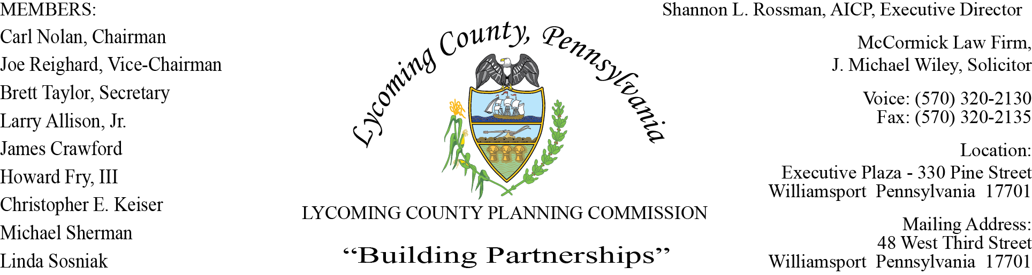

LYCOMING COUNTY PLANNING COMMISSION MEETING
Executive Plaza Building
August 20, 2020
6:00pm

MEMBERS PRESENT: Brett Taylor, Chris Keiser

MEMBERS PRESENT VIA CONFERENCE CALL: Carl Nolan, Howard Fry, III, Jim Crawford, Linda Sosniak

MEMBERS ABSENT: Joe Reighard, Larry Allison, Jr., Michael Sherman
OTHERS PRESENT VIA CONFERENCE CALL:

OTHERS PRESENT: Mike Ruther, Williamsport Sun-Gazette, Shannon Rossman, PCD, John Lavelle, PCD, Tiffany Krajewski, PCD, Alyssa Henry, PCD, Heather George PCD, J. Michael Wiley, Solicitor

- CALL TO ORDER

Carl Nolan, Chairman, called the meeting to order at 6:00pm.

- MINUTES OF REGULAR MEETING

Linda Sosniak made a motion to accept minutes of July 16, Howard Fry, III second motion. Motion carried

- COMMITTEE REPORTS/DISCUSSION

Shannon noted Committee Reports will be on next month’s agenda.

- PUBLIC COMMENTS ON AGENDA ITEMS ONLY – None

- OLD & FUTURE BUSINESS

Shannon briefed the committee on how the Planning Department has taken the lead on the County’s Federal COVID CARES Act Fund. The County received 10.2 million dollars, which will be administered thru SEDA-COG. There will be a Small Business Grant for small businesses, SEDA-COG and the Chamber will be utilized for outreach. The applications will be distributed August 31, ZOOM meeting will be held on September 2 with the applications due back September 18. The funds have to be spent by December 30, 2020. Planning and Community Development is also assisting with coordination of the COVID CARES Act funds for the county, Non-Profit, Municipalities, Fire/EMS and School Districts.

- Staff update - Shannon updated members of the open position for Zoning Officer vacated by Chris Musto. Chris moved into another position within the department. The Natural Resource Planner will begin in September also Lori Weston replaced Deb Bennett’s position as Administrative Support Supervisor. Lori transferred from the Budget and Finance Department.

- SUBDIVISION & LAND DEVELOPMENT PLANS

- Multi-Lot Presentations - None

- Land Development - None

C. Single-Lot Ratifications

Tiffany presented four Subdivision Single-Lot Ratification handout.

Brett Taylor made a motion to approve, Chris Keiser second, motion carried.

- ACTION ITEMS - None

- DISCUSSION ITEMS

- Hazard Mitigation Plan Update – Alyssa Henry, Hazard Reduction Planner, gave an update for the Hazard Mitigation Plan from Michael Baker. Stakeholder meetings will be held August 27th and October 15th both in person and via webinar. The draft plan will be submitted to FEMA by January 20, 2021 current plan expires April 8, 2021.

- Zoning Fee Schedule Update - Tiffany revisited the proposed Fee Schedule for 2021 with fee schedule increases. The committee will receive an email with different versions of the fee schedule to review. Tiffany reminded the committee they would like to present this to the Commissioners by the end of September.

- Bridge Bundling Update - John updated members on the Bridge Bundling. The Steering Committee had their first meeting on July 29 via conference call. All owners of the bridges were in on the call. This was an informational meeting giving insight to plans. Bassett Engineering will be producing feasibility studies to give each bridge owner options that will eventually be signed off by the municipality.

- PUBLIC COMMENTS – None

- ADJOURNMENT

Brett Taylor made a motion to adjourn, Chris Keiser seconded. Motion carried.

Meeting adjourned at 6:46pm.

Respectfully submitted,

_________________________ _________________________
Shannon L. Rossman, Director Brett Taylor, Secretary

DATE: ____________ DATE: _____________

