Lycoming County’s Clean Water Plan Check-In Meeting
March 25, 2021
9:30am-11:30am

Meeting Notes

- Meeting goals
  - Ensure stakeholders understand CAP milestones and benchmarks
  - Create continuity between Peer Group communication
  - Begin considering programmatic/policy recommendations

- Stakeholder highlights
  - This is a summarized list of skills, priorities, and values that I have heard from stakeholders:
    - Skills – technical knowledge on ag, conservation, preservation, restoration, and trails/parks; implementing projects; supplying resources (data, personnel, venues, funding); experience; outreach; planning; generating ideas; mapping
    - Priorities – proactive planning; reliable and accurate data; collaboration and partnership; realistic and implementable plan
    - Values – preserving ag land and open space; teaching conservation practices; stewardship; working together and providing support; stream restoration
    - Goals – to be a model for local water quality improvement through reliable, replicable, and smart land management practices

- Benchmarks and milestones
  - Lycoming County goal of reducing ~1.2 million lbs/yr nitrogen and 76,000 lbs/yr phosphorus by 2025
  - We have just begun planning, and we’ve already accomplished so much! Here is a diagram of our timeline and process:
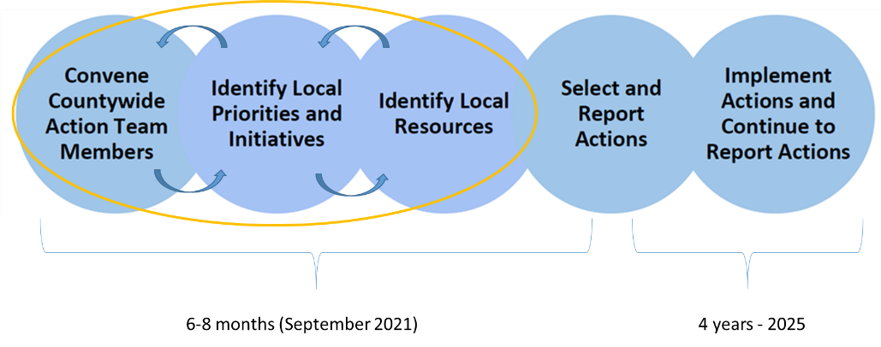
  - Benchmarks outline
    - March –September: planning meetings with peer groups (one per week)
    - Drafts/CAST model runs: April 29th, June 24th, July 29th
    - Final submission: September 30th

- Peer Group Updates
  - Agriculture - Embedded in local and regional ag community, has expertise in agricultural best management practices (BMPs) – March 2nd
  - Resources – Supplies knowledge of funding sources, technical assistance, personnel, etc. Also considers the resources that would be needed or available for project implementation – March 4th
  - Watershed – Knowledgeable of watershed ecosystem services, and could supply projects, policies, and programmatic recommendations – March 9th
  - Policy - Considers policies, programs, outreach, and resources that could be implemented – March 16th
  - Recreation - Connected to outdoor recreation and stewardship, able to provide projects, policies, and outreach with this specific outdoor recreation framework – March 23rd
  - Municipal - Provides expertise in potential outreach and education, projects, policies, ordinances, etc. – March 29th
  - Implementation - Focused on how CAP actions would be implemented and potentially prioritized – April 6th

- Peer Group planning meetings – housekeeping and reminders
  - Meetings can be scheduled during early morning, late afternoon, evening, and weekends (not just during 8:30-5)
  - Meetings can be held in-person with COVID precautions
  - Upcoming meetings See web page for “skeleton schedule”
    - Planning page calendar will contain additional meetings
    - Come prepared and engaged for discussion!

- Co-Benefits Discussion
  - Tree canopy
    - Implementing these conservation and restoration practices:
      - Agricultural forest buffers.
      - Forest conservation.
      - Urban forest buffers.
    - Also benefit these outcomes:
      - Habitat biodiversity.
      - Air quality.
      - Land use methods.
      - Fish habitats.
      - Healthy watersheds.
      - Forest buffers.
  - Wetlands
    - Implementing these conservation and restoration practices:
      - Wetlands.
      - Wet ponds.
      - Urban forest buffers.
    - Also benefit these outcomes:
      - Black ducks.
      - Climate adaption.
      - Flood control/mitigation.
      - Groundwater recharge/infiltration.
      - Recreation.
  - Stream health
    - Implementing these conservation and restoration practices:
      - Forest conservation.
      - Agricultural forest buffers.
      - Urban forest buffers.
      - Urban stream restoration.
    - Also benefit these outcomes:
      - Brook trout.
      - Healthy watersheds.
      - Forest buffers.
      - Flood control/mitigation.
      - Protected lands.

- Programmatic/Policy Recommendations (“If/Then” Scenarios)
  - See template

- Next Steps
  - Meetings
    - Next check-in meeting is Thursday, April 29th at 9:30am
    - Recruit!
    - Come prepared and ready for discussion
    - Consider if more peer group meetings need to be scheduled (each group is different)
  - Planning
    - How can we prioritize the projects that we already have in our templates?
    - What are additional programmatic recommendations?
    - Draft #1 due Thursday, April 29th

For questions or additional information, please contact:
Eve Adrian
Lycoming County Natural Resource Planner
eadrian@lyco.org
570-329-4761

Or visit https://www.lyco.org/CWAP

