Lycoming County’s Countywide Action Plan (CAP) Stakeholder Meeting
Agenda
March 25, 2021

***Welcome, and THANK YOU for participating!***

PURPOSE
- Ensure stakeholders understand CAP milestones and benchmarks
- Create continuity between Peer Group communication
- Begin considering programmatic/policy recommendations

AGENDA
- Zoom functions and housekeeping
  - Reactions
  - Chat – rename yourself (First, Last Name – Affiliation); type in your name, affiliation, and any other participants joining you in the meeting
- Stakeholder highlights
  - Skills, priorities, values, and goals
- Benchmarks and Milestones
  - Lycoming County pollution reduction goals: ~1.2 million lbs/yr nitrogen, 76,000 lbs/yr phosphorus
  - Where we are in the planning phase
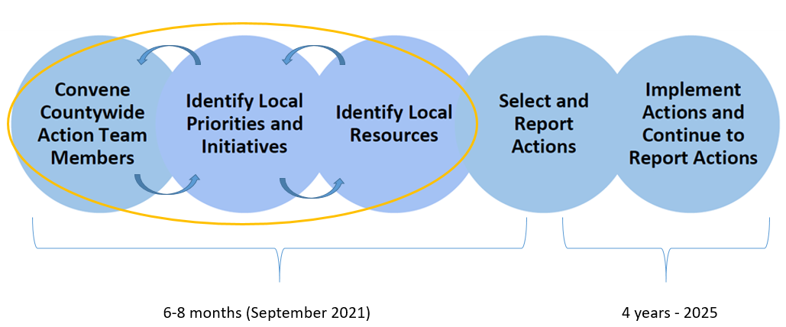
  - Benchmarks outline
    - March –September: planning meetings with peer groups (about one or two per week)
    - Drafts/CAST model runs: April 29th, June 24th, July 29th
    - Final submission: September 30th

- Peer Group Updates
  - Agriculture - Embedded in local and regional ag community, has expertise in agricultural best management practices (BMPs) – March 2nd
  - Resources – Supplies knowledge of funding sources, technical assistance, personnel, etc. Also considers the resources that would be needed or available for project implementation – March 4th
  - Watershed – Knowledgeable of watershed ecosystem services, and could supply projects, policies, and programmatic recommendations – March 9th
  - Policy - Considers policies, programs, outreach, and resources that could be implemented – March 16th
  - Recreation - Connected to outdoor recreation and stewardship, able to provide projects, policies, and outreach with this specific outdoor recreation framework – March 23rd
  - Municipal - Provides expertise in potential outreach and education, projects, policies, ordinances, etc. – March 29th
  - Implementation - Focused on how CAP actions would be implemented and potentially prioritized – April 6th
  - Planning meetings can be scheduled during early morning, late afternoon, evening, and weekends (not just during 8:30—5), and they can be in person (with COVID precautions)
  - Template highlights and common themes
- Questions/Concerns
- Co-Benefits
  - Overview
  - What examples have you seen?
  - What co-benefits would you like to see?
- Programmatic/Policy Recommendations
  - If/Then scenarios
- Next steps
  - Recruit
  - More peer group meetings
  - What we’ll discuss in our next meeting:
    - What else can we include in the plan?
    - How can we ensure these initiatives are successful (think through the planning process and consider implementation)?
    - How can we prioritize the projects that we already have in our templates?
- Next check-in meeting: Thursday, April 29th 9:30am-11:30am

