Lycoming County’s Countywide Action Plan (CAP) Stakeholder Meeting
Agenda
June 24, 2021
9:30am-11:30am

***Welcome, and THANK YOU for participating!***

PURPOSE
- Discuss DEP meeting updates and Draft 1 BMP reductions
- Strategize BMPs and future CAST model runs
- Cover Peer Group Updates
  - Meeting schedule changes
  - Current prioritization strategy
- Plan Next Steps

AGENDA
- DEP meeting updates
  - Mid-Point Check-in meeting (June 17th)
    - Be specific about our resource needs/recommendations. We need “X” resource to be able to achieve “X” outcome.
      - What would we like to do that other counties have done?
      - What changes would we like to make to existing practices (like the Transect Survey)?
      - What recommendations do we have to improve (again, like the Transect Survey)?
      - What funding, support, services, or staff would we need to achieve our goals?
    - Multiple BMPs can be captured under one project.
    - Land use/watershed location affects reduction rates.
      - Prioritizing hot spot watersheds will be important.
    - Projects we can include (reporting caveat):
      - MS4 projects
      - Section 319 areas (may not have any in Lyco Co)
      - NRCS projects
      - Existing practices
  - CAST Run Results meeting (June 17th)
    - Use the new BMP template.
      - We can report existing and new BMPs in new template
    - We’re at 4% nitrogen and 8% phosphorus reductions based on our submission.
    - Use Toolbox recommendations
    - Review DEP’s comments on CAP draft
- Review BMP reductions
  - Recap - these are Lycoming County’s goals

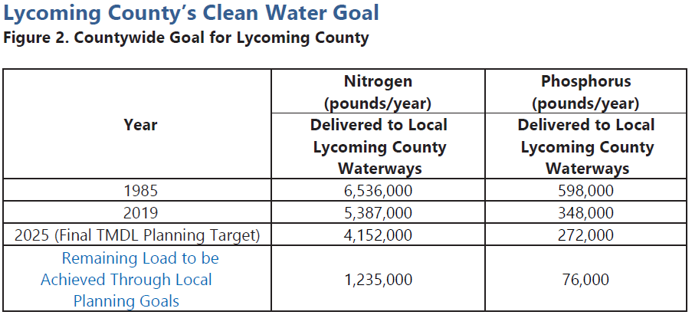
- This was our first BMP draft submission to go through CAST Model
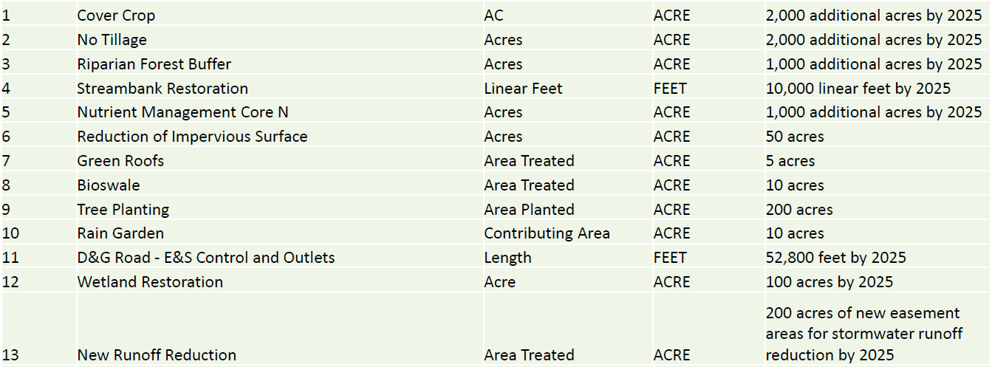
- This is a breakdown of our reductions based on the above submission
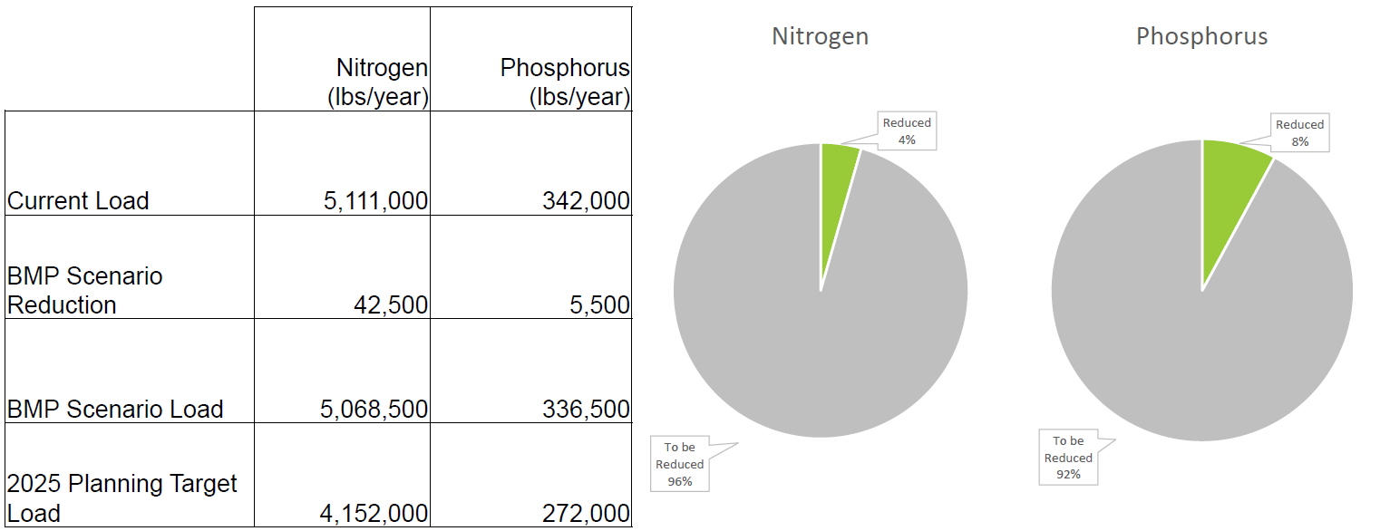
- Draft benchmarks
  - Draft 2 submission (was end of June), now will be Tuesday, July 6th.
  - Draft 3 submission (was end of July), now will be Monday, August 9th.
  - Final draft September 30th
- Peer Group meeting schedule changes
  - Pausing future Peer Group meetings EXCEPT FOR Implementation and Ag Peer Groups
  - We will have one-on-one/small group technical meetings instead
    - Municipal follow-up from survey/park improvements in municipalities
    - Technical ag meetings
    - Watershed-specific meetings, etc.
- Draft prioritization strategy
  - Tier 1 – Priority scoring weight
    - Reduction capacity
    - “Project efficiency” (best bang for your buck projects)
  - Tier 2 – Secondary scoring weight
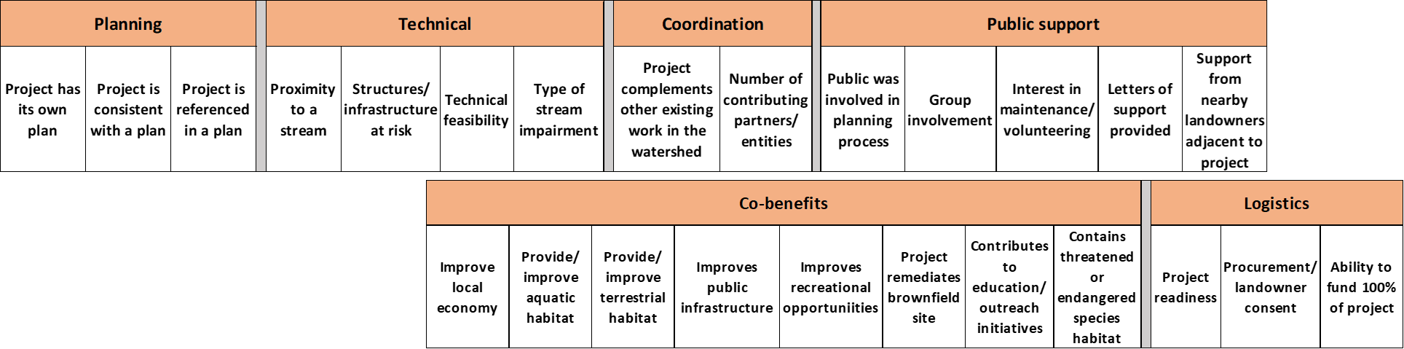
- Next steps
  - Draft 2 submission
    - Strategize based on DEP feedback and suggestions
    - Work toward reducing nutrients
  - Meetings
    - We will reach out to schedule smaller technical meetings
    - Peer Group meeting schedules will be updated on the web page
    - Stakeholder check-in meeting materials on web page: lyco.org/CWAP
  - Outreach
    - Continued outreach to the public and ag community
      - Virtual Open House (June 16)
      - Lycoming County Fair (July 14-24)
      - Surveys – links to fillable pdf’s and web surveys available
        - Ag Practices survey
        - Landowner Outreach survey
  - Prioritization
    - Improve and refine prioritization scoring
- Questions/concerns
- Next check-in meeting: Thursday, May 27th at 9:30am

