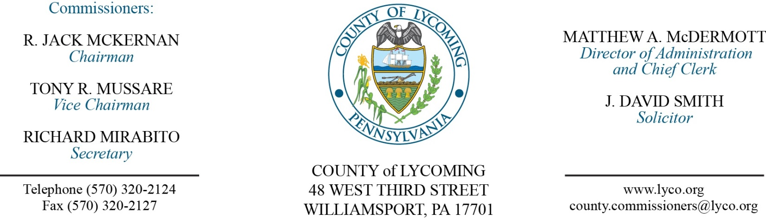
Commissioners’ Meeting Agenda
July 12, 2018

Opening Prayer

Pledge to the Flag

1.0 OPERATIONS

1.1 Convene Commissioners’ meeting.

1.2 Approve the minutes of the previous meetings.

1.3 Receive public comments (agenda items only).

2.0 ACTION ITEMS

2.1 Adopt resolution 2018-19 updating list of county solicitors.

2.2 Award contract to Oldcastle Precast, Inc., for 8-Concrete Manhole Box Structures in the amount of $94,600. (Jason Yorks)

2.3 Approve amendment to professional service agreement with NMS Labs for the District Attorney’s Office. (Mya Toon)

2.4 Approve MATP grant agreement with PA Department of Human Services $1,727,099. (Mya Toon)

2.5 Approve lease agreement with ECAN. (Mya Toon)

2.6 Approve purchase of Bunker & Field Rake (60 month lease) from John Deere in the amount of $12,500. (Mya Toon)

2.7 Approve professional service agreement with Schuylkill Mobile Fone not to exceed $56,000. (Leslie Kilpatrick)

2.8 Approve update to TDA: Sergeant and Deputy Sheriff positions as Union. (Roxanne Grieco)

2.9 Approve grant application to the PA Board of Probation & Parole in the amount of $1,168,824. (Matt McDermott)

2.9 Appoint Jeff Bower to the Board of Assessment Appeals.

2.10 Approve the following personnel actions: (Roxanne Grieco)
Collections – Reese L. Homes as full time replacement Administrative Enforcement Officer – Pay grade 7 - $18.08/hour effective 7/15/18.
Fiscal Services – Tina L. Jedrziewski as part time replacement Clerk III – Pay grade 4 - $12.96/hour effective 7/16/18, not to exceed 1,000 hours annually.
Information Services – Michael Gehr as full time replacement Network Engineer - $42,179.89/annually effective 7/17/18.
Maintenance – Doug Hasko as full time replacement Custodial Worker – Pay grade 1 – $10.84/hour effective 7/16/18.
Courts – Judge Linhardt – Zachary S. Stirparo as full time replacement Law Clerk – Pay grade 8 – $38,548.49/annually effective 9/4/18.
District Attorney – Lisa D. DiMassimo as full time replacement Clerk III – Pay grade 4 – $13.95/hour effective 7/16/18.

Recess Commissioners’ Meeting

3.0 SALARY BOARD

3.1 Convene Salary Board.

3.2 Approve update to Salary Schedule: Sergeant and Deputy Sheriff positions as Union.

3.3 Adjourn Salary Board.

Reconvene Commissioners’ Meeting

5.0 REPORTS/INFORMATION ITEMS

5.1 Present service pins:
20 years
John Nixon of JPO
10 years
Trevor Bowes of Prison

5.4 Recognize Marci Hessert upon her retirement.

6.0 COMMISSIONER COMMENT:

7.0 PUBLIC COMMENT:

8.0 NEXT REGULARLY SCHEDULED MEETING: Planning Session on Tuesday, July 17, 2018.

9.0 ADJOURN COMMISSIONERS’ MEETING.

