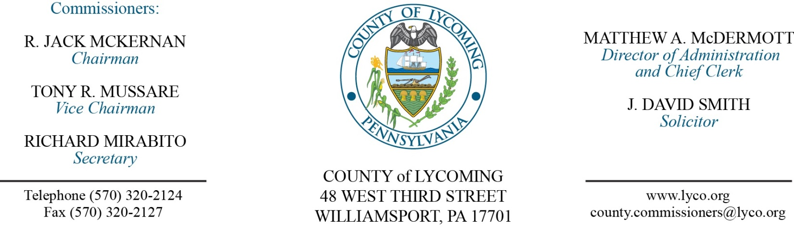
Commissioners’ Meeting Agenda
April 17, 2018

Opening Prayer

Pledge to the Flag

1.0 OPERATIONS

1.1 Convene Commissioners’ meeting.

1.2 Approve the minutes of the previous meetings.

1.3 Receive public comments (agenda items only).

Bid Opening:
Flood Mitigation Acquisition & Demolition project (4 bidders)

2.0 ACTION ITEMS

2.1 Approve accounts payable cash requirement report through April 25, 2018, for payment on April 18, 2018, in the amount of $1,452,392. (Michele McDermott)

2.2 Adopt resolution 2018-10 designating Joshua Schnitzlein to act as project manager for Lawshee Run Project. (Joshua Schnitzlein)

2.3 Adopt resolution 2018-11 committing $250,000 for the Lawshee Run Project. (Joshua Schnitzlein)

2.4 Adopt resolution 2018-12 designating Joshua Schnitzlein and Carey Entz-Rine to act as project managers for the Muncy Creek Streambank Protection and Restoration Project. (Joshua Schnitzlein)

2.5 Approve grant agreement with PEMA for HMGP in the amount of $2,047,290. (Joshua Schnitzlein)

2.6 Approve professional service agreement with Centre County Youth Service Bureau for the Juvenile Probation Office. (Ed Robbins/Nancy Ackley)

2.7 Approve Susquehanna Motor Company’s final invoice for maintenance of Mack Roll Off Truck in the total amount of $29,107.57. (Jason Yorks)

2.8 Approve update to policy 911 – County Emergency Medical Services Assistance Guidelines - of the County’s policy & procedures manual. (Matt McDermott)

2.9 Approve agreement with GEO Reentry Services, LLC. (Matt McDermott)

2.10 Approve the following personnel actions:
District Attorney – Full time replacement Assistant County Detective (NEU) – Pay grade AD - $20.92/hour effective 4/22/18.
Pre-Release – Elizabeth N. Deuel as full time replacement Resident Supervisor – Pay grade 5 - $15.22/hour effective 4/22/18.
Pre-Release – Jennifer Black - Jarrett as full time replacement Resident Supervisor – Pay grade 6 - $16.59/hour effective 4/23/18.

5.0 REPORTS/INFORMATION ITEMS

5.1 Tyler Technologies Assessment Software. (Tom Heap)

6.0 COMMISSIONER COMMENT:

7.0 PUBLIC COMMENT:

8.0 NEXT REGULARLY SCHEDULED MEETING: Planning Session on Tuesday, April 24, 2018. No meeting Thursday, April 19, 2018.

9.0 ADJOURN COMMISSIONERS’ MEETING.

