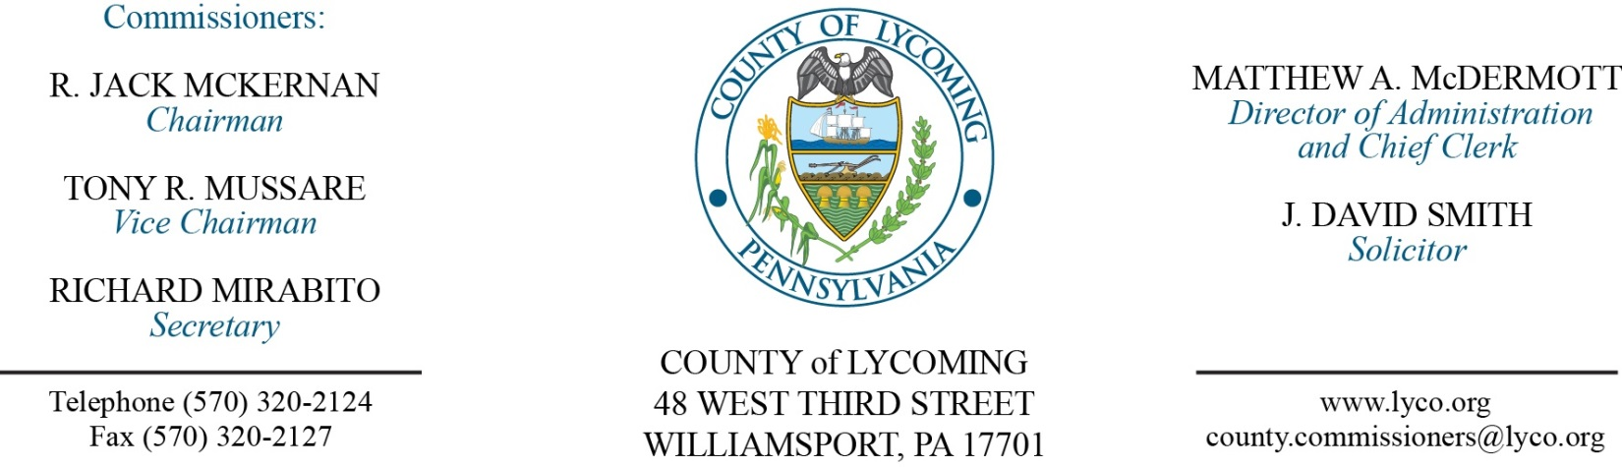
Commissioners’ Meeting Agenda
March 22, 2018

Opening Prayer

Pledge to the Flag

1.0 OPERATIONS

1.1 Convene Commissioners’ meeting.

1.2 Approve the minutes of the previous meetings.

1.3 Receive public comments (agenda items only).

Recess Commissioners’ Meeting

Public Hearing for Zoning Ordinance Amendment
(John Lavelle)

Reconvene Commissioners’ Meeting

2.0 ACTION ITEMS

2.1 Enact Ordinance 2018-01 for Zoning Ordinance Amendment. (John Lavelle)

2.2 Approve CIPP grant application to PCCD. (Jenn McConnell)

2.3 Approve 2018 County Liquid Fuels allocations (attachment A). (Mark Murawski)

2.4 Approve professional service agreement with Professional Petroleum Service Co for RMS. (Jason Yorks)

2.5 Approve amendment to agreement with Green Machine Sales, LLC - Maint & Repairs Single Stream Equip. (Jason Yorks)

2.6 Approve professional service agreement with ERA for Crane Service. (Jason Yorks)

2.7 Waive disposal fees for waste collected from the Great American Cleanup days from April 7th through April 30th, 2018. (Jason Yorks)

2.8 Approve 902 grant application to PADEP in the amount of $349,666.40 for DEP’s portion with the total amount being $388,518.22. (Lauren Strausser)

2.9 Approve professional service agreement with Willo Products Locking Controls for the Prison. (Mya Toon)

2.10 Award contracts for food products on a per item as needed basis to the following: (Mya Toon)
Keyco Distributors Benjamin Foods.
Feesers, Inc. Sysco Food Services LLC.

2.11 Approve quote from ePlus for Cisco Smartnet maintenance and support on core network switches for the downtown and Lysock campus in the amount of $17,531.56. (Jerry Kennedy)

2.12 Approve the following personnel actions: (Lauren Bower)
District Attorney – Anne M. Mungo as full time replacement Clerk III – Pay grade 4 - $13.95/hour effective 3/26/18.
Prison – Maggie C. Marshall as full time replacement Female Correctional Officer – COI - $16.01/hour effective 3/25/18.
Prison – promotion of Clyde E. Kennelley, Jr. as full time replacement Lieutenant – Pay grade 10 - $32.74/hour effective 4/8/18.
Public Defender – Kelli J. Harding-Cervinsky as full time replacement Paralegal – Pay grade 7 - $18.08/hour effective 3/26/18.
Domestic Relations – Joshua M. Klinger as full time replacement Domestic Relations Investigator – Pay grade 7 - $16.83/hour effective 3/26/18.
Soil Conservation – Rita J. Groy as part time West Nile Virus Technician – Pay grade 7 - $16.83/hour effective 4/2/18.
Maintenance – promotion of Regina D. Rooker as full time replacement Custodial Supervisor – Pay grade 6 - $16.59/hour effective 3/25/18.
Courts – MDJ Kemp – Danielle A. Ehrgood as full time replacement Clerk III – Pay grade 4 - $14.200843/hour effective 3/25/18.

Recess Commissioners’ Meeting

4.0 BOARD of ASSESSMENT REVISION

4.1 Convene Board of Assessment Revision.

4.2 Approve real estate exonerations as listed in attachment B.

4.3 Approve the following real estate refund:
Eugene Schurer – 43-007-102 - $305.73.

4.4 Adjourn Board of Assessment Revision.

Reconvene Commissioners’ Meeting

5.0 REPORTS/INFORMATION ITEMS

5.1 Comp Plan review Issue #6 (Volunteerism). (Tom Krajewski)

6.0 COMMISSIONER COMMENT:

7.0 PUBLIC COMMENT:

8.0 NEXT REGULARLY SCHEDULED MEETING: Planning Session on Tuesday, March 27, 2018.

9.0 ADJOURN COMMISSIONERS’ MEETING.

Attachment A

Municipality | Allocation | LTAP Bonus | Total
Anthony Township | 2,107.00 |  | 2,107.00
Armstrong Township | 908.00 |  | 908.00
Bastress Township | 642.00 |  | 642.00
Brady Township | 579.00 |  | 579.00
Brown Township | 629.00 |  | 629.00
Cascade Township | 1,157.00 |  | 1,157.00
Clinton Township | 3,226.00 | 400.00 | 3,626.00
Cogan House Township | 2,888.00 |  | 2,888.00
Cummings Township | 934.00 |  | 934.00
Eldred Township | 2,939.00 |  | 2,939.00
Fairfield Township | 2,986.00 |  | 2,986.00
Franklin Township | 4,366.00 |  | 4,366.00
Gamble Township | 2,781.00 |  | 2,781.00
Hepburn Township | 3,899.00 | 50.00 | 3,949.00
Jackson Township | 1,697.00 |  | 1,697.00
Jordan Township | 2,863.00 |  | 2,863.00
Lewis Township | 2,278.00 |  | 2,278.00
Limestone Township | 3,025.00 |  | 3,025.00
Loyalsock Township | 10,889.00 |  | 10,889.00
Lycoming Township | 3,136.00 |  | 3,136.00
McHenry Township | 845.00 |  | 845.00
McIntyre Township | 780.00 |  | 780.00
McNett Township | 1,144.00 |  | 1,144.00
Mifflin Township | 1,717.00 | 250.00 | 1,967.00
Mill Creek Township | 1,985.00 |  | 1,985.00
Moreland Township | 4,566.00 |  | 4,566.00
Muncy Township | 1,988.00 |  | 1,988.00
Muncy Creek Township | 4,352.00 |  | 4,352.00
Nippenose Township | 1,128.00 |  | 1,128.00
Old Lycoming Township | 5,511.00 | 300.00 | 5,811.00
Penn Township | 4,900.00 |  | 4,900.00
Piatt Township | 1,976.00 |  | 1,976.00
Pine Township | 1,791.00 |  | 1,791.00
Plunketts Creek Twp | 1,494.00 |  | 1,494.00
Porter Township | 2,045.00 |  | 2,045.00
Shrewsbury Township | 1,803.00 |  | 1,803.00
Susquehanna Township | 898.00 |  | 898.00
Upper Fairfield Township | 2,854.00 |  | 2,854.00
Washington Township | 3,176.00 |  | 3,176.00
Watson Township | 1,122.00 |  | 1,122.00
Wolf Township | 4,347.00 | 300.00 | 4,647.00
Woodward Township | 2,500.00 |  | 2,500.00
Duboistown Borough | 856.00 |  | 856.00
Hughesville Borough | 1,739.00 |  | 1,739.00
Jersey Shore Borough | 3,520.00 |  | 3,520.00
Montgomery Borough | 1,244.00 |  | 1,244.00
Montoursville Borough | 4,305.00 |  | 4,305.00
Muncy Borough | 1,940.00 | 550.00 | 2,490.00
Picture Rocks Borough | 744.00 |  | 744.00
Salladasburg Borough | 176.00 |  | 176.00
South Williamsport Borough | 5,082.00 | 50.00 | 5,132.00
Williamsport City | 23,543.00 | 500.00 | 24,043.00
Total | 150,000.00 | 2,400.00 | 152,400.00

Attachment B
Parcel Number | Owner's Name | Site Location | From Value | To Value | Diff | Cty Taxes | Reason | Years Exoned
43-007-102 | Eugene Schurer | 2023 Carlton Terr | 470960 | 417760 | -53200 | ($345.80) | Court Order | 2018
27-001-518-022 | Sharon Adams | 3605 Lyc Ck Rd Lt 22 | 1910 | 0 | -1910 | ($12.42) | Trailer razed | 2017-2018
42-386-154.04 | Stephen & Nadine Willits | 206 Kelly Dr | 171750 | 0 | -171750 | ($1,116.38) | Veteran's Exemption | 2018
67-023-511 | Thomas & Sandy Gilbert | 3336 W Fourth St | 85160 | 0 | -85160 | ($553.54) | Veteran's Exemption | 2018

