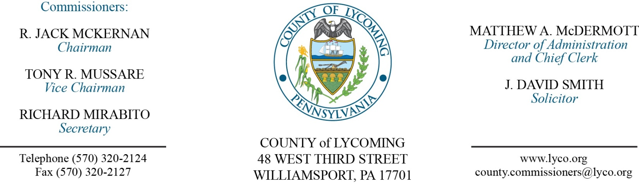
Commissioners’ Meeting Agenda
February 8, 2018

Opening Prayer

Pledge to the Flag

1.0 OPERATIONS

1.1 Convene Commissioners’ meeting.

1.2 Approve the minutes of the previous meetings.

1.3 Receive public comments (agenda items only).

2.0 ACTION ITEMS

2.1 Approve grant agreement with PA DCED for Riverwalk Connector in the amount of $180,000. (Mark Murawski)

2.2 Approve amendment to professional service agreement with Justice Works for the Juvenile Probation Department. (Nancy Ackley)

2.3 Award contracts for vehicle rental equipment on a per item as needed basis to the following: (Mya Toon)

1. Allison Crane & Rigging, Inc.
2. Best Line Equipment
3. Blue Line Rentals, LLC.
4. Cleveland Brothers Equipment Company, Inc.
5. Commonwealth Equipment Corporation
6. Five Star Equipment, Inc.
7. Groff Tractor
8. Herc Rentals, Inc.
9. Lundy Construction Company, Inc/Susquehanna Crane Service
10. United Rentals (North America), Inc.

2.4 Approve amendment 4 to agreement with Brinjac Engineering.( Mya Toon)

2.5 Approve Emergency Solutions Grant agreement in the amount of $30,000. (Mya Toon)

2.6 Approve subrecipient agreement with the YWCA for Emergency Solutions Grant in the amount of $30,000. (Mya Toon)

2.7 Approve update to Policy 903 - Workers’ Compensation – of the County’s Policy and Procedure Manual. (Lauren Bower)

2.8 Accept Human Resources report through January 31, 2018. (Lauren Bower)

2.9 Approve the following personnel actions: (Lauren Bower)
Public Defender – Susan Saba Roinick as full time replacement Assistant Public Defender – union - $52,764.08/annually effective 2/11/18.

5.0 REPORTS/INFORMATION ITEMS

5.1 LCRMS is requesting bids for Equipment Tires & Tire Repair. (Mya Toon)

6.0 COMMISSIONER COMMENT:

7.0 PUBLIC COMMENT:

8.0 NEXT REGULARLY SCHEDULED MEETING: Planning Session on Tuesday, February 13, 2018.

9.0 ADJOURN COMMISSIONERS’ MEETING.

