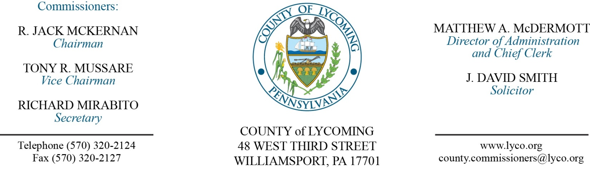
Commissioners’ Meeting Agenda
November 2, 2017

Opening Prayer

Pledge to the Flag

1.0 OPERATIONS

1.1 Convene Commissioners’ meeting.

1.2 Approve the minutes of the previous meetings.

1.3 Receive public comments (agenda items only).

2.0 ACTION ITEMS

2.1 Approve agreement for Information Technology Products and Services with Conduent Enterprise Solutions, LLC through July 31, 2022. (Kathy Rinehart)

2.2 Approve purchase from DRS Imaging Group of Microfilm ScanPro 2200P -2018 in the amount of $12,263.85. (Jerry Kennedy)

2.3 Approve quote from Cleveland Brothers Equipment Company, Inc., for the replacement parts and labor in the amount of $13,112.29. (Jason Yorks)

2.4 Approve professional service agreement with Kourt Security Partners, LLC dba Select Security for keyless entry at Lysock View Complex not to exceed $17,253. (Ken George)

2.5 Approve grant application to the EPA for Revolving Loan Fund (RLF) in the amount of $1,000,000. (Kim Wheeler)

2.6 Approve co-location agreement with Zito Media for a period of 10 years. (John Yingling)

2.7 Approve Equivant License Adjustment (Karl Demi)

2.8 Approve the following personnel actions:
Adult Probation – promotion of Erin L. Crist as full time replacement Administrative Case Officer – Pay grade 6 - $16.59/hour effective 11/19/17.
Sheriff – Ericka M. Heath as full time replacement Deputy Sheriff – Pay grade 7 - $18.08/hour effective 11/6/17.
Prison – Danielle M. Brion as full time replacement LPN – Pay grade 6 - $21.00/hour effective 11/13/17.
Maintenance – Donald L. Webb as full time replacement Custodial Worker – Pay grade 1 - $10.84/hour effective 11/6/17.

5.0 REPORTS/INFORMATION ITEMS

5.1 Master Gardner Recognition. (Linda Betts)

5.2 Request bids for food products 1st quarter. (Mya Toon)

5.3 2018 budget display (Beth Johnston)

6.0 COMMISSIONER COMMENT:

7.0 PUBLIC COMMENT:

8.0 NEXT REGULARLY SCHEDULED MEETING: Planning Session on Tuesday, November 14, 2017. No meetings November 7 or 9, 2017.

9.0 ADJOURN COMMISSIONERS’ MEETING.

