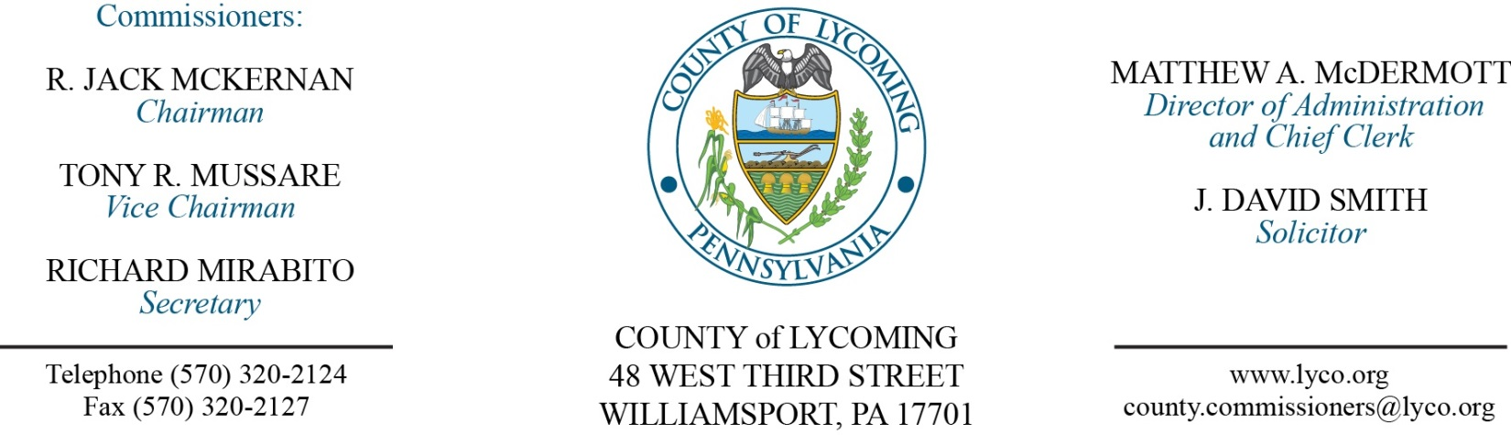
Commissioners’ Meeting Agenda
September 7, 2017

Opening Prayer

Pledge to the Flag

1.0 OPERATIONS

1.1 Convene Commissioners’ meeting.

1.2 Approve the minutes of the previous meetings.

1.3 Receive public comments (agenda items only).

2.0 ACTION ITEMS

2.1 Proclaim September, 2017, as Suicide Prevention and Awareness Month in Lycoming County.

2.2 Approve 2016 Flood Mitigation Assistance Grant from PEMA in the amount of $2,681,750. (Josh Shnitzlein)

2.3 Approve purchase from Productivity Products and Services, Inc. of a Global Navigation Satellite Guided Construction System with accessories in the amount of $254,279.20. (David Bonus)

2.4 Approve Tower Site Grounding Enhancement, AON 3070-004 Project. (Marci Hessert)

2.5 Approve update to TDA – District Attorney’s Office - the addition of one temporary part time Paralegal position. (Roxanne Grieco)

2.6 Approve the following personnel actions: (Roxanne Grieco)
Treasurer – Tina Emerick as full time replacement Clerk III – Pay grade 4 - $13.95/hour effective 9/25/17.
RMS – Nathanial Edkin as full time replacement Equipment Operator – Pay grade 5, $15.22/hour effective 9/18/17.
DPS – reclassification of Samantha Garlick fully qualified Telecommunicator I – Pay grade 7 - $18.08/hour effective 9/10/17.
Sheriff – Rebecca Willits as full time replacement Clerk III – Pay grade 4 - $13.95/hour effective 9/11/17.
Public Defender – Brittany Ohnmeiss as full time replacement Paralegal – Pay grade 6 - $16.59/hour effective 9/25/17.
District Attorney – Cortney Rachael as temporary part time Paralegal – Pay grade 7 - $18.612623/hour effective 9/10/17, not to exceed 1,000 hours annually.

Recess Commissioners’ Meeting

3.0 SALARY BOARD

3.1 Convene Salary Board.

3.2 Approve update to Salary Schedule reflecting addition of one temporary part time Paralegal position in the District Attorney’s office effective September 10, 2017 through mid-January, 2018.

3.3 Adjourn Salary Board.

Reconvene Commissioners’ Meeting

6.0 COMMISSIONER COMMENT:

7.0 PUBLIC COMMENT:

8.0 NEXT REGULARLY SCHEDULED MEETING: Planning Session on Tuesday, September 15, 2017.

9.0 ADJOURN COMMISSIONERS’ MEETING.

