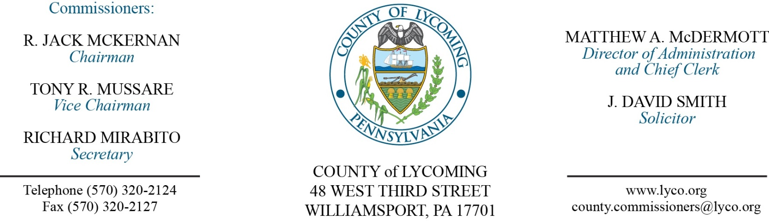Commissioners’ Meeting Agenda

***June 29, 2017***

***Opening Prayer***

***Pledge to the Flag***

**1.0 OPERATIONS**

1.1 Convene Commissioners’ meeting.

1.2 Approve the minutes of the previous meetings.

1.3 Receive public comments (agenda items only).

**2.0 ACTION ITEMS**

2.1 Approve engineering proposal from Larson Design Group in the amount of $8,500 for the 911 electrical upgrade. (Ken George)

2.2 Approve the following personnel actions:

Register & Recorder – Donna J. Markley as full time replacement Clerk I – Pay grade 2 - $11.79/hour effective 7/10/17.

RMS – Lukas A. Brungard as full time replacement Equipment Operator – Pay grade 6 - $16.59/hour effective 7/5/17.

2.3 Accept Human Resources report through June 30, 2017.

***Recess Commissioners’ Meeting***

**4.0 BOARD of ASSESSMENT REVISION**

4.1 Convene Board of Assessment Revision.

4.2 Approve the following real estate exoneration requests:



4.3 Adjourn Board of Assessment Revision.

***Reconvene Commissioners’ Meeting***

**6.0 COMMISSIONER COMMENT:**

**7.0 PUBLIC COMMENT:**

**8.0 NEXT REGULARLY SCHEDULED MEETING:** Regular Meeting on Tuesday, July 11, 2017. There will be no meetings July 4 or 6.

**9.0 ADJOURN COMMISSIONERS’ MEETING.**