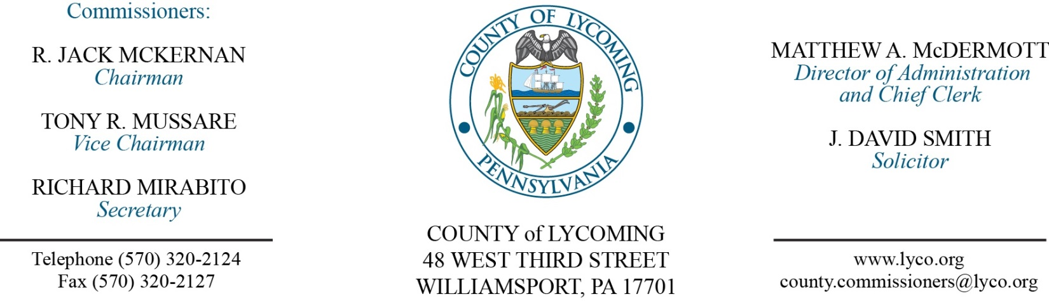
Commissioners’ Meeting Agenda
June 8, 2017

Opening Prayer

Pledge to the Flag

1.0 OPERATIONS

1.1 Convene Commissioners’ meeting.

1.2 Approve the minutes of the previous meetings.

1.3 Receive public comments (agenda items only).

2.0 ACTION ITEMS

2.1 Approve the following Child Welfare Services contracts for the period July 1, 2016 through June 30, 2017: (Mark Egly)
Adelphoi Village, Inc. at per diems ranging from $75.82day to $283.43/day.
Youth Services Agency at per diems ranging from $155.00/day to $175.00/day.
The Christian Home of Johnstown at the per diem rate of $142.85/day.

2.2 Approve professional service agreement with Stephanie Ellison not to exceed $5,000 for the period March 1, 2017 through June 30, 2017. (Mark Egly)

2.3 Approve professional service agreement with the Praed Foundation not to exceed $6,320 from April 1, 2017 through June 30, 2018. (Mark Egly)

2.4 Approve amendment to professional service agreement with MailRoom Systems for the period 2017 – 2020. (Leslie Kilpatrick)

2.5 Approve Keystone Grant receipt in the amount of $40,000. (Mya Toon)

2.6 Accept Human Resources Report through 5/31/17. (Roxanne Grieco)

2.7 Approve Tolling Agreement with Cummings & Smith, Inc. (Matt McDermott)

5.0 REPORTS/INFORMATION ITEMS

5.1 Recognize the SPCA for 125 years.

5.2 Recognize Craig Altemose on his retirement.

5.3 Present Service Awards:
10 years
Barb Davenport Ag Ext.
Lacy Swain Prison.
Tammy Stidfole PRC.
Charles Opp RMS.
20 years
Harry Rogers Jr. Prison.

6.0 COMMISSIONER COMMENT:

7.0 PUBLIC COMMENT:

8.0 NEXT REGULARLY SCHEDULED MEETING: Planning Session on Tuesday, June 13, 2017.

9.0 ADJOURN COMMISSIONERS’ MEETING.

