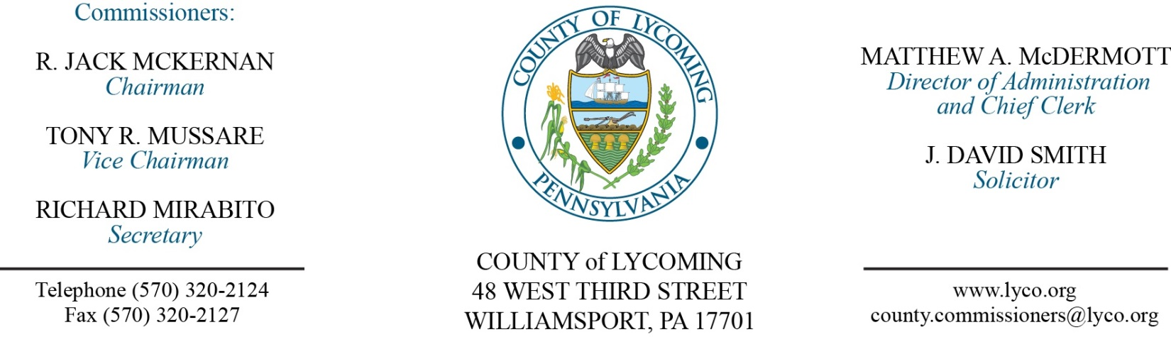
Commissioners’ Meeting Agenda
June 1, 2017

Opening Prayer

Pledge to the Flag

1.0 OPERATIONS

1.1 Convene Commissioners’ meeting.

1.2 Approve the minutes of the previous meetings.

1.3 Receive public comments (agenda items only).

2.0 ACTION ITEMS

2.1 Approve grant and monitoring agreement with West Branch Fireman’s Association, Inc. in the amount of $15,000.

2.2 Approve invoice from KeyMark IMR in the amount of $11,000 for Full Court for Prothonotary

2.3 Approve second amendment to agreement with DirectEnergy extending it for an additional 36 months.

2.4 Approve 2015 CDBG amendment for an additional $250,000.

2.5 Approve increase to quote from Cleveland Brothers Equipment Company for tubgrinder repairs for a total of $15,708.66.

2.6 Approve final invoice from Cleveland Brothers Equipment Company final invoice for repairs to D8T Track Type Tractor in the amount of $47,631.80.

2.7 Award contracts via municibid auctions as follows:
Lot Number-1: Kevin Mostik; highest bid price offered at $2,600.
Lot Number-2: Kevin Mostik; highest bid price offered at $2,450.
Lot Number-3: Douglas Millheim; highest bid price offered at $2,500.
Lot Number-4: Todd Beyer; highest bid price offered at $1,950.

2.8 Approve Air Quality Plan approval extension submission to DEP.

2.9 Approve the following personnel actions:
RMS – Operations – reclassification of Thomas R. Williams as full time replacement Equipment Operator – Pay grade 6 - $16.59/hour effective 6/4/2017.
District Attorney – Full time replacement Assistant County Detective NEU – DET - $18.305/hour effective 6/4/17.

6.0 COMMISSIONER COMMENT:

7.0 PUBLIC COMMENT:

8.0 NEXT REGULARLY SCHEDULED MEETING: Planning Session on Tuesday, June 6, 2017.

9.0 ADJOURN COMMISSIONERS’ MEETING.

