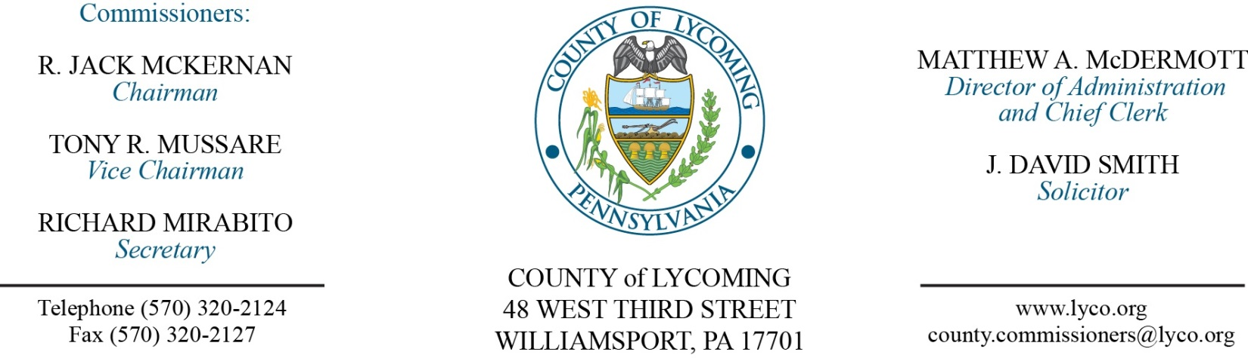
Commissioners’ Meeting Agenda
April 6, 2017

Opening Prayer

Pledge to the Flag

1.0 OPERATIONS

1.1 Convene Commissioners’ meeting.

1.2 Approve the minutes of the previous meetings.

1.3 Receive public comments (agenda items only).

2.0 ACTION ITEMS

2.1 Proclaim April as “Child Abuse Awareness Month.” (Judge McCoy)

2.2 Proclaim April as “Safe Digging Month.”

2.3 Approve professional service agreement with Bruce Anderson, M.A. Licensed Psychologist to provide mental health services to Lycoming County Children and Youth Services at the hourly rate of $60, not to exceed $10,000 for the period January 1, 2017 through June 30, 2017. (Mark Egly)

2.4 Approve professional service agreement with Educational and Treatment Alternatives, Inc. to provide Aggression Replacement Training (ART) recertification to Lycoming County Children and Youth Service’s Day Treatment staff on May 22, 2017 at the rate of $2,500 plus travel expenses. (Mark Egly)

2.5 Approve Human Services Development Fund contract with Project CoffeeHouse’s Montgomery Summer Alive program in the amount of $2,000 for the period July 1, 2016 to June 30, 2017. (Mark Egly)

2.6 Approve FFY 205 CDBG subrecipient agreement with Montgomery Volunteer Fire Company in the amount of $29,118.57. (Kristin McLaughlin)

2.7 Award contract for vending services to Bittner Vending. (Mya Toon)

2.8 Approve professional service agreement for Chaplain Services with Andrew France for the Prison. (Mya Toon)

2.9 Approve professional service agreement with Woods CRW Corp. for preventive and scheduled maintenance, emergency repairs and certified equipment inspection work tasks. (Mya Toon)

2.10 Approve professional service agreement with Logisys CAD 2 CAD interface not to exceed $15,500. (John Yingling)

2.11 Approve application for 2017-2018 Radiation Emergency Response Fund grant to PEMA in the amount of $5,876.00. (John Yingling)

2.12 Approve amendment 1 to professional service agreement with Value Payment Systems, LLC for internet & phone payment. (Tom Heap)

2.13 Approve agreements for grant-in-aid funds and supervision funds with Pennsylvania Board of Probation and Parole for the Adult Probation Office. (Ed McCoy)

2.14 Approve professional service agreement with PATH for the Juvenile Probation Office. (Nancy Ackley)

2.15 Approve professional service agreement with Crossroads for the Juvenile Probation Office. (Nancy Ackley)

2.16 Approve County Bridge 106 utility reimbursement agreement with Penn Electric Company. (Mark Murawski)

2.17 Approve 2017 Liquid Fuel allocations to municipalities. (Mark Murawski)

2.18 Approve designation of agent for Hazard Mitigation Grant Program. (Josh Schnitzlein)

2.19 Accept personnel action report through March 31, 2017. (Roxanne Grieco)

Recess Commissioners’ Meeting

4.0 BOARD of ASSESSMENT REVISION

4.1 Convene Board of Assessment Revision.

4.2 Approve real estate exemptions:
14-271-122 - Alan & Barbara McCoy - $511.14.
26-331-207.B – Gail Myers - $18.97.
14-250-125.F – Harvey Schefsky Et Al – 660.48.
09-303-110 – Michael & Susan Manzitti - $2678.29.

4.3 Approve real estate exonerations:
28-243-125 Black Rock Gun Club 8864R Trout Run Rd.
61-001-304 Donald Durkin 1111 Washington Blvd .
02-371-105 Thomas Dincher & Susan Colberg 661 Sylvan Dell Park Rd.
31-306-107.A-001 Krag Hall 5813 Rt 287 Hwy.
26-331-207.B Gail Myers 1961 Walters Rd.
37-002-409 Barron Zimmers 112 W Penn St.

4.4 Adjourn Board of Assessment Revision.

Reconvene Commissioners’ Meeting

5.0 REPORTS/INFORMATION ITEMS

5.1 Announce draft FFY 2017 CDBG application preparation schedule. (Kristin McLaughlin)

5.2 LCRMS is requesting bids for 2016 Landfill Gas System Modifications Project. (Mya Toon)

5.3 Lycoming County is requesting bids for paving project at PRC & Lysock View. (Mya Toon)

5.4 Announce intent to apply for a grant for the Sylvan Dell Project.

6.0 COMMISSIONER COMMENT:

7.0 PUBLIC COMMENT:

8.0 NEXT REGULARLY SCHEDULED MEETING: Planning Session on Tuesday, April 11, 2017. Town Hall meeting tonight at 6:00 p.m.

9.0 ADJOURN COMMISSIONERS’ MEETING.

