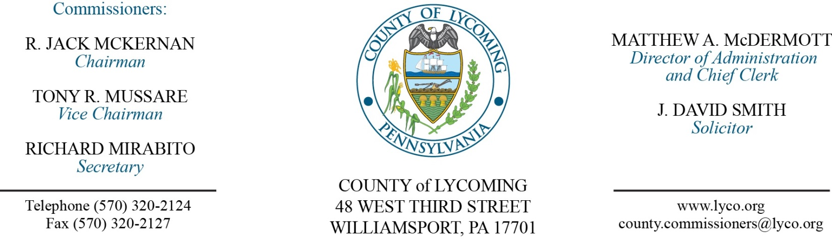
Commissioners’ Meeting Agenda
March 2, 2017

Opening Prayer

Pledge to the Flag

1.0 OPERATIONS

1.1 Convene Commissioners’ meeting.

1.2 Approve the minutes of the previous meetings.

1.3 Receive public comments (agenda items only).

2.0 ACTION ITEMS

2.1 Approve professional service agreement with Windstream for a period of five years. (Leslie Kilpatrick)

2.2 Approve amendment to professional service agreement with Karl K. Baldys. (John Lavelle)

2.3 Approve professional service agreement with SEDA COG. (Josh Schnitzlein)

2.4 Award contract to Stahl-Schaeffer Engineering for Phase I flood mitigation basement evacuation in the amount of $1,455,250. (Josh Schnitzlein)

2.5 Reject bids for Phase II flood mitigation house raising. (Josh Schnitzlein)

2.6 Approve agreement with Constable Stanley Crum for use of police frequency 1. (Mya Toon)

2.7 Approve agreement with Snyder County for inmate housing on an as needed basis in the amount of $72/day/inmate. (Mya Toon)

2.8 Approve grant agreement from Department of Environmental Protection, Office of Water Management in the amount of $250,000. (Mark Davidson)

2.9 Approve grant agreement from U.S. Department of Agriculture in the amount of $663,693. (Mark Davidson)

2.10 Approve TDA change in Conservation District – create part time West Nile Virus Technician not to exceed 1000 hours annually grade 7/8. (Roxanne Grieco)

2.11 Approve the following personnel actions: (Roxanne Grieco)
Prothonotary – Mary Harman as full time replacement Clerk III – Pay grade 4 - $13.95/hour effective 3/12/17.
Pre-Release – Cassin J. Diggs as full time replacement Resident Supervisor I – Pay grade 5 - $15.22/hour effective 3/6/17.
Information Services – Kris D. Black as full time replacement Senior Network Engineer – Pay grade 10 - $46,137.13/annually effective 3/6/17.

Recess Commissioners’ Meeting

3.0 SALARY BOARD

3.1 Convene Salary Board.

3.2 Approve update to salary schedule.

3.3 Adjourn Salary Board.

Reconvene Commissioners’ Meeting

5.0 REPORTS/INFORMATION ITEMS

5.1 Lycoming County is requesting proposals for Vending Service. (Mya Toon)

5.2 Lycoming County is requesting bids for fire protection upgrade. (Mya Toon)

6.0 COMMISSIONER COMMENT:

7.0 PUBLIC COMMENT:

8.0 NEXT REGULARLY SCHEDULED MEETING: Planning Session on Tuesday, March 7, 2017.

9.0 ADJOURN COMMISSIONERS’ MEETING.

