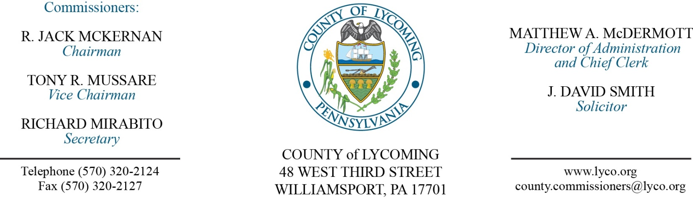
Commissioners’ Meeting Agenda
February 16, 2017

Opening Prayer

Pledge to the Flag

1.0 OPERATIONS

1.1 Convene Commissioners’ meeting.

1.2 Approve the minutes of the previous meetings.

1.3 Receive public comments (agenda items only).

2.0 ACTION ITEMS

2.1 Approve Designation of Agent Resolution 2016 Flooding Event – Mya Toon

2.2 Approve Agency Service Agreement with PayGOV US LLC – Mya Toon

2.3 Approve purchase of washer for prison from PAC Industries off PA State Contract in the amount of $11,146 – Mya Toon

2.4 Adopt Resolution 2017-02 declaring property as surplus – Jason Yorks

2.5 Adopt Resolution 2017-03 declaring property as surplus – Jason Yorks

2.6 Approve Purchase Agreements for rental equipment on an as needed basis to the following:

Allison Crane & Rigging, Inc.
Best Line Equipment
Bradco Supply Company
Cleveland Brothers Equipment Company, Inc.
Commonwealth Equipment Corporation
Five Star Equipment, Inc.
Lundy Construction Company, Inc.
Murrysville Machinery Company, LLC. – Jason Yorks

2.7 Approve Purchase Agreement for concrete product on an as needed basis to Central Builders Supply Company – Jason Yorks

2.8 Approve Purchase Agreements for Aggregate Products on an as needed basis to the following:

Glenn O. Hawbaker, Inc.
Hanson Aggregate, PA LLC.
New Enterprise Stone & Lime Company, Inc.
Pikes Creek Asphalt & Crushed Stone – Jason Yorks

2.9 Approve Purchase Agreements for equipment tires and tire repair on an as needed basis to the following:

Bastian Tire & Auto Center
McCarthy Tire Services – Jason Yorks

2.10 Approve 2017 VMware Software Licensing Annual Renewal in the amount of $29,358 – Karl Demi

2.11 Adopt Resolution 2017-04 regarding condemnation of a portion of land in McIntyre Township - Solicitor

2.12 Approve Justin F. Smith – Assessment – Full Time Replacement Field Assessor – Paygrade 5 - $15.22 per hour – effective 2/27/17 – Roxanne Grieco

2.13 Approve Kerry A. Bennett – Adult Probation – New Position – Full Time Clerk III - $16.578515 per hour – effective 2/26/17 – Roxanne Grieco

5.0 REPORTS/INFORMATION ITEMS

5.1 Deputy Recognition – Deputy Luke Motter, Deputy Josh Klinger, Sergeant Matt Kula and Sergeant Eric Spiegel

5.2 February is Heart Awareness Month – Tip of the week: Protect your heart with Exercise.

5.3 Swift 911 Emergency Notification System will be placed into service in Lycoming County effective February 21, 2017.

6.0 COMMISSIONER COMMENT:

7.0 PUBLIC COMMENT:

8.0 NEXT REGULARLY SCHEDULED MEETING: Planning Session on Tuesday, February 21, 2017.

9.0 ADJOURN COMMISSIONERS’ MEETING.

