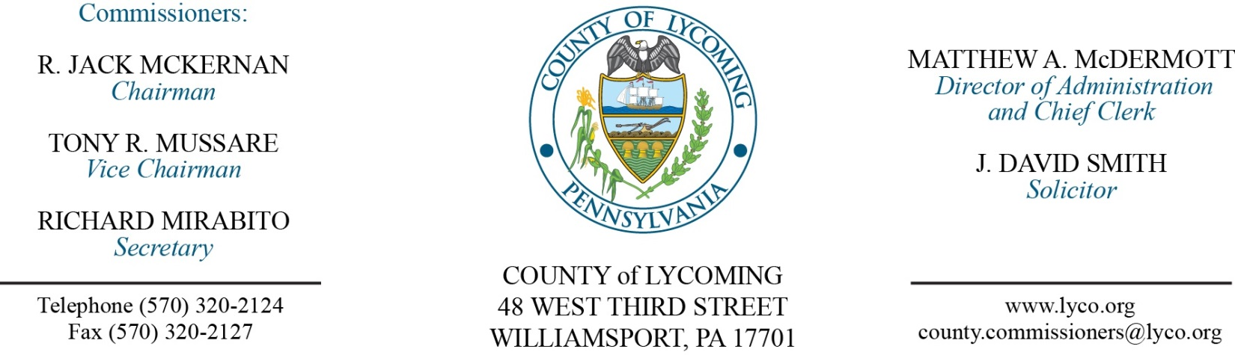
Commissioners’ Meeting Agenda
December 8, 2016

Opening Prayer

Pledge to the Flag

1.0 OPERATIONS

1.1 Convene Commissioners’ meeting.

1.2 Approve the minutes of the previous meetings.

1.3 Receive public comments (agenda items only).

2.0 ACTION ITEMS

2.1 Approve amendment 2 to professional service agreement with Brinjac Engineering. (Megan Lehman)

2.2 Approve professional service agreement with Adelphoi for JPO. (Nancy Ackley)

2.3 Approve 2016 PHARE grant agreement with PHFA in the amount of $300,000. (Kim Wheeler)

2.4 Award contract to for consumable energy products to Superior Plus Energy Services on an as needed basis. (Mya Toon)

2.5 Approve professional service agreement with Susquehanna Motor Co., Inc. for LCRMS. (Mya Toon)

2.6 Approve agreement with Penrac, LLC for car rental services. (Mya Toon)

2.7 Approve amendment to agreement with Rogers Uniforms. (Mya Toon)

2.8 Award contract of tire recycling to the lowest compliant bidder, Mahantango Enterprise, Inc. on an as needed basis. (Mya Toon)

2.9 Approve the Travelers Excellence in Community Resilience Award n application to the Travelers Foundation in the amount of $100,000. (Mya Toon)

5.0 REPORTS/INFORMATION ITEMS

5.1 Recognize Leadership Lycoming Class.

6.0 COMMISSIONER COMMENT:

7.0 PUBLIC COMMENT:

8.0 NEXT REGULARLY SCHEDULED MEETING: Planning Session on Tuesday, December 13, 2016.

9.0 ADJOURN COMMISSIONERS’ MEETING.

