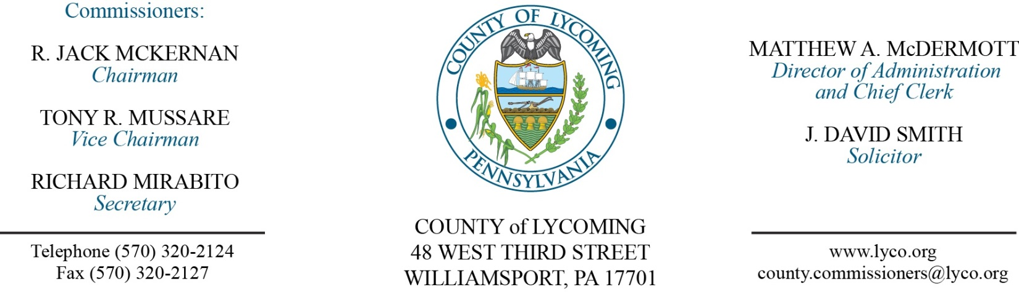
Commissioners’ Meeting Agenda
December 15, 2016

Opening Prayer

Pledge to the Flag

1.0 OPERATIONS

1.1 Convene Commissioners’ meeting.

1.2 Approve the minutes of the previous meetings.

1.3 Receive public comments (agenda items only).

Recess Commissioners’ Meeting

Public Hearing for Zoning Map and Zoning Text Amendment

John Lavelle

Reconvene Commissioners’ Meeting

2.0 ACTION ITEMS

2.1 Enact Zoning ordinances 2016-03 & 2016-04 – John Lavelle

2.2 Approve amendment to professional service agreement with GEO –Mya Toon.

2.3 Adopt resolution 2016-29 for the five year capital plan – Beth
Johnston

2.4 Adopt resolution 2016-30 for the 2017 budget – Beth Johnston

2.5 Adopt resolution 2016-31 setting the millage rate for 2017– Beth Johnston

2.6 Adopt resolution 2016-32 setting the pre-determined ratio for
2017 - Beth Johnston

2.7 Approve professional service agreement with Don Martino-Adrianne Stahl

2.8 Approve professional service agreement with Ryan Gardner – Adrianne Stahl

2.9 Approve 2017 professional service agreement with Tetra Tech – Kurt Hausammann

2.10 Approve professional service agreement with Contrast Communications for ContrastCare – Leslie Kilpatrick

2.11 Approve professional service agreement Contrast Communications for Telecom network – Leslie Kilpatrick

2.12 Adopt resolution 2016-28 for the TDA – Ann Gehret/Roxanne Grieco

2.13 Approve update to County’s Policy & Procedures Manual for the following policies: 400 (job code listing) and 401(pay scale) Ann Gehret/Roxanne Grieco.

2.14 Approve the following personnel actions:

Prison – Jason K. Young as full time Correctional Officer Relief COI - $15.77/hour effective 1/9/17.

5.0 REPORTS/INFORMATION ITEMS

5.1 Jerry Fink retirement from prison

5.2 Recognize the Youth Development Task Force

5.3 Lycoming County is requesting bids for Planning and Zoning Solicitor Services – Mya Toon

5.4 Lycoming County is requesting bids for flood mitigation acquisition demolition – Mya Toon

6.0 COMMISSIONER COMMENT:

7.0 PUBLIC COMMENT:

8.0 NEXT REGULARLY SCHEDULED MEETING: Planning Session on Tuesday, January 3, 2017.

9.0 ADJOURN COMMISSIONERS’ MEETING.

