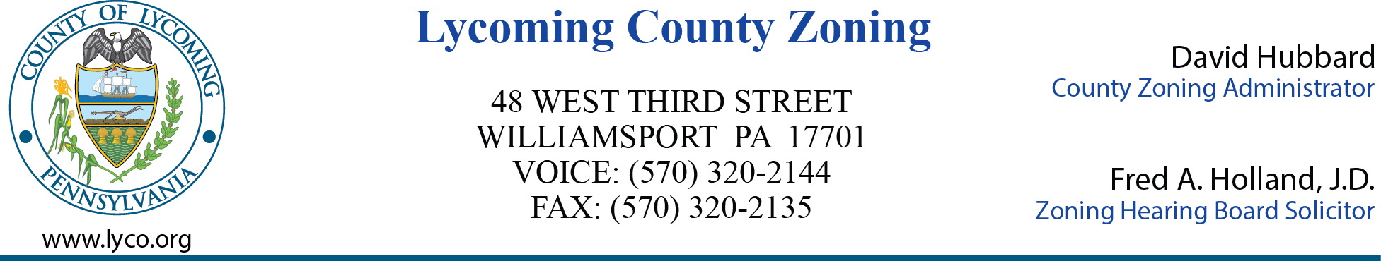

LYCOMING COUNTY ZONING HEARING BOARD MEETING MINUTES
Executive Plaza Building
1st Floor Commissioner’s Board Room
April 28, 2021
6:00pm

- CALL TO ORDER

Chairman Bill Klein called the meeting to order at 6:00pm.

- ROLL CALL (Members & Alternates)

Members Present: Bill Klein, Chris Logue, Dan Clark, David Hines

Members Present via Conference Call:

Members Absent: Rom Andraka, Leslie Whitehill

- MINUTES OF PREVIOUS MEETING

The April 28, 2021 meeting minutes were approved as presented. Chris Logue motioned to approve, Dan Clark second motion. Motion carried.

- NEW BUSINESS

- ZHB Case 2021-006
GEISINGER
Muncy Township
VARIANCE - Signage

Seated Members: Bill Klein, Dan Clark, David Hines

Chris Hodges presented to the Zoning Hearing Board case number 2021-006, located in Muncy Township. The applicant is requesting Variance for additional signage on the property along with dimensional relief for sign area and height requirements. The Medical Center is currently being constructed at 255 Route 220 Highway off I-180 Exit 15. The property is located in the Suburban Mixed Use (SM) Zoning District in Muncy Township.

The applicant is requesting one additional wall sign that will be facing US-220. The Lycoming County Zoning Ordinance Section 8630.F permits two wall signs when a building has two main street frontages for office use. There is also a request for five additional directional signs. The Zoning Ordinance Section 8610 E. permits 1 directional sign per lot. The applicant is also requesting dimensional relief for sign area and height requirements on 6 directional signs. The Zoning Ordinance Section 8610 E. permits directional sign not to exceed 6 sq. ft. in sign area and 4 ft. in height. Please see “Variance Request Details on Signs for Zoning Hearing Board” attachment for additional information and clarification.

The subject property of tax parcel #41-353-168.B contains approximately 21.46 acres and is located in the Suburban Mixed Use(SM) Zoning District in Muncy Township. The property is off I-180 Exit 15. The Geisinger Medical Center is currently being constructed.

General Standards for a VARIANCE uses are listed in the Lycoming County Zoning Ordinance, Section 10430.

Chris Hodges reviewed the following communications:

- Zoning Permit Application received 2/12/2021.
- Variance Application received March 5, 2021 and updated March 19, 2021.
- Notices sent to interested parties: Lycoming County Planning Commission, Lycoming County Commissioners, Muncy Township Supervisors, Applicant, Solicitor, and Zoning Hearing Board.
- Legal notice published in Sun-Gazette 4/13/2021, 4/20/2021.
- Property posted 4/13/2021.

The Zoning Hearing Board packet containing the Variance application, Copy of LCPC comments from Shannon Rossman, Overhead GIS sight plan view,

The following are exhibits presented by Chris Hodges:

Z#1 – ZHB packet including letter from Shannon Rossman
Z#2 – Legal posting Williamsport, Sun-Gazette
Z#3 – Property posting
Z#4 – Email from Muncy Township

Chris stated there is one sign with additional five directional signs. The directional signs vary in size
with the largest 25 sq. ft., 10.25 sq. ft. for the smallest. The height being 4’, 16.2 sq. ft. largest and
5.5 sq. ft. smallest.

Dave Watral spoke on behalf of Geisinger, stating that they are building the Medical Center located in Muncy. They are placing wall signs that are visible from I-180 with an additional wall sign at the pedestrian level to be viewed as the public approaches the hospital. All but two of the directional signs include the word of either “Emergency” or “Ambulance” they are strictly for public safety while pedestrians are approaching the hospital. As you drive into the Hospital, the Ambulance Entrance is on a different wall then the pedestrian entrance and the Emergency Department. It is important to Geisinger to get the public steered in the right way. The directional signs used as one main sign along the road frontage, which is 16 ft. tall, the other one showing people as they are driving where to turn in. The other signs are smaller with words and arrows saying “Ambulance” here “Main Entrance” here. Other than the main entry turn, the smaller signs are used for vehicular traffic and the remaining directional signs are signs on the front of the canopies. Two signs, one to say “Emergency” the other “Main Entrance”. The focus is to steer people on where they need to go. There is one additional sign that when they applied for the HOP the adjacent Wolf Animal Clinic had to agree to abandon their driveway as part of PennDot approval. Due to Geisinger, sharing the driveway with Wolf Run Animal Clinic the sign will include verbiage for Wolf Run Animal Clinic. As the traffic turns onto Geisinger driveway there will be one sign saying Wolf Run Animal Clinic, that is the only sign not hospital related.

Bill stated that all the signs are designed for safety minded flow of traffic with people moving around.

OFF THE RECORD

Fred spoke on behalf of the board, the consensus of the board is the VARIANCE should be granted with no conditions.

David Hines motioned to approve, Dan Clark second motion. Motion carried.

ADJOURNMENT

Meeting adjourned at 6:29 pm.

Respectfully submitted,

______________________________ ______________________________
Heather George, Recording Secretary Bill Klein, Chairman

DATE: _______________ DATE: _______________

