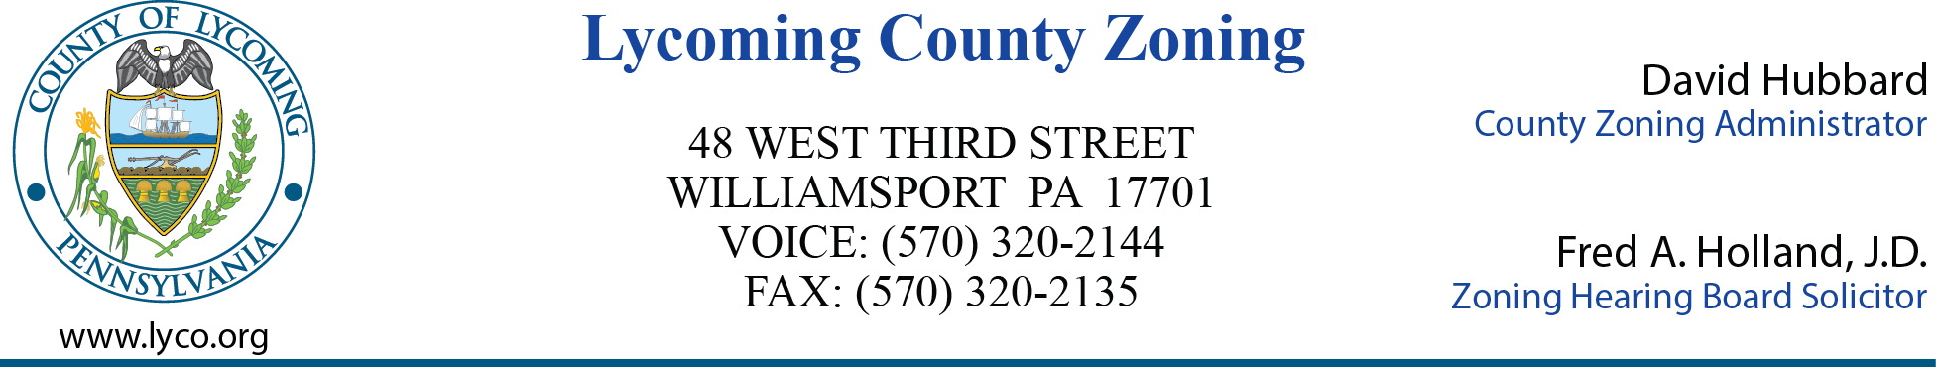

MEETING AGENDA

LYCOMING COUNTY ZONING HEARING BOARD
Executive Plaza Building
November 17, 2021
6:00pm

- CALL MEETING TO ORDER 6:00

- ROLL CALL (Members & Alternates) 6:05

- MINUTES OF PREVIOUS MEETING - October 27, 2021 6:10

- NEW BUSINESS

- ZHB Case 2021-011 6:15
Matthew Sehenuk
Plunketts Creek
Special Exception – Home Business

- ZHB Case 2021-012 6:30
William & Susan Klein
Moreland Township
Special Exception – Family Care Unit

- ADJOURNMENT 6:45

