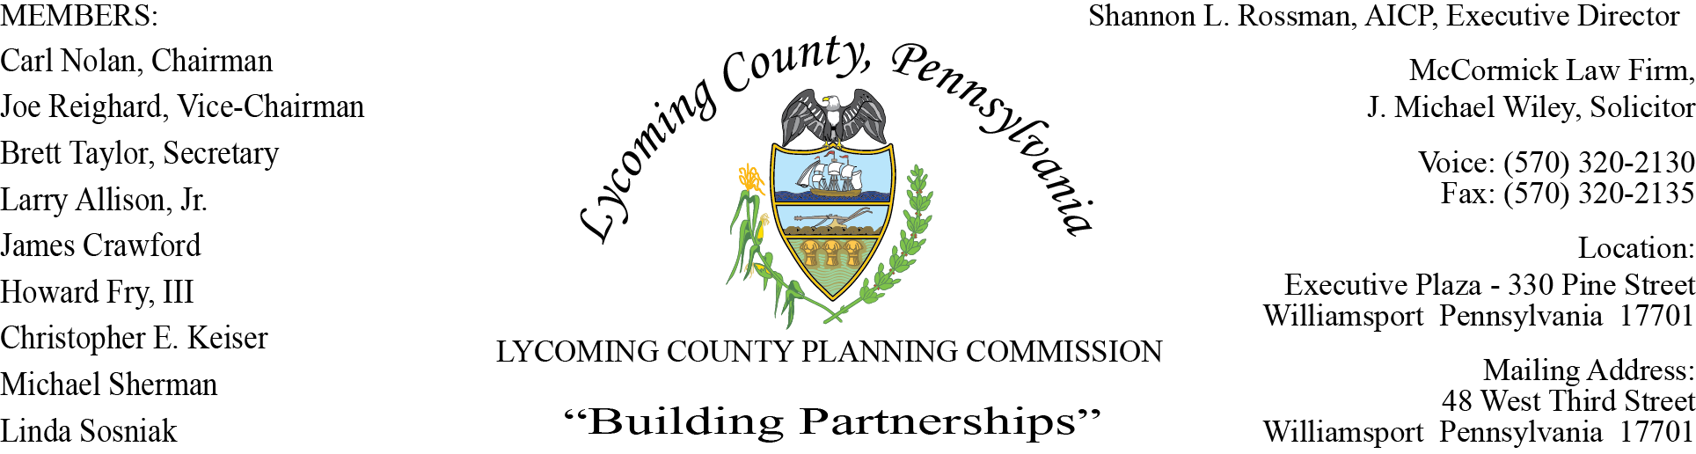

LYCOMING COUNTY PLANNING COMMISSION MEETING
Executive Plaza Building
February 18, 2021
6:00pm

MEMBERS PRESENT: Joe Reighard, Jason Bogle

MEMBERS PRESENT VIA CONFERENCE CALL: Linda Sosniak, Carl Nolan, Brett Taylor,
Jim Crawford, Larry Allison, Jr.,
Howard Fry, III

MEMBERS ABSENT:
OTHERS PRESENT VIA CONFERENCE CALL:

OTHERS PRESENT: Shannon Rossman, PCD, John Lavelle, PCD, Tiffany Krajewski, PCD, Joshua
Billings, PCD, Heather George, PCD, J. Michael Wiley, Solicitor,
Mike Ruther, Sun-Gazette

- CALL TO ORDER

Joe Reighard, Chairman, called the meeting to order at 6:00pm.

- MINUTES OF REGULAR MEETING

Joe Reighard asked for motion to accept the January 21, Linda Sosniak motion to approve, Jim Crawford second to approve. Motion carried.

- PUBLIC COMMENT ON AGENDA ITEMS ONLY – None

- OLD & FUTURE BUSINESS

- Planning Commission Solicitor

Members voted to retain J Michael Wily at his current rate, as the Solicitor for the Planning Commission.
Larry Allison, Jr motioned to approve, Linda Sosniak second motion to approve. Motion carried.

Shannon Rossman spoke briefly of Chik-Fil-A and Starbucks going in at the Target Mall. Shannon noted a Development plan was sent to the municipality to review for comment, the developer was not ready for February’s meeting but will be for March. There is a signed agreement with Starbucks and an understanding with Chik-Fil-A but no signed agreement. Shannon also stated they have not received plans for Popeye’s which they may not if it is going into an existing building.
Shannon revealed to members that the Planning Department would be purchasing new Zoning and Subdivision software. The new software will allow for new reporting on land development and permits within the county.

- SUBDIVISION & LAND DEVELOPMENT PLANS

- Multi-Lot Presentations - None

- Land Development

- LBM Properties LP
Industrial Building Addition Land Development
Muncy Township

Joshua Billings presented to board members a proposed plan from LBM Properties. The main
contact is Lou Miele with engineering work performed by Vassallo Engineering. Last year
LBM Properties purchased the old Gander Mountain building to use for light manufacturing.
The Zoning Hearing Board granted the special exception last year as a light industry use, which
is permitted in the CR Zoning District. LBM is proposing a land development plan for an
addition to the northern side of the building that encroaches into the existing parking lot.
When LBM Properties purchased the building they removed the landscape buffer from along
roads that was previously required for the Gander Mountain development.
They were notified when submitting for land development they would have to replace the
landscaping in accordance with the Zoning Ordinance. The final plan will consist of new
landscape design against the roads.
Joshua presented a revised land development plan with modified building addition design that
was received prior to meeting that day. The Original plan had two additions to the north side of
the building, encompassing about 10,000 square feet. The new plan eliminates the grand
entrance and expands the garage addition further to the north for a total of 10,832 square feet.
They redesigned to accommodate for office space, entry way and expand manufacturing space.
The developer has not submitted a zoning permit application yet and is aware it is required.

Mike Wiley suggested to members to make a motion to conditionally approve the plans using
the conditions proposed by Joshua in his summary along with the condition that the prior
permission to proceed with installing the footers set forth in the MOU would be withdrawn.

CONDITIONS

- Upon Staff’s and LPC Consulting Engineer concurrence of a cost estimate to complete the required Land Development improvements, an Improvement Guarantee/Developers Agreement with Financial Guarantee must be established within 60 days of final land development approval. Extension of the 60 days is at staff’s discretion (to be provided prior to signing and recording of the final land development plan).
- The developer shall finalize the land development plan consistent with Planning Staff’s letter of 2/9/2021 for minor revisions and a lighting plan and landscaping plan that meets the requirements of the Lycoming County Zoning Ordinance (to be provided prior to signing and recording of the final land development plan).
- After the Planning Commission approval, the approved land development plans, the applicant signed approval letter, must be recorded within 90 days of the date when all conditions are met. Applicant has 6 months from the conditioned approval date to satisfy all conditions. Extension of the 6 months is at Staff’s discretion.

Joe Reighard asked for motion to approve. Jim Crawford motion to approve, Linda Sosniak
second motion. Motion carried.

C. Single-Lot Ratifications

There were no questions from members on the four single-lot ratifications.

Joe Reighard asked for motion to approve ratification, Brett Taylor motion to approve, Howard
Fry, III second motion. Motion carried.

- ACTION ITEMS - None

- COMMITTEE REPORTS/DISCUSSION

- By Laws

Jason Bogle briefed board members on the Ad Hoc Committee that was formed by Chairman Reighard. Chairman Reighard appointed Larry Allison, Jr., Brett Taylor and himself to an Ad Hoc Committee. The committee was tasked to review and update the existing By Laws, the committee met numerous times over the past month and are in the process to propose updates. The updates will ensure the committee’s mission and make sure they are in compliance with local, state and federal guidelines. The committee will meet with Mike Wiley in the coming weeks to possibly have the first reading at the next planning commission meeting.

- MONTHLY REPORTING

- PCD Staff Meeting Report
- Land Use Staff Meeting Report
- UPI Reports
- Development Report
- New Construction Report

- DISCUSSION ITEMS

- CARES Act Fund Distribution

Shannon Rossman informed the committee that they have finalized all the fund distributions of
the CARES Act from the fall and that new funding is out for hospitality. Once the commissioners
find out who qualifies they will make an announcement of the application period. She also noted
there is Rental Relief money out that they will review with current partners like STEP.

Joe Reighard mentioned to members the Commissioners acted upon the recommendations that the committee made to extend everyone’s term by one year if the member chooses to.

Shannon Rossman mentioned to members the Ethic Forms were mailed, we need those returned so they can be filed.

- ADJOURNMENT

Joe Reighard asked for a motion to adjourn, Brett Taylor motion to approve, Jim Crawford second motion. Motion carried.
Meeting adjourned at 7:14 pm.

Respectfully submitted,

_________________________ _________________________
Shannon L. Rossman, Director Carl Nolan, Secretary

DATE: ____________ DATE: _____________

