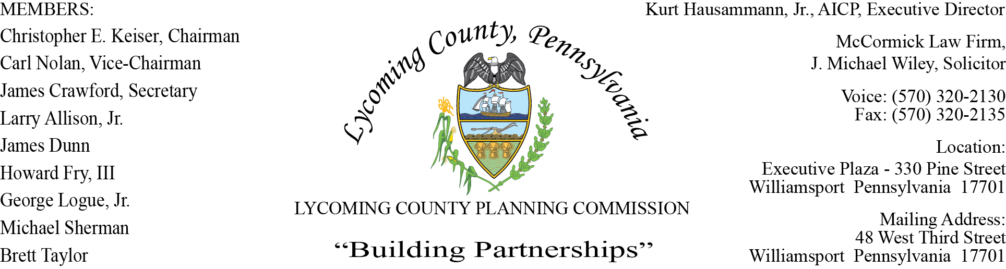
LYCOMING COUNTY PLANNING COMMISSION MEETING
Executive Plaza Building
August 17, 2017
6:00pm

MEMBERS PRESENT: Chris Keiser, Carl Nolan, Larry Allison, Jim Dunn, Herm Logue,
Michael Sherman and Brett Taylor

MEMBERS ABSENT: Howard Fry and Jim Crawford

OTHERS PRESENT: J. Michael Wiley, Solicitor, Jane Magyar, Kurt Hausammann, Jr., Austin
Daily and John Lavelle, LCPC staff.

- CALL TO ORDER

Chairman Chris Keiser called the meeting to order at 6:00pm.

- MINUTES OF REGULAR MEETING

Jim Dunn made a motion to approve the June 15, 2017 meeting minutes as presented. Mike Sherman seconded the motion. Motion carried.

- COMMITTEE REPORTS – None

- PUBLIC COMMENTS ON AGENDA ITEMS ONLY – None

- OLD BUSINESS – None

- SUBDIVISION & LAND DEVELOPMENT PLANS

- Multi-Lot Presentations - None
- Land Developments – None
- Single-Lot Ratification

Jim Dunn commented that setback requirements for compressor stations need to be addressed in the near future. John Lavelle stated that with the Comprehensive Plan process coming to an end, staff will have time to revisit this issue.

Brett Taylor questioned the Ralston Area Joint Authority re-approval. Austin Daily stated that the subdivision was approved in 2013 but it was never recorded.

Jim Dunn made a motion to approve the single-lot ratification as presented. Herm Logue seconded the motion. Motion carried.

- ACTION ITEMS – None

- DISCUSSION ITEMS

- 2016 Annual Report Draft

Kurt Hausammann stated that an Annual Report is technically due under the Municipal Planning Code (MPC) by the end of March. Completion was delayed due to working on the Comprehensive Plan.

He asked LCPC members to review and submit any corrections, comments, etc. to him or Kim Wheeler. The final version will be approved at the September meeting and then submitted to the County Commissioners for their approval.

The Annual Report will also be posted on the County website after approval by the Commissioners.

Brett noted the large number of variance requests; i.e. animal sheds and the need to revisit setback requirements. These Zoning Hearing Board cases consume a lot of staff time, solicitor time, etc.

- Comp Plan Issue Write-Ups

Kurt Hausammann stated that eight priority issues were identified by the LCPC for the Comprehensive Plan. The following three issues are being presented:

- Flooding (Priority Issue #4)

Fran McJunkin stated that flooding is a primary disaster threat to lives, property and communities within Lycoming County.

Lycoming County has one of the highest numbers of stream, river and creek miles (2,200) in the state. Since1955 when the levee was built, we have had numerous presidential declarations: 1972, 1975, 1984, 1996, 2004, and 2011. There were no issues with the levee. Cumulative amount of loss associated with past flood events is about $1.3 trillion.

During Tropical Storm Lee, 955 residential units sustained damage-87% were classified as owner occupied.

Total flood damage to property and infrastructures since the 2006 Comp Plan exceeded $30 million.

The estimated number of structures in the floodplain up until 2016 ranged between 5,300 and 5,500.
Eighteen (18) months ago, in conjunction with FEMA, we were able to delineate floodplain boundaries more accurately which resulted in reducing the number of structures in the floodplain to 4,188.

57% of structures in the County are covered by National Flood Insurance.

There are five significant projects we follow when looking at floodplain issues:

- Levee certification-high economic priority
- Home remediation; i.e. basement evacuations, elevations, acquisitions
- Updated maps-helps identify areas in floodplain that need to be redrawn
- Acquisition/demolition-based on current disaster event
- Flood insurance reform-foremost in dealing with the Federal Government

PHARE funds are being utilized to have an engineer do elevation certificates and process the LOMAs (Letter of Map Amendment) for the property owners. We recommend that the property owners obtain X Zone flood insurance (least expensive) due to weather patterns changing, etc.

Herm Logue complimented Fran on doing an excellent job with the County hazard mitigation program.

There was discussion on the assessed value of property being inflated versus actual damage incurred, mapping and high cost of insurance.

- Land Use

John Lavelle stated that all 52 municipalities within Lycoming County have either adopted their own zoning ordinances or joined the County Zoning Partnership. These ordinances have the ability to impact the enjoyment, value, and development potential of the land.

It is important to continually update/streamline permit processes, amend ordinances to ensure consistency with comprehensive plans, educate municipal officials/landowners on land use planning, practices and regulations, and find ways to minimize the cost of development.

Priority issues are:

- Central Susquehanna Valley Transportation Project (CSVT)
- Changing landscape of the retail market and its impact on the Lycoming Mall
- Extension of utilities into the US15 South Corridor and the resulting increase in development potential
- Continuation of Brownfields Redevelopment
- Cyclical nature of the natural gas industry
- Shifting paradigm for land use planning

Kurt Hausammann stated that we will be applying for a PennDOT grant to do a corridor study of 180 to see what the future traffic effects will be and kind of growth pressure there will be at the interchanges when the traffic changes. Traffic is projected to change in 2021.

Other areas discussed relating to the above priority issues were:

- interchange zoning
- ordinance updates to buy-in with the Comp Plan and have consistency
- impact of US15 bypass to SR147
- new development along 180
- future of Lycoming Mall
- reasons for decline in retail business
- shared use zoning
- expand uses through zoning ordinance changes
- more walkable community concepts; i.e. cafes, sidewalks, bike paths
- US15 South Corridor growth potential
- optimal uses for Brownfields
- review of setback requirements
- uses that need to be added to the Zoning Ordinance

Projects of Regional Significance for Land Use:

- Explore Re-Use Opportunities for Vacant Commercial/Industrial Properties
- CSTV - I-180 Interchange Zoning Reviews and Traffic Impact Study
- Zoning Review Process
- Land Use Education and Training
- Opportunities for Developing Pedestrian/Bike Friendly Routes

- Drugs

Kurt Hausammann presented relevant information pertaining to drugs (heroin and opioids) that are creating significant social, economic, public health and safety problems within the County.

Overview:

- Hinders economic development and expansion opportunities
- Only 30-40% of qualified job applicants pass drug screening
- Taints image of the community
- Additional burden on law enforcement, EMS services and social service programs
- In a 2016 survey, 70% of the respondents identified crime and drugs as being a major concern
- High volume of prescription drugs being used by students prior to taking illegal drugs
- Increase in deaths due to drug overdoses

- Incarceration alone does not help-need coordinated drug rehab while incarcerated

Top viable projects of regional significance to this issue that need support are:

Project Bald Eagle
Re-Entry Programming
Public Education
Law Enforcement Efforts
Drug and Alcohol Treatment Programs

Brett Taylor discussed the need for programs to help people who have a criminal record in obtaining employment. Jim Dunn referenced a program in Portugal that has been very successful.

Michael Sherman noted that a growing issue throughout the country is overweight kids which results in health problems and is also a major issue in this area. This issue is addressed within the Comp Plan under recreation.

It was noted that drugs is not a typical Comp Plan issue.

Mike Wiley stated that he did question how this issue fits into a Comp Plan; to the extent that we want a document that is utilized across the County by multiple users and their common threats. You are going to see drug issues within your public safety sector in terms of coordination efforts and resources to deal with this issue which will filter down through the Comp Plan.

Kurt stated that drug issues do affect the entire County in that so many of the County resources are going to the district attorney’s office, prison, law enforcement, etc. and being taken away from other resources. We need to obtain state funding to help with this problem.

- PUBLIC COMMENTS – None

- ADJOURNMENT

Meeting adjourned at 7:30pm.

Respectfully submitted,

______________________________ ______________________________
Kurt Hausammann, Jr., Director Chris Keiser, Chairman

DATE: _______________ DATE: _______________

