NOTIFICATION & RESOURCE MANUAL
OF THE
EMERGENCY OPERATIONS PLAN (EOP)

for

^{(Name of Municipality)}

Lycoming County, Pennsylvania

LAST UPDATED:
The contents of this Notification &
Resource Manual are not subject to
Pennsylvania’s Right to Know Law.

Updated: December 2021
DO NOT DISTRIBUTE

THIS PAGE LEFT INTENTIONALLY BLANK

DO NOT DISTRIBUTE
TABLE OF CONTENTS

Table of Contents | i
Certification of Review | ii
MUNICIPAL NOTIFICATION LISTS
Critical Personnel/EOC Staff | 1
Critical Facilities | 6
Special Facilities | 7
Route Alert Team Personnel | 9
Traffic Control Personnel | 9
Damage Assessment Team Personnel | 10
Transportation Personnel (Volunteer Drivers & Guides) | 10
MUNICIPAL SPECIAL NEEDS RESIDENTS
Residents requiring Ambulatory Assistance | 11
Visually Impaired Residents | 11
Hearing Impaired Residents | 12
Non-English Speaking Residents | 12
Other Residents Requiring Assistance | 13
MUNICIPAL RESOURCE LISTINGS
Equipment | 14
Supplies | 16
Services | 17
PEMA RESOURCE REQUEST FORM | 18

DO NOT DISTRIBUTE
CERTIFICATION OF REVIEW

A regular (biennial or sooner) review of this Notification & Resource Manual has been done by the Emergency Management Agency and the review is hereby certified by the Municipal Emergency Management Coordinator.

Date | Signature | Title
DO NOT DISTRIBUTE

CRITICAL PERSONNEL/EOC STAFF NOTIFICATION LIST
POSITION | NAME | ADDRESS | PHONE | EMAIL | CERTIFICATIONS
ELECTED OFFICIALS |  |  | H:
 |  |  | W:
 |  |  | C:
 |  |  | H:
 |  |  | W:
 |  |  | C:
 |  |  | H:
 |  |  | W:
 |  |  | C:
 |  |  | H:
 |  |  | W:
 |  |  | C:
 |  |  | H:
 |  |  | W:
 |  |  | C:
 |  |  | H:
 |  |  | W:
 |  |  | C:
 |  |  | H:
 |  |  | W:
 |  |  | C:
 |  |  | H:
 |  |  | W:
 |  |  | C:
 |  |  | H:
 |  |  | W:
 |  |  | C:
ROADMASTER |  |  | H:
 |  |  | W:
 |  |  | C:
EMC |  |  | H:
 |  |  | W:
 |  |  | C:
Deputy EMC/  Alternate |  |  | H:
 |  |  | W:
 |  |  | C:
DO NOT DISTRIBUTE
CRITICAL PERSONNEL/EOC STAFF NOTIFICATION LIST (cont.)
POSITION | NAME | ADDRESS | PHONE | EMAIL | CERTIFICATIONS
EOC STAFF
Safety Officer |  |  | H:
 |  |  | W:
 |  |  | C:
Deputy/  Alternate |  |  | H:
 |  |  | W:
 |  |  | C:
Liaison Officer |  |  | H:
 |  |  | W:
 |  |  | C:
Deputy/  Alternate |  |  | H:
 |  |  | W:
 |  |  | C:
Public Information Officer (ESF #15) |  |  | H:
 |  |  | W:
 |  |  | C:
Deputy/  Alternate |  |  | H:
 |  |  | W:
 |  |  | C:
OPERATIONS SECTION CHIEF |  |  | H:
 |  |  | W:
 |  |  | C:
Deputy/  Alternate |  |  | H:
 |  |  | W:
 |  |  | C:
Communications (ESF #2) |  |  | H:
 |  |  | W:
 |  |  | C:
Deputy/  Alternate |  |  | H:
 |  |  | W:
 |  |  | C:
Firefighting  (ESF #4) |  |  | H:
 |  |  | W:
 |  |  | C:
Deputy/  Alternate |  |  | H:
 |  |  | W:
 |  |  | C:
DO NOT DISTRIBUTE
CRITICAL PERSONNEL/EOC STAFF NOTIFICATION LIST (cont.)
POSITION | NAME | ADDRESS | PHONE | EMAIL | CERTIFICATIONS
EOC STAFF
Public Health &  Medical (ESF #8) |  |  | H:
 |  |  | W:
 |  |  | C:
Deputy/  Alternate |  |  | H:
 |  |  | W:
 |  |  | C:
Search & Rescue (ESF #9) |  |  | H:
 |  |  | W:
 |  |  | C:
Deputy/  Alternate |  |  | H:
 |  |  | W:
 |  |  | C:
Oil & Hazmat (ESF #10) |  |  | H:
 |  |  | W:
 |  |  | C:
Deputy/  Alternate |  |  | H:
 |  |  | W:
 |  |  | C:
Public Safety & Security (ESF #13) |  |  | H:
 |  |  | W:
 |  |  | C:
Deputy/  Alternate |  |  | H:
 |  |  | W:
 |  |  | C:
PLANNING SECTION CHIEF |  |  | H:
 |  |  | W:
 |  |  | C:
Deputy/  Alternate |  |  | H:
 |  |  | W:
 |  |  | C:
Emergency Management  (ESF #5) |  |  | H:
 |  |  | W:
 |  |  | C:
Deputy/  Alternate |  |  | H:
 |  |  | W:
 |  |  | C:
DO NOT DISTRIBUTE
CRITICAL PERSONNEL/EOC STAFF NOTIFICATION LIST (cont.)
POSITION | NAME | ADDRESS | PHONE | EMAIL | CERTIFICATIONS
EOC STAFF
LOGISTICS SECTION CHIEF |  |  | H:
 |  |  | W:
 |  |  | C:
Deputy/  Alternate |  |  | H:
 |  |  | W:
 |  |  | C:
Transportation (ESF #1) |  |  | H:
 |  |  | W:
 |  |  | C:
Deputy/  Alternate |  |  | H:
 |  |  | W:
 |  |  | C:
Public Works/  Engineering  (ESF #3) |  |  | H:
 |  |  | W:
 |  |  | C:
Deputy/  Alternate |  |  | H:
 |  |  | W:
 |  |  | C:
Mass Care/  Housing/Human  Services (ESF #6) |  |  | H:
 |  |  | W:
 |  |  | C:
Deputy/  Alternate |  |  | H:
 |  |  | W:
 |  |  | C:
Resource Support (ESF #7) |  |  | H:
 |  |  | W:
 |  |  | C:
Deputy/  Alternate |  |  | H:
 |  |  | W:
 |  |  | C:
Ag. & Natural Resources  (ESF #11) |  |  | H:
 |  |  | W:
 |  |  | C:
Deputy/  Alternate |  |  | H:
 |  |  | W:
 |  |  | C:
DO NOT DISTRIBUTE
CRITICAL PERSONNEL/EOC STAFF NOTIFICATION LIST (cont.)
POSITION | NAME | ADDRESS | PHONE | EMAIL | CERTIFICATIONS
EOC STAFF
Energy (ESF #12) |  |  | H:
 |  |  | W:
 |  |  | C:
Deputy/  Alternate |  |  | H:
 |  |  | W:
 |  |  | C:
FINANCE/  ADMIN CHIEF |  |  | H:
 |  |  | W:
 |  |  | C:
Deputy/  Alternate |  |  | H:
 |  |  | W:
 |  |  | C:
Long-Term Recovery  (ESF #14) |  |  | H:
 |  |  | W:
 |  |  | C:
Deputy/  Alternate |  |  | H:
 |  |  | W:
 |  |  | C:
 |  |  | H:
 |  |  | W:
 |  |  | C:
Lycoming County EMA |  |  | H:
 |  |  | W:
 |  |  | C:
Adjacent  Municipal EMAs |  |  | H:
 |  |  | W:
 |  |  | C:
 |  |  | H:
 |  |  | W:
 |  |  | C:
 |  |  | H:
 |  |  | W:
 |  |  | C:
 |  |  | H:
 |  |  | W:
 |  |  | C:
DO NOT DISTRIBUTE

CRITICAL FACILITIES
FACILITY | ADDRESS | POINT OF CONTACT | PHONE
Emergency Operatons Center (EOC)
Alternate Emergency Operations Center (EOC)
Emergency Shelters/Warming Centers
Logistics Points of Distribution (POD)
Strategic National Stockpile (SNS) Points of Distribution
DO NOT DISTRIBUTE
SPECIAL FACILITIES
FACILITY TYPE | FACILITY NAME | ADDRESS | POINT OF CONTACT | PHONE
Utilities/
Public Works
Hospitals
Nursing Homes
Personal Care Homes
Group Homes
Child Care Centers/Homes
Schools
DO NOT DISTRIBUTE
SPECIAL FACILITIES (cont.)
FACILITY TYPE | FACILITY NAME | ADDRESS | POINT OF CONTACT | PHONE
Prisons
Camps
Businesses
Others
*Criteria for industries/businesses are based on the number of employees/residents and the time required for evacuation or shut-down of facility
DO NOT DISTRIBUTE
ROUTE ALERT TEAM PERSONNEL
NAME | ADDRESS | PHONE |  |  | CERTIFICATIONS
 |  | Home | Work | Cell
TRAFFIC CONTROL PERSONNEL
NAME | ADDRESS | PHONE |  |  | CERTIFICATIONS
 |  | Home | Work | Cell
DO NOT DISTRIBUTE
DAMAGE ASSESSMENT TEAM PERSONNEL
NAME | ADDRESS | PHONE |  |  | CERTIFICATIONS
 |  | Home | Work | Cell
TRANSPORTATION – VOLUNTEER DRIVERS & GUIDES
NAME | ADDRESS | PHONE |  |  | CERTIFICATIONS
 |  | Home | Work | Cell
DO NOT DISTRIBUTE
RESIDENTS REQUIRING AMBULATORY ASSISTANCE
NAME | ADDRESS | PHONE |  |  | ASSISTANCE NEEDED
 |  | Home | Work | Cell
VISUALLY IMPAIRED RESIDENTS
NAME | ADDRESS | PHONE |  |  | ASSISTANCE NEEDED
 |  | Home | Work | Cell
DO NOT DISTRIBUTE
HEARING IMPAIRED RESIDENTS
NAME | ADDRESS | METHOD OF NOTIFICATION
NON-ENGLISH SPEAKING RESIDENTS
NAME | ADDRESS | PHONE |  |  | PRIMARY LANGUAGE
 |  | Home | Work | Cell
DO NOT DISTRIBUTE
OTHER SPECIAL NEEDS RESIDENTS
NAME | ADDRESS | PHONE |  |  | ASSISTANCE NEEDED
 |  | Home | Work | Cell
DO NOT DISTRIBUTE
MUNICIPAL RESOURCE LISTINGS

Those resources listed with a “TYPE” are based on the definitions in FEMA’s Resource Typing Library Tool. TYPE generally refers to the capability or sustainability of the resource. Actual definitions can be found on the Resource Typing Library Tool website at: https://rtlt.preptoolkit.fema.gov/Public. If your municipality does not have a resource listed, simply put “County EMA/9-1-1” as your contact for that resource. To request resources from the County EMA, complete a Resource Request Form and forward it to the EMC.
EQUIPMENT RESOURCE LISTING
EQUIPMENT | TYPE | # AVAILABLE | POINT OF CONTACT | PHONE NUMBER
EMERGENCY MEDICAL
Air Ambulance, Rotary Wing | I
Air Ambulance, Rotary Wing | II
Ground Ambulance | I
Ground Ambulance | II
Ground Ambulance | III
Ground Ambulance | IV
FIRE & HAZMAT RESPONSE
Brush Patrol, Firefighting | I
Engine, Fire (Pumper) | I
Engine, Fire (Pumper) | II
Engine, Fire (Pumper) | III
Engine, Fire (Pumper) | IV
Fire Truck (Ladder) | I
Fire Truck (Ladder) | II
Fire Truck (Platform) | I
Engine, Fire (Pumper) | IV
Foam Tender, Firefighting | I
Foam Tender, Firefighting | II
Hand Crew, Firefighting | I
HAZMAT Entry Team | I
HAZMAT Entry Team | II
Mobile Communications Unit | I
Water Tender, Firefighting (Tanker) | I
Water Tender, Firefighting (Tanker) | II
Water Tender, Firefighting (Tanker) | III
Water Tender, Firefighting (Tanker) | IV
Decontamination Strike Team
LAW ENFORCEMENT
Bomb Squad/Explosives Team
Mobile Field Force, Law Enforcement
SWAT Tactical Team
DO NOT DISTRIBUTE
EQUIPMENT RESOURCE LISTING (cont.)
EQUIPMENT | TYPE | # AVAILABLE | POINT OF CONTACT | PHONE NUMBER
PUBLIC WORKS
All Terrain Crane
Backhoe Loader
Concrete Cutter
Dump Truck, On-Road | I
Dump Truck, On-Road | II
Dump Truck, On-Road | III
Generator | I
Generator | III
Generator | V
Hydraulic Excavator (LARGE) | I
Hydraulic Excavator(Medium) | II
Hydraulic Truck Crane | III
Track Dozer | I
Track Dozer | II
Track Dozer | II
Water Truck (Potable) | III
Wheel Loader (Med) | III
Wheel Loader (Small) | III
SEARCH & RESCUE
Canine Search and Rescue Team | III
Swiftwater/Flood Search and  Rescue Team | III
Wilderness Search and  Rescue Team | III
VEHICLES
All-Terrain Vehicles
Buses
Trucks (supply)
Snow Plow
Vehicles w/Loud Speakers
Tow Trucks
Fuel Dispensing
Water Dispensing (Potable)
Water Pumping
Boats(row/motor)
Farm Tractors
Snowmobiles
COMMUNICATIONS
Radio: fixed
Radio: handheld
Telephone
Remote Unit
Other
DO NOT DISTRIBUTE
SUPPLIES RESOURCE LISTING
ITEM | TYPE | # AVAILABLE | POINT OF CONTACT | PHONE NUMBER
Air Conditioning Units (Wheeled)
Beds/Cots
Bedding
Barriers
Body Bags
Bull Horns
Citizens Band Radio Sets
Clerical
Dry Ice
Field Kitchen
Flares
Flashlights/Lantern
Flashlight Batteries
Flood Light Sets
Freezer Bags
Fuel (gas/oil, propane)
Heaters
Ice
Loud Speaker sets
Lumber
Medical
Sand Bags
Special Clothing (wet/cold weather)
Special Tools
Tents
Tools
Portable Toilets
Portable Telephones
Water Coolers
Water (bottled)
Welding Equipment
DO NOT DISTRIBUTE
SERVICES RESOURCE LISTING
ITEM | TYPE | # AVAILABLE | POINT OF CONTACT | PHONE NUMBER
Amateur Radio Emergency Services
American Red Cross
Incident Management Team
Fuel & Oil
Hazardous Materials Clean-up
Maintenance
Road Clearance
Septic Pumping & Disposal
Towing Service
Transportation
VOAD
Water Services
DO NOT DISTRIBUTE

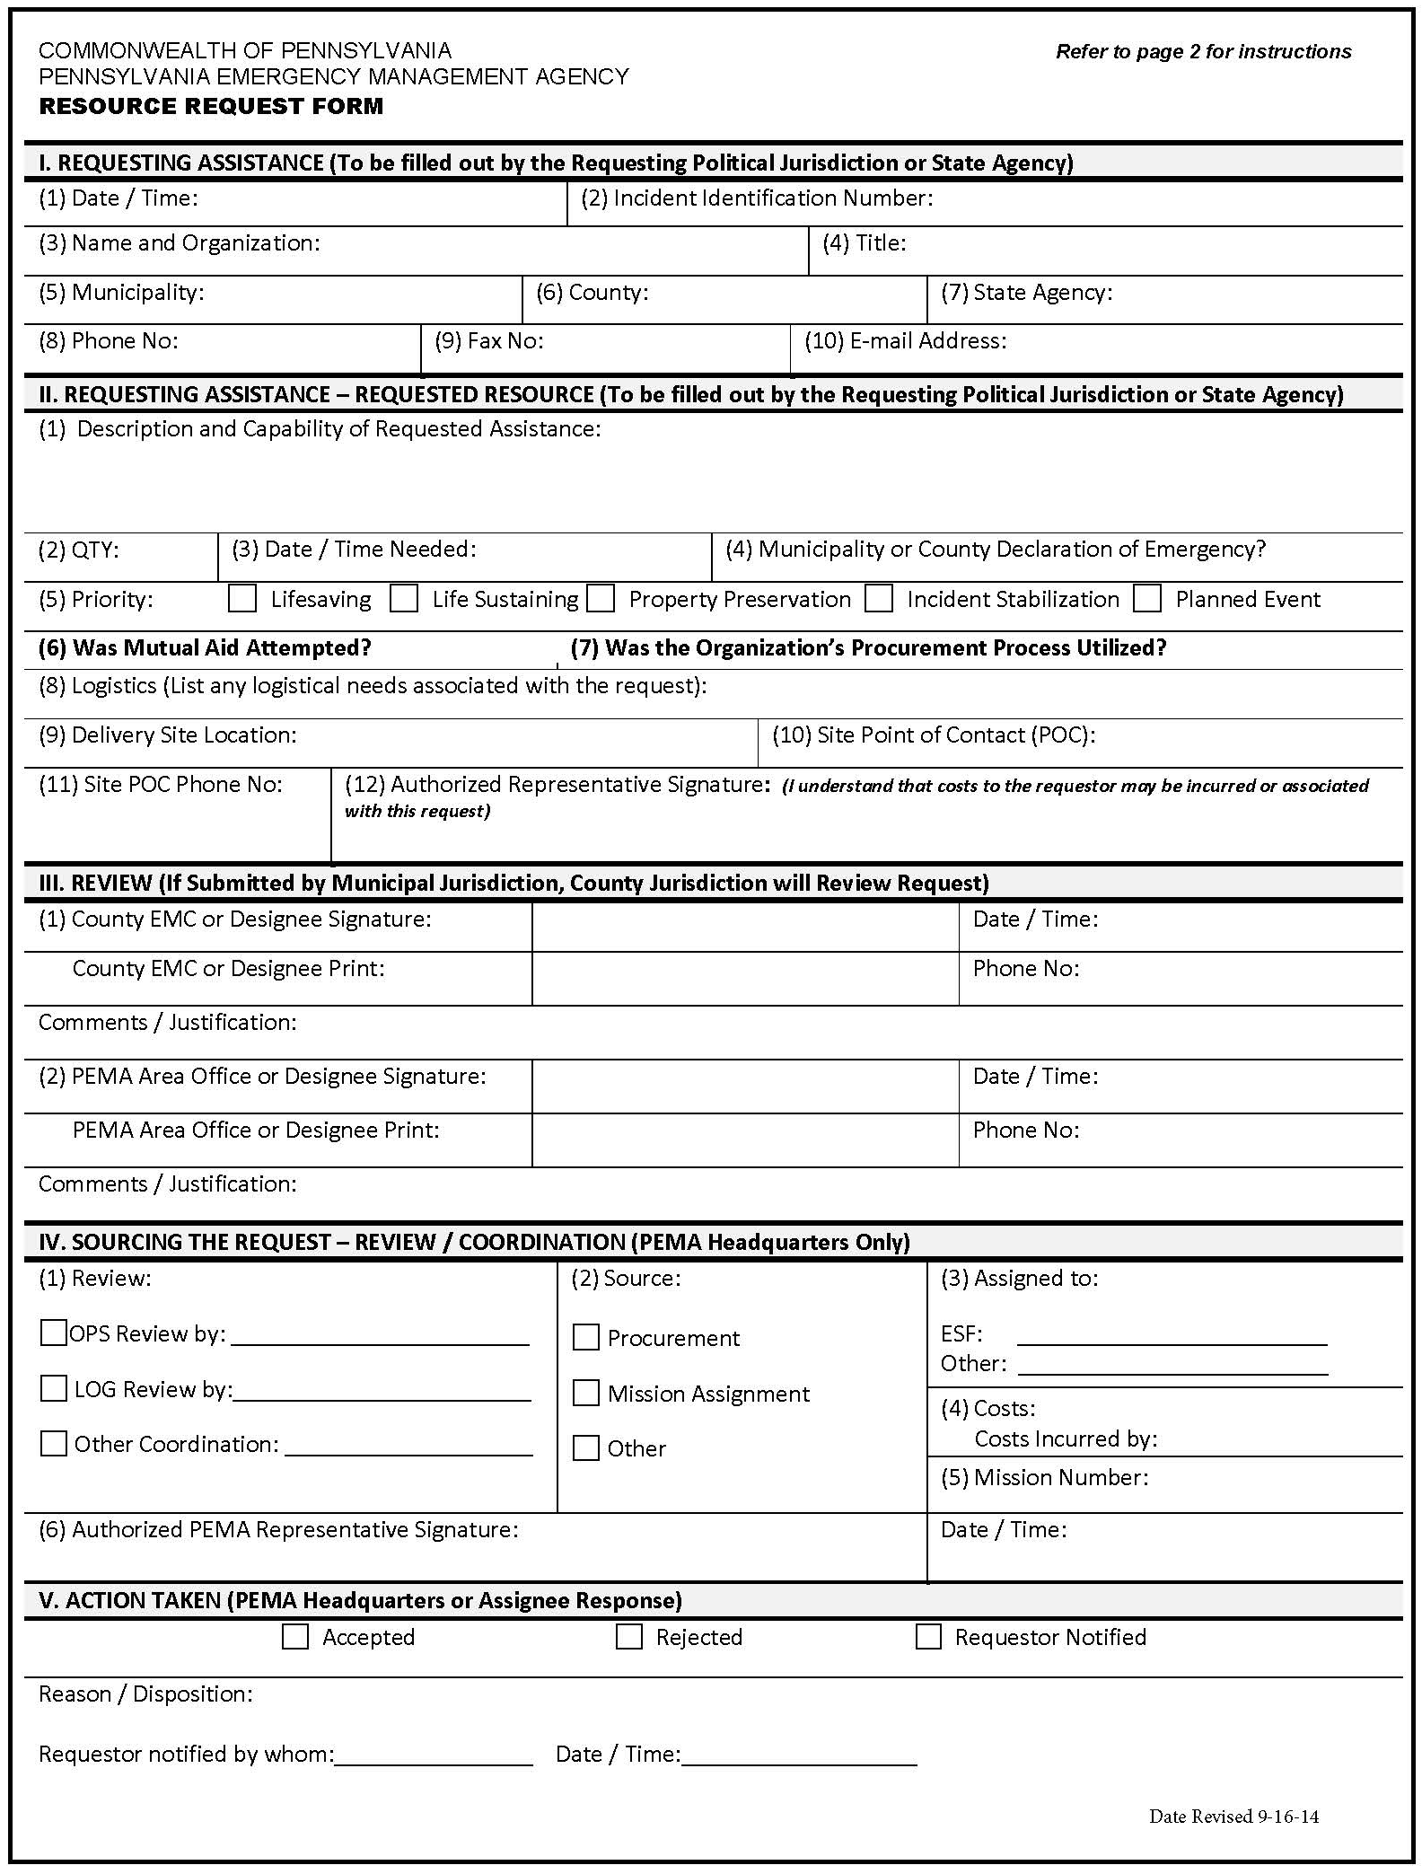
PEMA Resource Request Form

