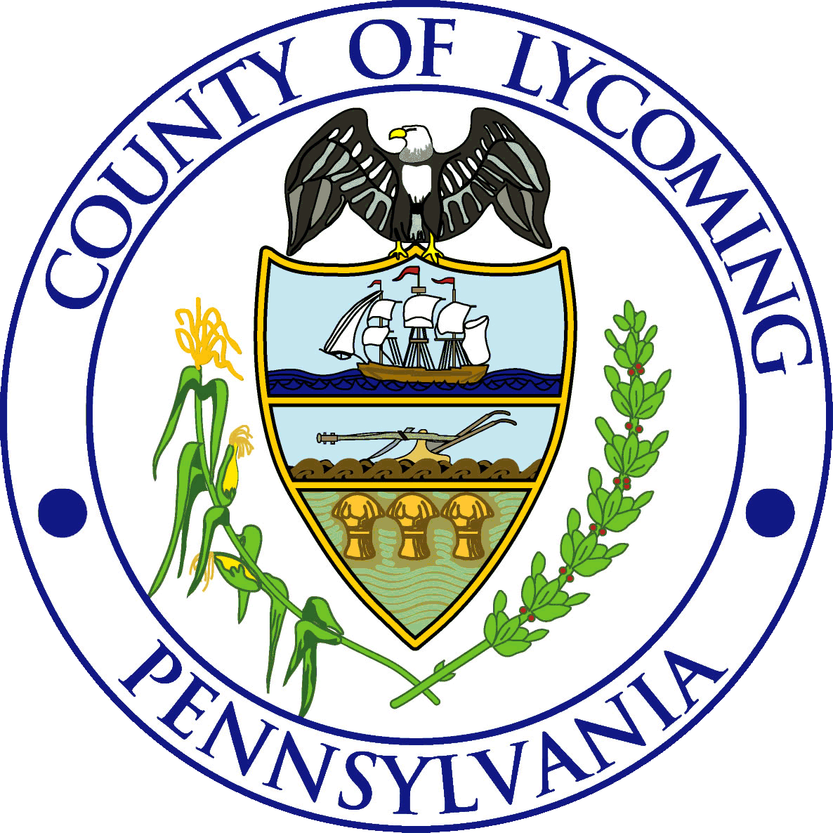
Lycoming County Department of Public Safety
LEPC
Local Emergency Planning Committee
Course Request Form

FSC: Bucks FSC Number |  | Hours: Hours
Course Title: Bucks Course Title
Course Dates & Times: (Please list all dates and times)
All course dates & Times

Instructor: (if known) Instructors Name if Contacted
Course Location: Choose an item.
Course Address: Address
Contact Person for Course:  Contact Person | Phone: Phone
 | E-mail: Email
DOH ConEd Requested: Choose an item.
Additional Materials Needed:
Additional Items

Person/Title Requesting Course:  Name & Title |  | Date:  Date

Submit Form to: pyoung@lyco.org

By signing your name above, you are agreeing to an open course for Lycoming County first responders.
If a course request is full (25), please submit a roster with names and contact phone numbers and/or e-mails of all students within your station.

