2018 MAMA/CAFCA REGIONAL FIRE/RESCUE TRAINING SCHEDULE

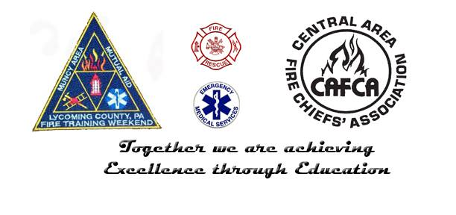

Email: mamatraining1@gmail.com
Phone: (570)327-1602

Overview
The goal of the MAMA/CAFCA Training Committee is to provide departments within our region professional certifications and local level training opportunities in a format which distributes programs throughout our area. This schedule is established in an attempt to eliminate the duplication of programs, and ensure programs roster with an adequate amount of students.
For 2018, we have implemented “career path” schedules, which break down training and certification into specific technical areas including: Exterior Firefighter, Interior Firefighter, Driver/Operator, Officer, and Rescue Technician. Each one of these disciplines will consist of course offerings in either Spring/Fall, or throughout the year. The structure of this program is designed so an individual has a clear path towards training and certification levels offered within their chosen technical area. In subsequent years, career paths such as Driver/Operator, Officer, and Rescue Technician will continue into more advanced programs and certifications. The certification courses offered within this schedule will be the only certification courses offered by the MAMA/CAFCA Training Committee for the 2018 calendar year. Departments who wish to schedule additional certification courses through the MAMA/CAFCA Committee should contact us directly and those requests will be evaluated on a case by case basis.
The Training Committee has also scheduled standard local-level programs that do not lead to certification for departments who have requested them up to this point. We will continue to schedule such courses as they are requested by departments. ALL course requests should be completed on the attached MAMA/CAFCA Training Request Form, and forwarded to mamatraining1@gmail.com.
There are courses listed within this packet with location and/or times to be determined. If you wish to host one of these programs please contact us. Otherwise, look for updated information on the calendar, and course announcement coming from the Lycoming County DPS.
Calendar
An up to date training calendar is available at:
http://www.lyco.org/Public-Safety/Public-Safety-Training-Calendar
This calendar will include all courses within this packet with the most up to date information on times and location. It will also include any additional local level courses that are scheduled after this packet is released. Course announcements will continue to come through Lycoming county DPS, but you can use this calendar to look forward throughout the year at courses that are scheduled region wide.
Registration
All registrations for MAMA/CAFCA Training Committee sponsored courses will be done through Lycoming County DPS. Pre-registration is required so that we may ensure classes will roster. Students may register at www.lyco.org and click on Public Safety, or call (570)433-4461. You must create or already have a username and password to register online. Please ensure all of your contact information is up to date, including your home department.
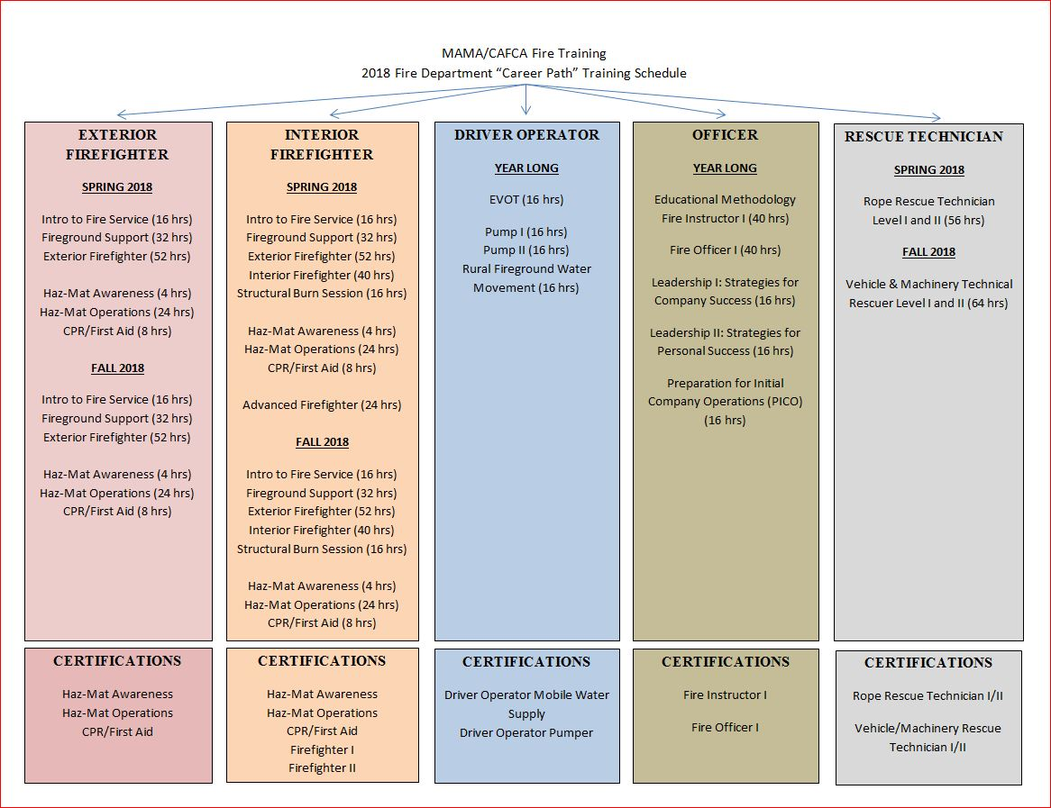
2018 Certification Levels Offered
Hazardous Materials Awareness
Hazardous Materials Operations
Firefighter I
Firefighter II
Fire Instructor I
Fire Officer I
Driver Operator Pumper
Driver Operator Mobile Water Supply
Rope Rescue Technician Level I and II
Vehicle and Machinery Rescuer Level I and II

See below course offering for dates and times of certification courses and tests. Specific questions regarding certification level pre-requisites or additional information that is not answered below should be forwarded to depfirechief@cityofwilliamsport.org, or by calling (570)327-1602 and speaking with Deputy Chief Dave Dymeck or Mike Gardner. CAFCA will continue to hold closed certification tests for departments requesting such utilizing the contact information above.

Interior/Exterior Firefighter Career Path
Hazardous Materials Awareness (RIHM) - NFA
FSC: 0114 Hours: 4.0 (Lecture: 4.0hrs / Lab: 0.0hrs)
Prerequisites: Age 14 and up Gear: None
Text Book: Jones and Bartlett, Hazardous Materials Awareness & Operations, 1st Edition
Description: This course will provide instruction in the basic skills of identifying hazardous material problems in a community. The student will learn to recognize the presence of hazardous materials and identify hazardous materials, as well as learn the associated hazard characteristics.

Spring Offering: January 30, 2018 (1800-2200)
Location: Picture Rocks VFC

Fall Offering: October 11, 2018 (1800-2200)
Location: TBD

Hazardous Materials Operations Level
FSC: 0472 Hours: 24.0 (Lecture: 12.0hrs / Lab: 12.0hrs)
Prerequisites: Age 16 and up, Hazardous Materials Awareness (RIHM) - NFA
Gear: TOG or Chemical Protective Clothing with Respiratory Protection
Text Book: Jones and Bartlett, Hazardous Materials Awareness & Operations, 1st Edition
Description: The goal of this program is to provide the First Responder with the training needed to comply with NFPA 472 Chapter 5 Competencies for the First Responder at the Operational Level, and 29 CFR 1910.120 OSHA’s Hazardous Waste Operations and Emergency Response,
(HAZWOPER), First Responder Operations Level. This program is designed to give the first responder the necessary skills to handle hazardous materials emergencies. After successfully completing this course you would be eligible to take the national certification testing for national certification in Hazardous Materials Operations Level.

Spring Offering: February 6 (1800-2200), February 8(1800-2200), February 10 (0800-1600), February 13 (1800-2200), February 15 (1800-2200)
Location: Picture Rocks VFC

Hazardous Materials Awareness and Operations Certification Test – February 17, 2018

Fall Offering: October 13 (0800-1600), October 14 (0800-1600), October 15 (1800-2200), October 18 (1800-2200),
Location: TBD

Hazardous Materials Awareness and Operations Certification Test – October 20, 2018

CPR/First Aid

Spring Offering: January 23 (1800-2200), January 25 (1800-2200)
Location: Picture Rocks VFC

Fall Offering: October 21 (0800-1600)
Location: TBD

Introduction to the Fire Service (ELIS)
FSC: 2459 Hours: 16.0 (Lecture: 10.0hrs / Lab: 6.0hrs)
Prerequisites: Age 14 and up Gear: TOG
Text Book: IFSTA, Essentials of Firefighting, 6th Edition
Description: This entry level course is designed to introduce new firefighters to basic information including an overview of the fire service, fire service organization, firefighter safety, personal protective equipment, tools and emergency lighting, and backing apparatus. This is the first of five levels (courses) in the curriculum.

Spring Offering: February 27 (1800-2200), March 1 (1800-2200), March 3 (0800-1600)
Location: Picture Rocks VFC

Fall Offering: August 27 (1800-2200), August 30 (1800-2200), September 8 (0800-1600)
Location: TBD

Fire Ground Support (ELFG)
FSC: 2460 Hours: 32.0 (Lecture: 12.0hrs / Lab: 20.0hrs)
Prerequisites: Age 14 and up, Introduction to the Fire Service (ELIS), Hazardous Materials
Awareness (RIHM) -NFA
Gear: TOG & SCBA
Text Book: IFSTA, Essentials of Firefighting, 6th Edition
Description: This entry level course is designed to introduce new firefighters to fire ground operation including fire behavior, building construction-structural collapse, fire hose, water supply, communications, ropes and knots, Self-Contained Breathing Apparatus (SCBA). This is the second of five levels (courses) in the curriculum.

Spring Offering: March 6 1800-2200), March 8 (1800-2200), March 13 (1800-2200),
March 15 (1800-2200), March 20 (1800-2200), March 22 (1800-2200), March 24 (0800-1600)
Location: Picture Rocks VFC

Fall Offering: September 10 (1800-2200), September 13 (1800-2200), September 15 (0800-1600), September 16 (0800-1600), September 17 (1800-2200), September 20 (1800-2200)
Location: TBD

Exterior Firefighting (ELEF)
FSC: 2462 Hours: 52.0 (Lecture: 16.0hrs / Lab: 36.0hrs)
Prerequisites: Age 14 and up, Fire Ground Support (ELFG), ICS-100: Introduction to the Incident Command System (ICS-100), National Incident Management System;
Introduction IS-700
Gear: TOG, SCBA
Text Book: IFSTA, Essentials of Firefighting, 6th Edition
Description: This entry level course is designed to introduce new firefighters to fire ground operation including Self-Contained Breathing Apparatus (SCBA), fire behavior, building construction, fire extinguishers, forcible entry, ladders, and fire streams/hose line advancement.
This is the third of five levels (courses) in the curriculum.

Spring Offering: March 27 (1800-2200), March 29 (1800-2200), March 31 (0800-1600), April 3 (1800-2200), April 5 (1800-2200), April 10 (1800-2200), April 12 (1800-2200), April 14 (0800-1600), April 17 (1800-2200), April 19 (1800-2200), April 24 (1800-2200)
Location: Picture Rocks VFC

Fall Offering: September 22 (0800-1600), September 23 (0800-1600), September 24 (1800-2200), September 27 (1800-2200), October 1 (1800-2200), October 4 (1800-2200), October 6 (0800-1600), October 7 (0800-1600), October 8 (1800-2200)
Location: TBD

Interior Firefighter Career Path

Interior Firefighting: Live Fire Exercises (ELIF)
FSC: 2469 Hours: 40.0 (Lecture: 12.0hrs / Lab: 28.0hrs)
Prerequisites: Age 18 and up, Exterior Firefighting (ELEF), Hazardous Materials Operations Level
Gear: TOG, SCBA
Text Book: IFSTA, Essentials of Firefighting, 6th Edition
Description: This entry level course is designed to introduce new firefighters to interior fire ground operations including Self-Contained Breathing Apparatus (SCBA), Search and Rescue
Procedures, Firefighter Survival, Ventilation, Utility and Loss Control, Origin and Cause, and
Fire Control (Suppression). This is the fourth of five levels (courses) in the curriculum.

Spring Offering: April 26 (1800-2200), April 28 (0800-1600), May 1 (1800-2200), May 3 (1800-2200), May 8 (1800-2200), May 10 (1800-2200), May 12 (0800-1600), May 15 (1800-2200)
Location: Picture Rocks VFC

Fall Offering: October 22 (1800-2200), October 25 (1800-2200), October 27 (0800-1600), October 28 (0800-1600), October 29 (1800-2200), November 1 (1800-2200), November 3 (0800-1600)
Location: TBD

Structural Burn Session (SBS)
FSC: 0600 Hours: 16.0 (Lecture: 4.0hrs / Lab: 12.0hrs)
Prerequisites: Age 18 and up, EBM or Interior Firefighting: Live Fire Exercises (ELIF) or
Interior Firefighting: No Live Fire Exercises (ELIF) or Bucks Basic Fire Academy or FF-1
Gear: TOG, SCBA
Text Book: Handouts provided by BCCC (Subject to change)
Description: This course will provide the student with a review and application of the techniques used in safe firefighting practices in an actual structural fire environment. Emphasis is placed on safety for both interior and exterior operations.

Spring Offering: May 19 (0800-1600), May 20 (0800-1600)
Location: Picture Rocks VFC/CAFCA

Firefighter I Certification Test – June 2, 2018

Fall Offering: November 5 (1800-2200), November 8 (1800-2200), November 10 (0800-1600)
Location: TBD/CAFCA

Firefighter I Certification Test – November 17, 2018

Advanced Firefighter (ELAF)
FSC: 2473 Hours: 24.0 (Lecture: 10.0hrs / Lab: 14.0hrs)
Prerequisites: Age 18 and up, Age 18 and up, EBM and Structural Burn Session (SBS) or Interior Firefighting: Live Fire Exercises (ELIF) or Interior Firefighting: No Live Fire Exercises (ELIF) or Bucks Basic Fire Academy or Fire Fighter 1 – NFPA 1001
Gear: TOG, SCBA
Text Book: IFSTA, Essentials of Firefighting, 6th Edition
Description: This entry level course is designed to introduce seasoned firefighters to advanced fire ground operations including Building Construction, Fire Safety Surveys/Fire and Life Presentation, Generators, Lighting Equipment, Technical Rescue, Fire Protection Systems, Service Testing of Hose, Combustible Gas and Liquid Fire Control, Foam, Coordinating Fire
Ground Operations Communications, and Advanced Origin, Cause and Arson. This is the fifth of five levels (courses) in the curriculum.

Spring Offering: June 5 (1800-2200), June 7 (1800-2200), June 9 (0800-1600), June 12 (1800-2200), June 14 (1800-2200)
Location: Picture Rocks VFC

Firefighter II Certification Test – June 16, 2018

Driver Operator Career Path
Emergency Vehicle Driver Training
FSC: 0235 Hours: 16.0 (Lecture: 8.0hrs / Lab: 8.0hrs)
Prerequisites: Age 18 and up, Current Motor Vehicle License
Gear: Emergency Services Apparatus, not personal vehicle
Text Book: VFIS, Emergency Vehicle Driver Training 2008 Version Participant Manual
Description: This course is suitable for both novice and veteran emergency vehicle operators.
This course provides instruction for emergency personnel who may be involved in operating emergency vehicles. Topics included: defensive driving, emergency response, vehicle maintenance, and a driver training obstacle course.

Spring Offering: May 19 (0800-1600), May 20 (0800-1600)
Location: TBD

Fall Offering: October 27 (0800-1600), October 28 (0800-1600)
Location: TBD

Pump Operations 1 (PUOP)
FSC: 0420 Hours: 16.0 (Lecture: 10.0hrs / Lab: 6.0hrs)
Prerequisites: Age 18 and up, Introduction to Safety and the Training System
Gear: Turn out gear
Text Book: Handouts provided by BCCC (Subject to change)
Description: This course provides the fire fighter with an introduction to basic pump construction and theory as well as operating techniques. Emphasis is placed on getting water to the pump, getting water from the pump for hose streams, and prevention of common mistakes in pump operations.

Offering: July 16 (1800-2200), July 18 (1800-2200), July 21 (0800-1600)
Location: Woodward Twp. VFC

Pump Operations 2 (PUOA)
FSC: 0421 Hours: 16.0 (Lecture: 8.0hrs / Lab: 8.0hrs)
Prerequisites: Age 18 and up, Pump Operations 1
Gear: Turn out gear
Text Book: Handouts provided by BCCC (Subject to change)
Description: This course is designed to instruct the student in advanced techniques of operating fire pumps. Topics covered include friction loss, relay pumping, master streams, and elevated master streams.

Offering: August 6 (1800-2200), August 8 (1800-2200, August 11 (0800-1600)
Location: Woodward Twp. VFC

Rural Fire Ground Water Movement (RFWM)
FSC: 0625 Hours: 16.0 (Lecture: 6.0hrs / Lab: 10.0hrs)
Prerequisites: Age 16 and up
Gear: Turn out gear
Text Book: Handouts provided by BCCC (Subject to change)
Description: This course instructs the student in the basic methods of water movement in the rural area for firefighting. Tank trucks and large diameter hose are utilized. Safe, efficient and recommended methods are discussed, demonstrated, and practiced.

Offering: September 10 (1800-2200), September 13 (1800-2200), September 15 (0800-1600)

Driver Operator Pumper Certification Test – September 22, 2018

Driver Operator Mobile Water Supply Test – October 6, 2018

Fire Officer Career Path
Educational Methodology for Local Level Instructors (EMLL)
FSC: 0250 Hours: 48.0 (Lecture: 40.0hrs / Lab: 8.0hrs)
Prerequisites: Contact your Regional Field Director
Gear: None
Text Book: IFSTA, Fire and Emergency Services Instructor, 8th Edition
Description: This course will provide instruction in adult learning, teaching techniques, preparation of instruction objectives, and formation of lesson plans to meet those objectives. Various formats of audio-visuals will be demonstrated. Each student will prepare and deliver at least three micro teaching sessions on a fire related topic. Successful completion of this course is necessary to become an instructor without prior teaching experience.

Spring Offering:
February 13 (1800-2200), February 15 (1800-2200), February 17 (0800-1600), February 18 (0800-1600), February 20 (1800-2200), February 22 (1800-2200), February 24 (0800-1600), February 25 (0800-1600)
Location: Loyalsock Volunteer Fire Company

Testing for Instructor I Certification Included

Fire Company Officer I – NFPA 1021
FSC: 0645 Hours: 40.0 (Lecture: 40.0hrs / Lab: 0.0hrs)
Prerequisites: Age 18 and up, Fire Fighter 2 – NFPA 1001, Fire Service Instructor I – NFPA 1041
Gear: Laptop Computer Recommended
Text Book: IFSTA, Fire Department Company Officer, 4thEdition
Description: This course will provide the student with a basic knowledge of management principles in a fire/rescue organization. Topics of discussion will include management style, communication modes, leadership, organizational structure, pre-planning, health and safety, and legal aspects for a fire officer. Successful completion of the program requires proficiency demonstration in written practical skills and a multiple choice examination. (ProBoard Certification)

Fall Offering: October 20 (0800-1600), October 21 (0800-1600), November 3 (0800-1600), November 4 (0800-1600), November 17 (0800-1600)
Location: TBD

Testing for Fire Officer I Certification Included

Leadership I: Strategies for Company Success (LSI) - NFA
FSC: 0219 Hours: 16.0 (Lecture: 12.0hrs / Lab: 4.0hrs)
Prerequisites: Age 16 and up
Gear: None
Text Book: Handouts provided by BCCC (Subject to change)
Description: Running an effective fire service organization, whether career, combination, or volunteer, requires leaders. Many line and administrative officers are very competent in technical areas, but need training and skill practice in key managerial strategies to reach their full potential in leading their organization. This course is targeted to officers who must make decisions, solve problems, or conduct meetings as part of his/her duties.

Spring Offering: April 9 (1800-2200), April 12 (1800-2200), April 16 (1800-2200), April 19 (1800-2200)
Location: Lycoming County DPS

Leadership II: Strategies for Personal Success (LSII) - NFA
FSC: 0231 Hours: 16.0 (Lecture: 12.0hrs / Lab: 4.0hrs)
Prerequisites: Age 16 and up, Leadership I: Strategies for Company Success (LSI) -NFA
Gear: None
Text Book: Handouts provided by BCCC (Subject to change)
Description: Running an effective fire service organization, whether career, combination or volunteer, requires leaders. Many line and administrative officers are very competent in technical areas, but need training and skill practice in key managerial strategies to reach their full potential in leading their organization. This course is targeted to company level junior line officers (lieutenant, captain, etc.) who wish to improve basic leadership skills in such areas as managing multiple roles, creativity, establishment of a "personal power base", and ethics. The course may also be applicable to those administrative officers of volunteer organizations (president, secretary, treasurer, etc.) who find that their responsibilities require similar skills.

Fall Offering: October 8 (1800-2200), October 11 (1800-2200), October 15 (1800-2200), October 18 (1800-2200)
Location: Lycoming County DPS

Preparation for Initial Company Operations (PICO)
FSC: 0380 Hours: 16.0 (Lecture: 16.0hrs / Lab: 0.0hrs)
Prerequisites: Age 16 and up, EBM or Interior Firefighting: Live Fire Exercises (ELIF) or
Interior Firefighting: No Live Fire Exercises (ELIF) or Bucks Basic Fire Academy or FF-1
Gear: None
Text Book: Handouts provided by BCCC (Subject to change)
Description: This course is designed to prepare the student to function as a company officer, by developing the skills required to safely and successfully managing company tactical operations at structural fires. The first in the series of programs designed to meet the needs of fire officers and crew operations. This course will provide a basic foundation for the management of one or more companies’ development of proficiency in critical skills. Key content includes Roles and Responsibilities, Readiness, Communication, Building Construction and Fire Behavior Factors, and Pre-incident Preparation.

Fall Offering: December 3 (1800-2200), December 6 (1800-2200), December 10 (1800-2200), December 13 (1800-2200)
Location: Lycoming County DPS

Rescue Technician Career Path

Rope Rescue Technician (Level 1 & 2) –NFPA 1006
FSC: 0451 Hours: 56.0 (Lecture: 16.0hrs / Lab: 40.0hrs)
Prerequisites: Age 18 and up,
Gear: Helmet with chin strap, Work Clothes, Work Shoes, Leather gloves
Text Book: Brown, Engineering Practical Rope Rescue Systems (Delmar) and CMC, Rope Rescue Manual, 4th Edition
Description: This program is designed to enhance the student’s ability to perform critical skill sets to meet the intent of NFPA 1006 Rope Rescue in the field of technical rescue. During this course, students will review rope rescue systems, application theories, and high angle challenges to accurately and safely execute the skill sets required for professional certification. Topics include: rescue incident management, technical vs. non-technical rescue considerations, rescue strategies and tactics, resource management, access and removal considerations, hazard identification and control, rope management, ascending and descending systems, rope rescue equipment identification and application, patient removal techniques and selection criteria, basic patient care, packaging, and removal, basic and advanced anchor systems, and applicable OSHA and NFPA laws and standards. This course is designed for the experienced rescuer with a strong working knowledge of technical rescue in accordance with NFPA 1006 and 1670. The course is designed to prepare the rescuer for professional certification testing (written and skills) in accordance with NFPA 1006 Rope Rescue. (ProBoard Certification)

Spring Offering: TBD
Location: Williamsport Bureau of Fire

Testing for Rope Rescue Technician Included

Vehicle and Machinery Rescue Technician (Level 1 & 2) –NFPA 1006
FSC: 0452 Hours: 64.0 (Lecture: 32.0hrs / Lab: 32.0hrs)
Prerequisites: Age 18 and up
Gear: TOG or Extrication jumpsuit with Eye Protection
Text Book: IFSTA, Principles of Auto Extrication, 3rdEdition
Description: This program is designed to enhance the student’s ability to perform critical skill sets to meet the intent of NFPA 1006 Vehicle & Machinery in the field of technical rescue.
During this course, students will review vehicle and machinery extrication theories, techniques, and challenges to accurately and safely execute the skill sets required for professional certification. Topics include: rescue incident management, machinery types, extrication strategies and tactics, resource management, stabilization systems, hazard identification and control, basic rescue knots, hitches, and bends, technical rescue equipment identification and application, extrication tools, methods, and selection criteria, basic patient care, packaging, and lifting and moving, basic and advanced extrication techniques, and applicable OSHA and NFPA laws and standards. This course is designed for the experienced rescuer with a strong working knowledge of technical rescue in accordance with NFPA 1006 and 1670. The course is designed to prepare the rescuer for professional certification testing (written and skills) in accordance with NFPA 1006 Vehicle & Machinery. (ProBoard Certification)

Fall Offering: TBD
Location: TBD

Testing for Vehicle and Machinery Rescue Technician Included

Local level Training Courses Currently Scheduled (As of December 14, 2017)

Electrical Emergencies January 22, 2018 (1900-2200)
Loyalsock Township VFC

Electrical Fire Investigation January 27, 2018 (0800-1700)
Loyalsock Township VFC

SCBA Refresher February 12, 2018 (1900-2200)
Loyalsock Township VFC

Search and Rescue Refresher February 19, 2018 (1900-2200)
Loyalsock Township VFC

Aerial Apparatus Practices February 24-25, 2018 (0800-1600)
Warrior Run Area Fire Department

Hazardous Materials Incident Scene Management March 19, 2018 (1830-2200)
Loyalsock Township VFC

Thermal Imaging Cameras Seminar April 9, 2018 (1900-2200)
Loyalsock Township VFC

Natural Gas/Propane/CO Seminar October 22, 2018 (1900-2200)
Loyalsock Township VFC

Clandestine Drug Laboratory Awareness November 12, 2018 (1900-2200)
Loyalsock Township VFC

To request local level courses, please use the attached training request form. Send completed form to mamatraining1@gmail.com

MAMA/CAFCA TRAINING
CLASS REQUEST FORM

Course Requested:
FSC: Hours:

Course Start Dates (Please List All Dates & Time):

Station Name and Address:

Contact Name:
Contact Number:
Contact Email:
Projected Number of students from Host Department:
Instructor Name (if you have an instructor you would like please contact and clear dates):

Additional Materials Needed:

Use of MAMA or CAFCA Grounds: (Please list dates & times):

Please note that if you do not contact an instructor for your class, Bucks will choose an instructor.

Email form to: mamatraining1@gmail.com

