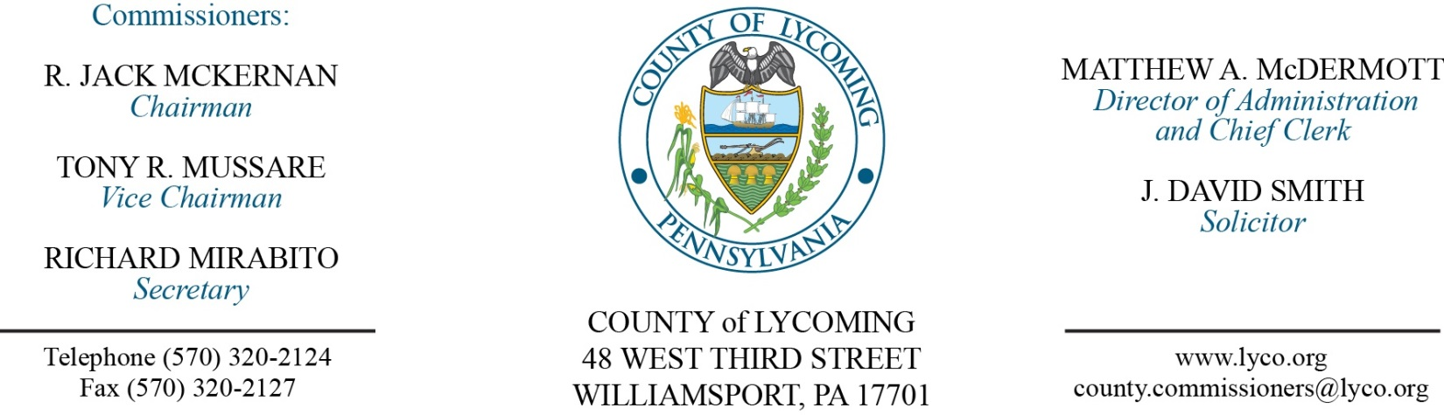
Commissioners’ Meeting Agenda
May 10, 2018

Opening Prayer

Pledge to the Flag

1.0 OPERATIONS

1.1 Convene Commissioners’ meeting.

1.2 Approve the minutes of the previous meetings.

1.3 Receive public comments (agenda items only).

2.0 ACTION ITEMS

2.1 Proclaim May 6-12, 2018, as Corrections Employee Week in Lycoming County. (Brad Shoemaker)

2.2 Adopt resolution 2018-13 for commitment of $511,882 to the East End Gateway Project. (Kim Wheeeler)

2.3 Award FMA 2015 Demolition Contract to Masters Excavating LLC. (Josh Schnitzlein)

2.4 Approve collective bargaining agreement with Teamsters Local 764 for Detectives. (Matt McDermott)

2.5 Approve Memorandum of Understanding with Teamsters Local 764 for Martin Wade. (Matt McDermott)

2.6 Approve Memorandum of Understanding with Teamsters Local 764 for Calvin Irvin and Curtis Laudenslager. (Matt McDermott)

2.7 Approve accounts payable cash requirement report through May 23, 2018, for payment on May 16, 2018, upon review & approval by the Commissioners. (Matt McDermott)

2.8 Approve purchase from G & M Bandsaw, Inc., for 1-new 2018 Scotchman DO 70/110-24M Ironworker with accessories in the amount of $28,787. (Mya Toon)

2.9 Approve professional service agreement with NMS Labs for the District Attorney’s Office. (Mya Toon)

2.10 Approve License and Services Agreement with Tyler Technologies for CAMA Software. (Tom Heap)

2.11 Approve the following personnel actions: (Roxanne Grieco)
District Attorney – Cassondra E. Leljedal as full time replacement Clerk III – Pay grade 4 - $14.514219/hour effective 5/20/18.
Coroner – Amy L. Turner as part time replacement Deputy Coroner On Call – Pay grade 7 - $16.83/hour effective 5/14/18, not to exceed 1,000 hours annually.

2.12 Approve update to Policy 907 - Vehicle Drivers Policy – of the County’s Policy and Procedures Manual. (Roxanne Grieco)

2.13 Approve agreement with STEP in the amount of $150,000 for the Loyalsock Center for Healthy Aging pending preparation and review of agreement.

5.0 REPORTS/INFORMATION ITEMS

5.1 LCRMS is requesting bids for HDPE Pipe and Landfill Gas Well Accessories and Portable Landfill Gas Extraction Monitor. (Mya Toon)

5.2 LCRMS is requesting bids for Concrete Manhole Boxes for a Force Main Waterline Project. (Mya Toon)

5.3 Announce City Swift Plan for levee remediation public outreach and meetings.

6.0 COMMISSIONER COMMENT:

7.0 PUBLIC COMMENT:

8.0 NEXT REGULARLY SCHEDULED MEETING: Planning Session on Tuesday, May 22, 2018. No meetings on May 15 or May 17, 2018.

9.0 ADJOURN COMMISSIONERS’ MEETING.

