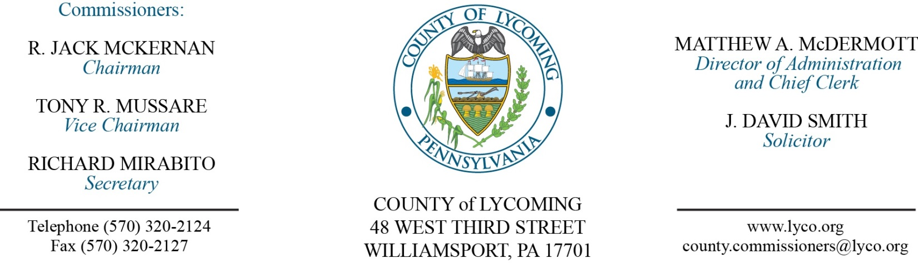
Commissioners’ Meeting Agenda
April 5, 2018

Opening Prayer

Pledge to the Flag

1.0 OPERATIONS

1.1 Convene Commissioners’ meeting.

1.2 Approve the minutes of the previous meetings.

1.3 Receive public comments (agenda items only).

2.0 ACTION ITEMS

2.1 Proclaim April 8-14, 2018 as library week in Lycoming County.

2.2 Adopt resolution 2018-09 for the language access plan. (Kristin McLaughlin)

2.3 Approve 2017 CDBG contract in the amount of $520,356. (Kristin McLaughlin)

2.4 Approve professional service agreement with SEDA CoG for 2017 CDBG. (Kristin McLaughlin)

2.5 Approve Montoursville Cooperative Agreement for FFY 2016 in the amount of $69,947. (Kristin McLaughlin)

2.6 Approve budget modification for CDBG FFY 2014. (Kristin McLaughlin)

2.7 Approve application to DEP for renewal for Title V air quality permit. (Michael Hnatin)

2.8 Approve the following personnel actions: (Roxanne Grieco)
DPS – Communications – Duane E. Long as full time replacement Telecommunicator I (WOE) – Pay grade 6 - $16.59/hour effective 4/9/18.
DPS – Communications – Igasha D. Brown as full time replacement Telecommunicator I (WOE) – Pay grade 6 - $16.59/hour effective 4/11/18.

5.0 REPORTS/INFORMATION ITEMS

5.1 Present Service pin:
10 years
Michael Koser RMS

5.2 Announce draft 2018 CDBG schedule. (Kristin McLaughlin)

5.3 Comp Plan – Issue #8 (Drugs). (Kurt Hausammann)

6.0 COMMISSIONER COMMENT:

7.0 PUBLIC COMMENT:

8.0 NEXT REGULARLY SCHEDULED MEETING: Planning Session on Tuesday, April 10, 2018.

9.0 ADJOURN COMMISSIONERS’ MEETING.

