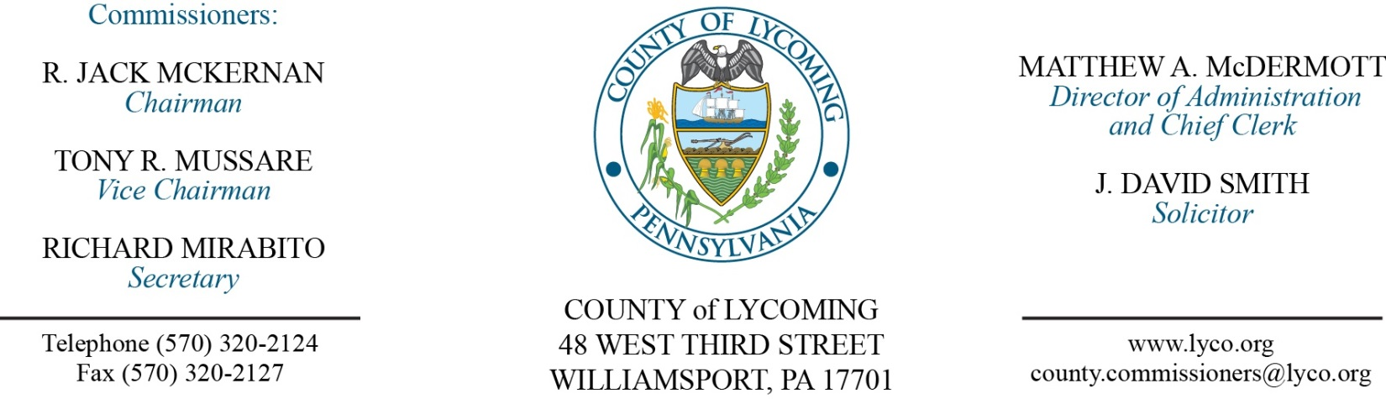
Commissioners’ Meeting Agenda
March 15, 2018

Opening Prayer

Pledge to the Flag

1.0 OPERATIONS

1.1 Convene Commissioners’ meeting.

1.2 Approve the minutes of the previous meetings.

1.3 Receive public comments (agenda items only).

2.0 ACTION ITEMS

2.1 Approve accounts payable cash requirement report through March 28, 2018, for payment on March 21, 2018, upon review & approval by the Commissioners. (Michele McDermott)

2.2 Adopt resolution 2018-08 updating the chain of succession. (John Yingling)

2.3 Approve renewal of Onbase for 2018 for the scanning of courts documents in the amount of $11,240.09/annually. (Karl Demi)

2.4 Approve the following agreements: (Mark Egly)
• Lycoming-Clinton Counties Commission for Community Action (STEP, Inc.) for the provision of Youth Workforce Development/Employment (YES) services for the period July 1, 2017 through June 30, 2018 not to exceed $100,000.
• Lycoming-Clinton Counties Commission for Community Action (STEP, Inc.) for the provision of Family Navigation services for the period July 1, 2017 through June 30, 2018 not to exceed $45,000.
• Families United Network, Inc. for foster care and residential care services at per diems ranging from $27.27/day to $198.05/day for the period July 1, 2017 through June 30, 2018.

(cont)
• Youth Services Agency for emergency shelter and residential care services at a per diem of $158.00day for the period July 1, 2017 through June 30, 2018.
• Adelphoi Village, Inc. for foster care and residential care services at per diems ranging from $76.45day to $289.11/day for the period July 1, 2017 through June 30, 2018.

2.5 Appoint Rosemary Holmes to the Lycoming County Library System Board with term expiration of 12/31/20.

5.0 REPORTS/INFORMATION ITEMS

5.1 Lycoming County is requesting bids for flood mitigation acquisition and demolition. (Mya Toon)

5.2 Announce receipt of refund check for Workers Compensation.

5.2 Comp Plan -Issue #5 (Land Use). (John Lavelle)

6.0 COMMISSIONER COMMENT:

7.0 PUBLIC COMMENT:

8.0 NEXT REGULARLY SCHEDULED MEETING: Regular Meeting on Thursday, March 22, 2018. No meeting Tuesday, March 20, 2018.

9.0 ADJOURN COMMISSIONERS’ MEETING.

