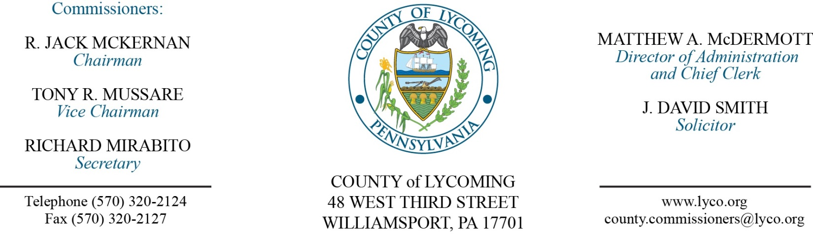
Commissioners’ Meeting Agenda
February 1, 2018

Opening Prayer

Pledge to the Flag

1.0 OPERATIONS

1.1 Convene Commissioners’ meeting.

1.2 Approve the minutes of the previous meetings.

1.3 Receive public comments (agenda items only).

2.0 ACTION ITEMS

2.1 Proclaim February 4-10, 2018, as FBLA-PBL week in Lycoming County. (Dolly Oden)

2.2 Adopt resolution 2018-02 declaring property valued in excess of $1,000 as surplus. (Mya Toon)

2.3 Approve professional service agreement with Dr. Obrien for the District Attorney’s office. (Mya Toon)

2.4 Approve professional service agreement with Dagostino Electronic Intercom Systems for the prison in the amount of $18,927.33. (Mya Toon)

2.5 Approve grant and monitoring agreement with Lycoming County Law Enforcement and Police Training Association in the amount of $25,000. (Mya Toon)

2.6 Approve purchase from Best Line Equipment, for 1- New 2018 JLG 1930 ES Electric Scissor Lift in the amount of $12,183.48. (Jason Yorks)

2.7 Approve update to action taken on January 25, 2018 and approve purchase from QED Environmental Services, Inc., for 1- New 2018 GEM5000 Portable Gas Extraction Monitor and accessories in the amount of $11,905. (Jason Yorks)

2.8 Approve the following personnel actions: (Ann Gehret)
PCD – Stacy L. Sweeting as part time Clerk I - Pay grade 2 - $10.94/hour effective 2/6/18, not to exceed 1,000 hours annually.
Prison – Scott A. Hamilton as full time replacement Correctional Officer Relief – Union - $16.01/hour effective 2/19/18.
Prison – Stephanie R. Hamilton as full time replacement Correctional Officer Relief (M/F) – Union - $16.01/hour effective 2/19/18.
Courts – Taylor J. Paulhamus as part time replacement Clerk III/Floater – Pay grade 4 - $12.96/hour effective 2/5/18, not to exceed 1,000 hours annually.

5.0 REPORTS/INFORMATION ITEMS

5.1 Lycoming County is requesting bids for food products (2nd quarter). (Mya Toon)

6.0 COMMISSIONER COMMENT:

7.0 PUBLIC COMMENT:

8.0 NEXT REGULARLY SCHEDULED MEETING: Planning Session on Tuesday, February 6, 2018.

9.0 ADJOURN COMMISSIONERS’ MEETING.

