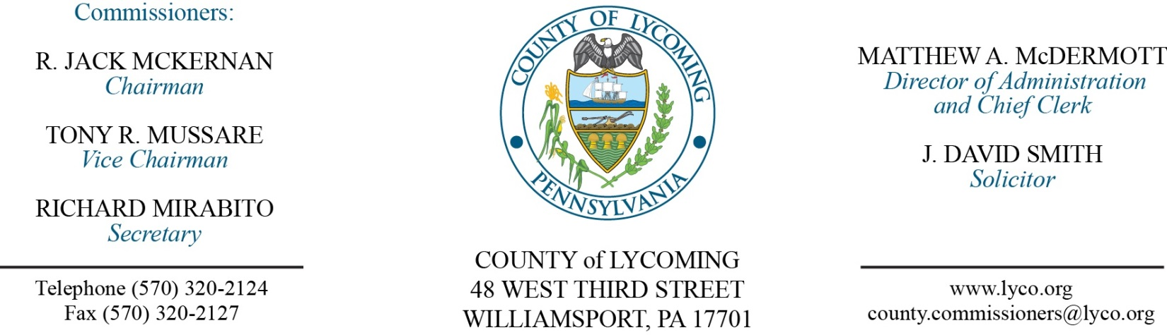
Commissioners’ Meeting Agenda
January 4, 2018

Opening Prayer

Pledge to the Flag

1.0 OPERATIONS

1.1 Convene Commissioners’ meeting.

1.2 Approve the minutes of the previous meetings.

1.3 Receive public comments (agenda items only).

2.0 ACTION ITEMS

2.1 Approve update to the County Emergency Operations Plan. (John Yingling)

2.2 Approve amendment to agreement with STEP for 2014 PHARE for Lead Agency Supportive Housing. (Jenny Picciano)

2.3 Approve invoice from Superion for 2018 efinance Maintenance Pt1 in the amount of $77,862.48. (Karl Demi)

2.4 Approve invoice from Superion for 2018 efinance Maintenance Pt2 in the amount of $19,726.66. (Karl Demi)

2.5 Approve intergovernmental agreement with Department of Corrections for PREA Reporting Hotline. (Mya Toon)

2.6 Approve intergovernmental agreement with Columbia County for inmate housing in the amount of $17/inmate/day on an as needed basis. (Mya Toon)

2.7 Approve amendment to professional service agreement with Enginuity for valve replacement at the prison. (Mya Toon)

2.8 Approve professional service agreement with SteelFusion Clinical Toxicology Laboratory LLC not to exceed $300/case. (Mya Toon)

2.9 Approve agreement with Penn College for off-campus project Columbarium to house unclaimed cremains in the Lycoming County Coroner’s Office. (Mya Toon)

2.10 Approve memorandum of understanding with West Branch D&A for Act 198 Adult Case Management in the amount of $30,000. (Mya Toon)

2.11 Approve memorandum of understanding with West Branch D&A for Act 198 Juvenile Case Management in the amount of $15,000. (Mya Toon)

2.12 Approve update to the TDA – District Attorney - Transfer of one DUI Special Detective position to Central Processing as a Central Processing Officer effective January 1, 2018, and removal of one Temporary Part-time Paralegal position effective January 13, 2018. (Roxanne Grieco)

2.13 Approve the following personnel actions: (Roxanne Grieco)
District Attorney – promotion of Kenneth A. Osokow as full time replacement District Attorney – Elected/appointed - $179,299/annually effective 1/1/2018.
District Attorney – promotion of Martin Wade as full time replacement 1st Assistant District Attorney/Deputy District Attorney – Pay grade 13 - $65,044.27/annually effective 1/1/2018.
District Attorney – promotion of Abigail Inns as full time replacement Paralegal – Pay grade 7 - $18.08/hour effective 1/14/18.
District Attorney – reclassification of James DeVore as part time Central Processing Officer– CPO - $15.64/hour effective 1/14/18, not to exceed 1,000 hours annually.
Courts – Judge Linhardt – reclassification of Paula J. Simpler to full time Executive Secretary – Pay grade 5 - $42,484.14/annually effective 1/1/18.

Recess Commissioners’ Meeting

3.0 SALARY BOARD

3.1 Convene Salary Board.

3.2 Adopt salary scale for year 2018.

3.3 Approve Table of Distribution and Authorizations for 2018.

3.4 Adjourn Salary Board.

Reconvene Commissioners’ Meeting

6.0 COMMISSIONER COMMENT:

7.0 PUBLIC COMMENT:

8.0 NEXT REGULARLY SCHEDULED MEETING: Planning Session on Tuesday, January 9, 2018.

9.0 ADJOURN COMMISSIONERS’ MEETING.

