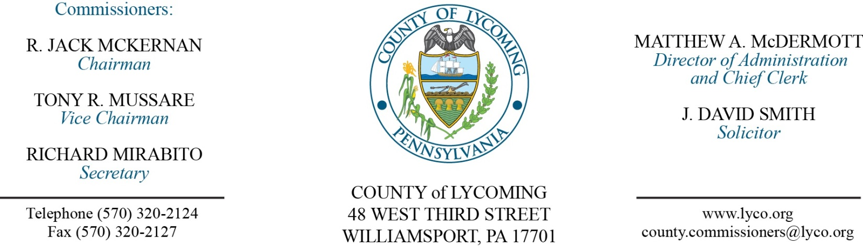
Commissioners’ Meeting Agenda
December 21, 2017

Opening Prayer

Pledge to the Flag

1.0 OPERATIONS

1.1 Convene Commissioners’ meeting.

1.2 Approve the minutes of the previous meetings.

1.3 Receive public comments (agenda items only).

2.0 ACTION ITEMS

2.1 Enact Ordinance 2017-05 updating the Hotel Tax Ordinance.

2.2 Adopt resolution 2017-35 for the 2018 TDA. (Ann Gehret/Roxanne Grieco)

2.3 Approve update to County Policy and Procedures Manual for the following policies: 400 (job code listing) and 401 (pay scale). (Ann Gehret/Roxanne Grieco)

2.4 Approve the following personnel actions: (Ann Gehret/Roxanne Grieco)
Juvenile Probation – Robin Leigh Kaiser as full time replacement Clerk I – Pay grade 2 - $11.79/hour effective 12/26/17.
Sheriff – Odessa R. Carichner as full time replacement Deputy Sheriff – Pay grade 7 - $18.08/hour effective 1/2/18.
DPS – Communications – reclassification of Scott W. Konkle as full time replacement Communications Specialist/Project Manager – Pay grade 9 - $30.06/hour effective 12/31/17.
Pre Release – reclassification of Thomas Probst as full time Resident Supervisor – Pay grade 6 - $16.59/hour effective 12/31/2017.

2.5 Approve amendment to agreement with Williams Pipeline Services Company for Transcontinental Gas Pipe Line Corp. - Site License Agreement. (Darla Greiner)

2.6 Approve PEMA Directive for Certified Hazardous Material Response Teams in Pennsylvania. (Darla Greiner)

2.7 Approve temporary permit for the force main project, and authorize the Director of RMS to sign. (Jason Yorks)

2.8 Approve change order 2 to the 2016 Landfill Gas System Modifications. (Jason Yorks)

2.9 Approve the 2018 fee schedules for the Landfill and Transfer Station. (Jason Yorks)

2.10 Approve 2018 software licensing and hardware maintenance agreement with Dominion Voting Systems in the amount of $20,889. (Forrest Lehman)

2.11 Approve professional service agreement with Election IQ not to exceed $50,000. (Forrest Lehman)

2.12 Approve professional service agreement with Phillips Office Solutions. (Marci Hessert)

2.13 Approve purchase of Pyramid Vehicular Repeater from Keystone Communications in the amount of $22,155.25 for the Sheriff’s office. (Marci Hessert)

2.14 Award contract for trash removal services to Fred Hamm, Inc. for 2018. (Marci Hessert)

2.15 Approve lease for ARD Operating, LLC (Alta) for 2nd & 3rd floor for a period of two years. (Marci Hessert)

2.16 Approve appointments/reappointments as listed on Attachment A.

6.0 COMMISSIONER COMMENT:

7.0 PUBLIC COMMENT:

8.0 NEXT REGULARLY SCHEDULED MEETING: Planning Session on Tuesday, January 2, 2018.

9.0 ADJOURN COMMISSIONERS’ MEETING.

Attachment A

Lycoming County Library System Board (3 year terms)
Evelyn Derrick 12/31/2018
Louise Eakin 12/31/2019
Christine Foresman 12/31/2019
Rick Mirabito 12/31/2019
Ben Brigandi 12/31/2018
Patricia Shipman 12/31/2018
Diane J. Eck 12/31/2020
Vacant 12/31/2020
Tom Burkholder 12/31/2020

Lycoming County Housing Authority (5 year terms)
Brian Booking 12/31/2022
Kenneth Young 12/31/2019
Holly Baker 12/31/2019
Alfreda Bair 12/31/2020
Nicoya Catino 12/31/2021

Lycoming County Conservation District (4 year terms)
Joseph Radley 12/31/2018
Denise Tobin 12/31/2018
Rick Mirabito 12/31/2018
Carl Schlappi 12/31/2019
Paul Wentzler 12/31/2019
Cameron Koons 12/31/2021
Bill Messersmith 12/31/2021

SEDA-COG Board of Directors (1 year term)
Jack McKernan 1/1/2019
Howard Fry 1/1/2019

Lycoming County Airport Authority (5 year terms)
Rebecca Burke 12/31/2021
Bill Martin 12/31/2022
Ryan Tira 12/31/2022
Chris Logue 12/31/2022
Atwood Welker 12/31/2019
Garth Everett 12/31/2019
Frank Pelligrino 12/31/2018

Lycoming County Water and Sewer Authority (5 year term)
Don Konkle 1/1/2021
Mike Miller 1/1/2021
Mike Philbin 1/1/2021
Charley Hall 1/1/2023
James Carpenter 1/1/2019
Frank Forscha 1/1/2019
Jan Ransdorf 1/1/2020
Paul Wentzler 1/1/2020
Victor Marquardt 1/1/2023

Joint Rail Authority (5 year term)
David Schultz 12/31/22
Scott Harvey 12//31/22

