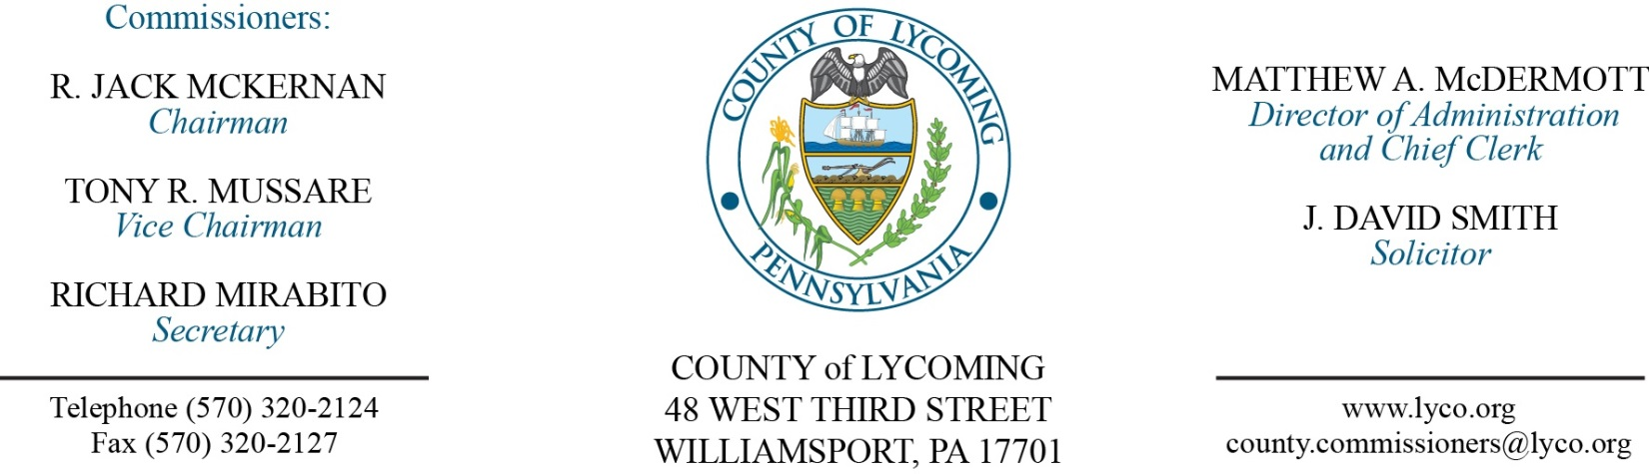
Commissioners’ Meeting Agenda
October 26, 2017

Opening Prayer

Pledge to the Flag

1.0 OPERATIONS

1.1 Convene Commissioners’ meeting.

1.2 Approve the minutes of the previous meetings.

1.3 Receive public comments (agenda items only).

2.0 ACTION ITEMS

2.1 Approve professional service agreement with T&T Lanco for a period of three years in the amount of $5,700/annually. (Mya Toon)

2.2 Approve invoice from Signet Golf Associates II, Inc. for removal and installation of sprinkler heads at the WDGC in the amount of $19,690. (Mya Toon)

2.3 Approve amendment 4 to professional service agreement with WSP USA Corp for Aerial Photo Mapping Service in the amount of $7,400. (Jason Yorks )

2.4 Approve county/regional application to the PA Department of Health for intranasal naloxone kits and designate the Lycoming County LTS EMS Council to serve as the centralized coordinating entity. (Wendy Hastings)

2.5 Approve memorandum of understanding with Susquehanna River Basin Commission for United States Army Corps of Engineers Project. (Josh Schnitzlein)

2.6 Approve nutrient credit sales agreement with the Pennsylvania Infrastructure Investment Authority. (Josh Billings)

2.7 Approve the following contracts for Children & Youth: (Mark Egly)
• Child Welfare Services Contract with KidsPeace National Centers, Inc. for foster care and residential care services at per diems ranging from $55.19/day to $333.08/day for the period July 1, 2016 through June 30, 2017.
• Patricia A. Shipman, Esq. to provide Substitute Guardian Ad Litem services for the period July 1, 2017 to June 30, 2018 at the rate of $65/hour.
• Greevy and Taylor Law Office to serve as substitute solicitor on an as-needed basis for Lycoming County Children and Youth Services at the rate of $120/hour for the period July 1, 2017 to June 30, 2018.
• Lycoming County Health Improvement Coalition for the provision of Strengthening Families Program services for the period July 1, 2017 through June 30, 2018 not to exceed $18,000.
• UMPC Susquehanna Health Home Care and Hospice for the provision of Nurse Family Partnership Program services for the period July 1, 2017 through June 30, 2018 not to exceed $75,000.
• Susquehanna Valley CASA – Voices for Children for the provision of child advocate services to dependent children for the period July 1, 2017 through June 30, 2018 not to exceed $30,000.

2.8 Approve the following Human Services Development Fund contracts for the period July 1, 2017 to June 30, 2018: (Mark Egly)
• Confer Home Health Services, LLC for adult homemaker services in the amount of $20,000.
• Favors Forward for Information and Referral services in the amount of $3,000.
• American Rescue Workers for emergency shelter services in the amount of $10,000.
• YWCA, Liberty House for emergency shelter services in the amount of $10,000.
• Community Alliance for Progressive Positive Action, CAPPA for life skills educational services in the amount of $16,000.
• Firetree Place for life skills educational services in the amount of $16,000.
• Jersey Shore Summer Recreation, Inc., for life skills educational services in the amount of $4,000.
• Project CoffeeHouse for the Montgomery Summer Alive program in the amount of $2,000.

2.9 Appoint Mike Philbin to the LCWSA with term expiration of 01/01/2021.

2.10 Approve update to the TDA: in Fiscal Services add one part-time Clerk III position pay grade 4, not to exceed 1000 hours annually, in Planning change one full time Clerk I(II) pay grade 2 to part time, not to exceed 1000 hours annually, and in Sheriff Office add four part-time Deputy Sheriff positions, pay grade 7, not to exceed 1000 hours annually.

2.11 Approve the following personnel actions:
District Attorney – Joseph C. Ruby as full time replacement Assistant District Attorney - ADA - $52,506.69/annually effective 11/6/17.
District Attorney – David S. Yael as part time replacement Central Processing Officer – Pay grade CPO - $15.64/hour effective 11/6/17, not to exceed 1,000 hours annually.
District Attorney – Robert A. Mausteller as part time replacement Central Processing Officer – Pay grade CPO - $15.64/hour effective 11/1/17, not to exceed 1,000 hours annually.
Courts – Amanda K. Bess as full time replacement Clerk III – Pay grade 4 - $13.95/hour effective 11/5/17.
Sheriff – Sidney E. Gable as part time Deputy Sheriff – Pay grade 7 - $18.08/hour effective 11/5/17, not to exceed 1,000 hours annually.
Sheriff – Derron M. Farber as part time Deputy Sheriff – Pay grade 7 - $18.08/hour effective 10/30/17, not to exceed 1,000 hours annually.
Sheriff – Arnold D. Duck, Jr. as part time Deputy Sheriff – Pay grade 7 - $18.08/hour effective 10/30/17, not to exceed 1,000 hours annually.
Sheriff – Kevin G. Stiles as part time Deputy Sheriff – Pay grade 7 - $18.08/hour effective 10/30/17, not to exceed 1,000 hours annually.

Recess Commissioners’ Meeting

3.0 SALARY BOARD

3.1 Convene Salary Board.

3.2 Approve update to the salary schedule.

3.4 Adjourn Salary Board.

Reconvene Commissioners’ Meeting

5.0 REPORTS/INFORMATION ITEMS

5.1 Lycoming County is requesting bids for Trash Removal Services. (Mya Toon)

5.2 Lycoming County is requesting proposals for Master Leasing. (Kim Wheeler/Mya Toon)

5.3 LCRMS is requesting proposals for Processing and Recycling of Electronic Waste. (Jason Yorks)

5.4 Present Job Well Done award to Jerri Rook.

6.0 COMMISSIONER COMMENT:

7.0 PUBLIC COMMENT:

8.0 NEXT REGULARLY SCHEDULED MEETING: Planning Session on Tuesday, October 31, 2017.

9.0 ADJOURN COMMISSIONERS’ MEETING.

