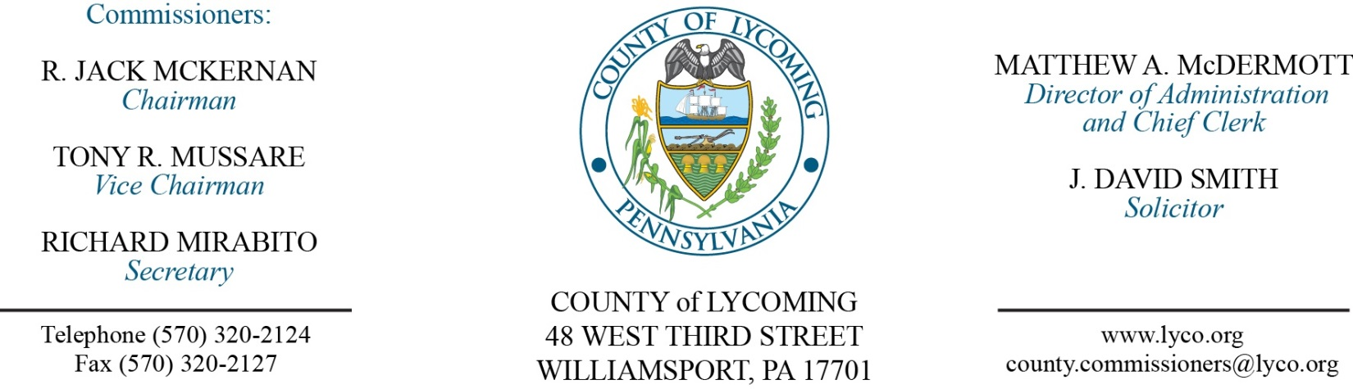
Commissioners’ Meeting Agenda
October 19, 2017

Opening Prayer

Pledge to the Flag

1.0 OPERATIONS

1.1 Convene Commissioners’ meeting.

1.2 Approve the minutes of the previous meetings.

1.3 Receive public comments (agenda items only).

2.0 ACTION ITEMS

2.1 Award CDBG-DR Engineering Services bid to RK Webster in the amount of $14,000. (Josh Schnitzlein)

2.2 Approve change order number-1 to the 2016 landfill gas system modifications project in the amount of $3,764.25. (Jason Yorks)

2.3 Approve professional service agreement with Dell Marketing for a period of one year in the amount of $6,135. (Jason Yorks)

2.4 Approve the following personnel actions: (Roxanne Grieco)
RMS – Transfer Station – Curtis R. Welter as full time replacement Truck Driver – Pay grade 6 - $16.59/hour effective 10/23/2017.

2.5 Approve separation agreement.

2.6 Approve invoice from KBF Print Technology for water bottles in the amount of $6371.

2.7 Approve agreement for three + one in the amount of $9,900.

2.8 Approve Business Associate Agreement with Jens Thorsen of USI.

5.0 REPORTS/INFORMATION ITEMS

5.1 LCRMS is requesting bids for Bottled Water Services. (Jason Yorks)

6.0 COMMISSIONER COMMENT:

7.0 PUBLIC COMMENT:

8.0 NEXT REGULARLY SCHEDULED MEETING: Planning Session on Tuesday, October 24, 2017.

9.0 ADJOURN COMMISSIONERS’ MEETING.

