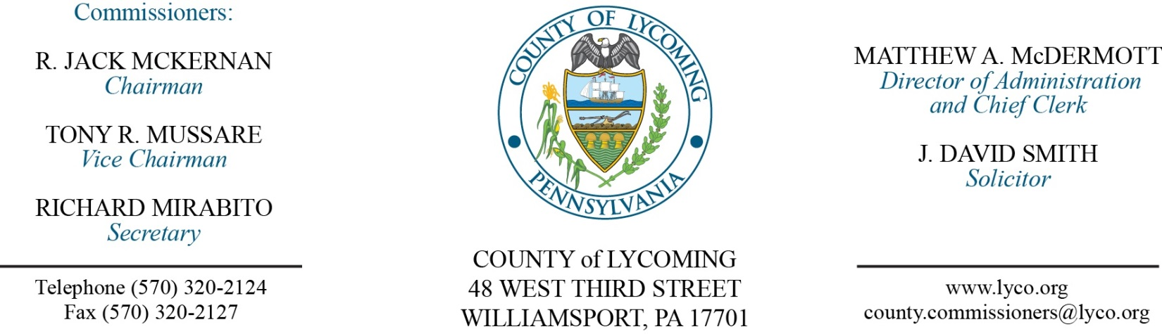
Commissioners’ Meeting Agenda
October 12, 2017

Opening Prayer

Pledge to the Flag

1.0 OPERATIONS

1.1 Convene Commissioners’ meeting.

1.2 Approve the minutes of the previous meetings.

1.3 Receive public comments (agenda items only).

Recess Commissioners’ Meeting

Final Public Hearing for 2017 CDBG
(Kristin McLaughlin)

Reconvene Commissioners’ Meeting

2.0 ACTION ITEMS

2.1 Approve the following CDBG documents:
• Approve projects and allocations for FFY 2017 CDBG funding consideration as presented.
• Adopt Resolution 2017-27 to submit FFY 2017 Community Development Block Grant application to the Pennsylvania Department of Community and Economic Development.
• Adopt resolution 2017-28 for Fair Housing.
• Adopt resolution 2017-29 for CDBG Plan Readoption.
• Adopt resolution 2017-30 for Section 504 Officer Designation.
• Approve Section 504 Grievance Procedure Policy
• Approve CDBG Program Income Reutilization Policy
• Approve CDBG Procurement Policy
• Approve CDBG Financial Management Plan

2.2 Approve Medical Assistance Transportation Program participation grant agreement. (Dan Merk)

2.3 Adopt resolution 2017-26 for purchase of a new UPS unit at Armstrong Tower site due to a lightning strike on August 21, 2017. (Mya Toon)

2.4 Approve professional service agreement with Julian Allatt, Esq for conflict attorney services in the amount of $40,000/annually. (Mya Toon)

2.5 Approve amendment 3 to the grant agreement with the PA Department of Health. (Wendy Hastings)

2.6 Approve memorandum of agreement with levee municipalities. (Fran McJunkin)

2.7 Approve 2017 PHARE Grant Application to PHFA in the amount of $500,000. (Kim Wheeler)

2.8 Approve submittal of the Small NAWCA grant for the Sylvan Dell conservation project. (Josh Billings)

2.9 Approve amendment 1 to professional service agreement with Seedway LLC. (Michael Hnatin)

2.10 Approve minor permit modification submission to DEP. (Michael Hnatin)

2.11 Approve the following personnel actions:
District Attorney – Full time replacement Assistant County Detective – NEU – union - $18.305/hour effective 10/23/17.
Prison – Iesha Leatherbury – Glover – Full time LPN – Pay grade 6 - $21.00/hour effective 10/22/17.
Prison – Andrea R. Hoover – Full time LPN – Pay grade 6 - $21.00/hour effective 10/22/17.
Prison – Erin M. Dvorscak – Full time LPN – Pay grade 6 - $21.00/hour effective 10/22/17.
Prison – Nicole D. Dawson – Full time LPN – Pay grade 6 - $21.00/hour effective 10/22/17.
Prison – Beverly V. Agnoni – Full time LPN – Pay grade 6 - $21.00/hour effective 10/22/17.

2.12 Remove from table and approve collective bargaining agreement with the Teamsters Local union 764 for the Assistant District Attorneys and the Assistant Public Defenders for the period January 1, 2017 to December 31, 2021.

5.0 REPORTS/INFORMATION ITEMS

5.1 LCRMS is requesting bids for protective cover aggregate material. (Michael Hnatin)

5.2 Recognize Karla Hanner on her retirement. (Dan Knerr)

6.0 COMMISSIONER COMMENT:

7.0 PUBLIC COMMENT:

8.0 NEXT REGULARLY SCHEDULED MEETING: Planning Session on Tuesday, October 17, 2017.

9.0 ADJOURN COMMISSIONERS’ MEETING.

