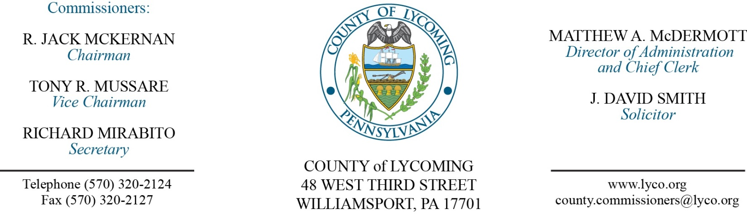
Commissioners’ Meeting Agenda
August 17, 2017

Opening Prayer

Pledge to the Flag

1.0 OPERATIONS

1.1 Convene Commissioners’ meeting.

1.2 Approve the minutes of the previous meetings.

1.3 Receive public comments (agenda items only).

2.0 ACTION ITEMS

2.1 Approve amendment 3 to professional service agreement with Bastian Tire & Auto Center to extend the current contract until December 31, 2017. (Mya Toon)

2.2 Approve amendment to professional service agreement with DSI-ITI, LLC. Inmate Telephone Services for secure messaging. (Mya Toon)

2.3 Approve subrecipient monitoring contract with West Branch D&A in the amount of $954,631 for the Intermediate Punishment Program. (Mya Toon)

2.4 Approve subrecipient monitoring contract with West Branch D&A in the amount of $215,234 for the Act 152 & in the amount of $507,485 for Behavioral Health Services Initiative Grant. (Mya Toon)

2.5 Approve amendment to professional service agreement with Louise Luck not to exceed $20,000. (Adrianne Stahl)

2.6 Approve Air Quality form submission to PADEP. (Michael Hnatin)

2.7 Approve final invoice from Cleveland Brothers Equipment Company in the amount of $16,139.84 for rebuild of hydraulic cylinder. (Jason Yorks)

2.8 Award surplus lots as follows: (Jason Yorks)
Lot Number-9 to Richard Carson in the amount of $2,200.
Lot Number-10 to Jack Northcutt in the amount of $2,200.
Lot Number-11 to John Bower in the amount of $3,600.
Lot Number-12 to Lardon Disposal in the amount of $1,700.
Lot Number-13 to Martin Novey in the amount of $1,550.

2.9 Approve amendment to professional service agreement with Steinbacher Enterprise. (Fran McJunkin)

2.10 Approve the following personnel actions: (Roxanne Grieco)
RMS – reclassification of Charles H. Opp as full time Work Crew Forman – Pay grade 6 - $20.22/hour effective 10/8/17.
Courts – promotion of Stephanie L. Snyder as full time replacement Clerk IV – Pay grade 5 - $17.47/hour effective 8/27/17.
Prison – Connor D. Cosentine as full time replacement Correctional Officer Relief – COI - $16.01/hour effective 8/28/17.
Prison – Travis J. Hartman as full time replacement Correctional Officer Relief – COI - $16.01/hour effective 8/28/17.
Prison – reclassification of Michael Jason Hill as full time Sergeant/Relief – Pay grade 9 - $26.59/hour effective 9/24/17.
District Attorney – reclassification of Sherri Jackson as full time Clerk II – Pay grade 3 - $13.00/hour effective 9/10/17.
Prothonotary – reclassification of Dale E. Schenck as full time Clerk II – Pay grade 3 - $13.00/hour effective 10/22/17.

2.11 Update Policy & Procedures Manual by removing Policy 507 – Lycoming County Retirement System and update policy 506 – Retirement Highlights. (Marci Hessert)

2.12 Approve agreement with Essential Management Solutions for 9IMS System Maintenance & Licensing in the amount of $18,504. (Marci Hessert)

2.13 Approve grant from PEMA in the amount of $356,907 for the North Central Task Force for the period 2017-2020. (Marci Hessert)

2.14 Approve invoice from Logistic Systems, Inc. for CAD software in the amount of $39,941. (Marci Hessert)

5.0 REPORTS/INFORMATION ITEMS

5.1 Information on National Health Center Week.

5.2 Discussion on amendment to GEO contract. (John Hogan)

5.3 Prison water reduction system discussion.

5.4 Lycoming County is requesting bids for James V. Brown Library Remodel Project. (Mya Toon)

5.5 Present Service Awards:
10 years:
Dane Dowling Prison
John Lavelle III PCD
Diane Day Maintenance
Diana Richardson Collections
Sharon Bailey Transfer Station

6.0 COMMISSIONER COMMENT:

7.0 PUBLIC COMMENT:

8.0 NEXT REGULARLY SCHEDULED MEETING: Planning Session on Tuesday, August 22, 2017.

9.0 ADJOURN COMMISSIONERS’ MEETING.

