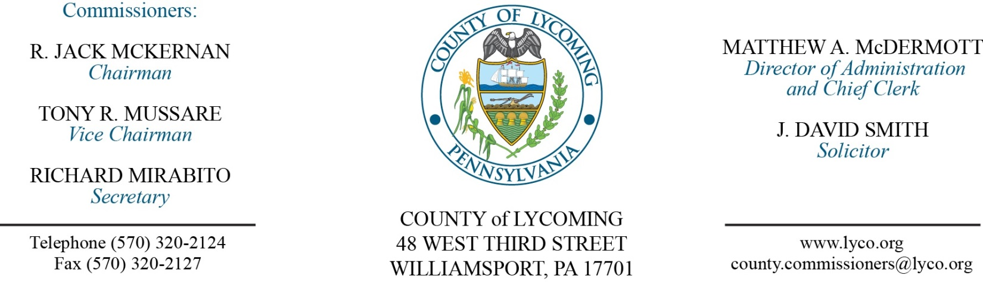
Commissioners’ Meeting Agenda
August 3, 2017

Opening Prayer

Pledge to the Flag

1.0 OPERATIONS

1.1 Convene Commissioners’ meeting.

1.2 Approve the minutes of the previous meetings.

1.3 Receive public comments (agenda items only).

2.0 ACTION ITEMS

2.1 Adopt resolution 2017-19 accepting grant from Muncy Bank. (Josh Schnitzlein)

2.2 Approve professional service agreement with SteelFusion for the Coroner’s Office. (Mya Toon)

2.3 Approve PADEP Air Quality Annual Compliance certification. (Michael Hnatin)

2.4 Approve quote from Green Machine Sales, LLC, for repair and parts in the amount of $34,865.80. (Michael Hnatin)

2.5 Approve quote from Snyder Equipment Company in the amount of $34,460. (Michael Hnatin)

2.6 Approve quote from ePlus for the annual Smartnet Nexus renewal in the amount of $12,906. (Jerry Kennedy)

2.7 Approve the following personnel actions: (Roxanne Grieco)
Prison – Maggie L. Marshall as full time replacement Female Correctional Officer Relief (M/F) – COI - $16.01/hour effective 8/14/17.
DPS Communications – Stephanie L. Knepp as full time replacement Telecommunicator I w/o/e – pay grade 6 - $16.59/hour effective 8/7/17.

Recess Commissioners’ Meeting

4.0 BOARD of ASSESSMENT REVISION

4.1 Convene Board of Assessment Revision.

4.2 Approve real estate exonerations:
• Parcel 34-009-200 for P&C LLC 175 Streibeigh Lane in the amount due to Property Split/Clerical Error.
• Parcel 37-003-123 for Casi & Jesse Confer 8 Center Ave due to Veteran's Exemption.
• Parcel 75-013-713 for George & Karn Wolfe 318 Woodland Ave due to Veteran's Exemption.

4.3 Adjourn Board of Assessment Revision.

Reconvene Commissioners’ Meeting

5.0 REPORTS/INFORMATION ITEMS

5.1 Recognize Karl Baldys. (Kurt Hausammann)

5.2 LCRMS is requesting bids for HDPE pipe and landfill gaswell accessories. (Michael Hnatin)

5.3 2017 CDBG project review. (Kristin McLaughlin)

6.0 COMMISSIONER COMMENT:

7.0 PUBLIC COMMENT:

8.0 NEXT REGULARLY SCHEDULED MEETING: Planning Session on Tuesday, August 15, 2017. No meetings August 8 & 10.

9.0 ADJOURN COMMISSIONERS’ MEETING.

