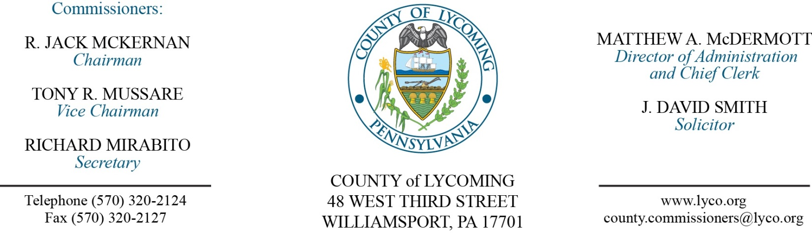
Commissioners’ Meeting Agenda
July 20, 2017

Opening Prayer

Pledge to the Flag

1.0 OPERATIONS

1.1 Convene Commissioners’ meeting.

1.2 Approve the minutes of the previous meetings.

1.3 Receive public comments (agenda items only).

2.0 ACTION ITEMS

2.1 Proclaim July 16-22, 2017, as Pretrial, Probation and Parole Supervision week in Lycoming County. (Ed McCoy)

2.2 Approve Grant-In-Aid Application and Funds Agreement and Supervision Fund Agreement from the PA Board of Probation and Parole. (Ed McCoy)

2.3 Approve the following Child Welfare Services contracts (7/1/2016 to 6/30/2017): (Mark Egly)
• Centre County Youth Service Bureau for emergency shelter and residential care services at per diem rates.
• Families United Network, Inc. for foster care and residential care services at per diem rates.
• Tioga County Department of Human Services for emergency shelter and residential care services at a per diem rates.
• Crossroads Counseling, Inc. to provide evaluation and counseling services for non-MA eligible clients.
• STEP Inc. increasing the Youth Workforce Development/Employment (YES) contract from $65,000 to $90,000.

2.4 Approve the following Child Welfare Services Contracts (7/1/2017 to 6/30/2018): (Mark Egly)
• John P. Pietrovito to serve as solicitor for Lycoming County Children and Youth Services at the all-inclusive rate of $5,500/month.
• Angela C. Lovecchio to provide Guardian Ad Litem Services in the amount of $3,200/month.
• Approve Trisha Hoover Jasper to provide Substitute Guardian Ad Litem services.
• Child Advocacy Center of the Central Susquehanna Valley to provide forensic child abuse interviews at $100/interview.
• Crossroads Counseling, Inc. to provide evaluation and counseling services for non-MA eligible clients.

2.5 Approve professional service agreement with Dr. Russell Gombosi, M.D. to serve as medical consultant to Lycoming County Children and Youth Services not to exceed $15,000 for the period April 1, 2017 through June 30, 2018. (Mark Egly)

2.6 Approve final invoice from Cleveland Brothers Equipment Company for purchase and installation of a reconditioned transmission and related parts within a 2009 Caterpillar D8T Track Type Tractor in the total amount of $81,291.53. (Jason Yorks)

2.7 Approve purchase from Eagle Equipment Corporation off of CoStars Contract for 4 new 2017 recycling containers in the total amount of $27,863. (Jason Yorks)

2.8 Approve agreement with Constable Thomas W. DeLange for use of County police frequency 1. (John Yingling)

2.9 Approve the CJAB Technical Assistance and Training Grant application and award in the amount of $1,440.00. (Mya Toon)

2.10 Approve amendment to agreement with Siemens Healthcare Diagnostics for PRC. (Mya Toon)

2.11 Approve subrecipient agreement with the City of Williamsport for 2015 PHARE (BNIP). (Jenny Picciano)

2.12 Approve quote from Dominion Voting for purchase of voting machine batteries in the amount of $25,650. (Forrest Lehman)

2.13 Approve agreement with West Branch D&A not to exceed $50,000. (Chris Ebner)

2.14 Approve the following personnel actions: (Lauren Bower)
PCD – Richard L. Heimbach II as full time replacement Zoning Officer - Pay grade 7 - $35,289.56/annually effective 7/25/17.
DPS - Communications – promotion of Logan W. Laidacker as full time replacement Telecommunicator II - Pay grade 8 - $20.05/hour effective 7/16/17.
Maintenance – Regina D. Rooker as full time replacement Custodial Worker - Pay grade 1 - $10.84/hour effective 7/31/17.
Maintenance – Sergey A. Kulikov as full time replacement Custodial Worker - Pay grade 1 - $10.84/hour effective 7/31/17.
Prison – Logan Bingaman as full time replacement Correctional Officer Relief - COI - $16.01/hour effective 7/31/17.

6.0 COMMISSIONER COMMENT:

7.0 PUBLIC COMMENT:

8.0 NEXT REGULARLY SCHEDULED MEETING: Planning Session on Tuesday, July 25, 2017.

9.0 ADJOURN COMMISSIONERS’ MEETING.

