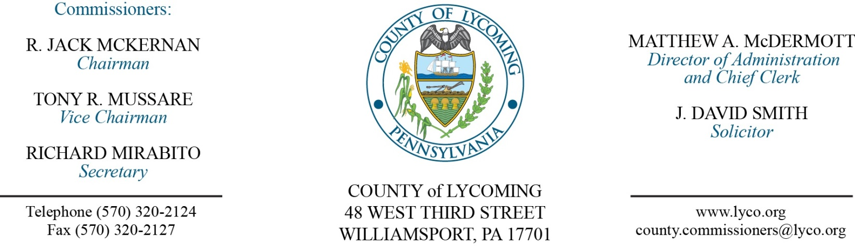
Commissioners’ Meeting Agenda
May 11, 2017

Opening Prayer

Pledge to the Flag

1.0 OPERATIONS

1.1 Convene Commissioners’ meeting.

1.2 Approve the minutes of the previous meetings.

1.3 Receive public comments (agenda items only).

2.0 ACTION ITEMS

2.1 Adopt resolution 2017-12 appointing solicitors to the board of commissioners. (Dave Smith)

2.2 Adopt resolution 2017-13 for amendment to agreement with PA Dept of Transportation for Bridge 106 reimbursement. (Mark Murawski)

2.3 Remove from table & vote on Memorandum of Understanding with IPPC Technologies, Inc. (Ed McCoy)

2.4 Approve amendment to agreement with Lundy Construction Co Inc. for equipment rental. (Jason Yorks)

2.5 Approve agreement with Wolf’s Liquid Hauling, LLC. (Jason Yorks)

2.6 Approve professional service agreement with DevNet for Licensing/Maintenance for a period of three years. (Tom Heap)

2.7 Approve agreement for NexGen 9-1-1 & ESInet. (Mya Toon)

2.8 Approve amendment to agreement with Oasis Management Systems, Inc. for Commissary Services. (Mya Toon)

2.9 Award contract to M&M Asphalt for paving project in the amount of $26,000. (Mya Toon)

2.10 Approve Williamsport Lycoming Community Fund grant application to the First Community Foundation Partnership in the amount of $89,610.00. (Mya Toon)

2.11 Approve the following personnel actions: (Roxanne Grieco)
Pre-Release – Robert L. Squires III as full time replacement Resident Supervisor – Pay grade 6 - $16.59/hour effective 5/22/17.
Pre-Release – Shawn E. Myers as full time replacement Resident Supervisor – Pay grade 6 - $16.59/hour effective 5/15/17.
Pre-Release – Erin M. Reighard as part time replacement Pre-Release Driver – Pay grade 4 - $12.96/hour effective 5/15/17, not to exceed 1,000 hours annually.

5.0 REPORTS/INFORMATION ITEMS

5.1 Lycoming County is requesting bids for Vehicle Maintenance. (Mya Toon)

5.2 Lycoming County is requesting bids for Bread Products 2nd half 2017. (Mya Toon)

6.0 COMMISSIONER COMMENT:

7.0 PUBLIC COMMENT:

8.0 NEXT REGULARLY SCHEDULED MEETING: Planning Session on Tuesday, May 23, 2017. There are no meetings May 16 & 18 due to elections.

9.0 ADJOURN COMMISSIONERS’ MEETING.

