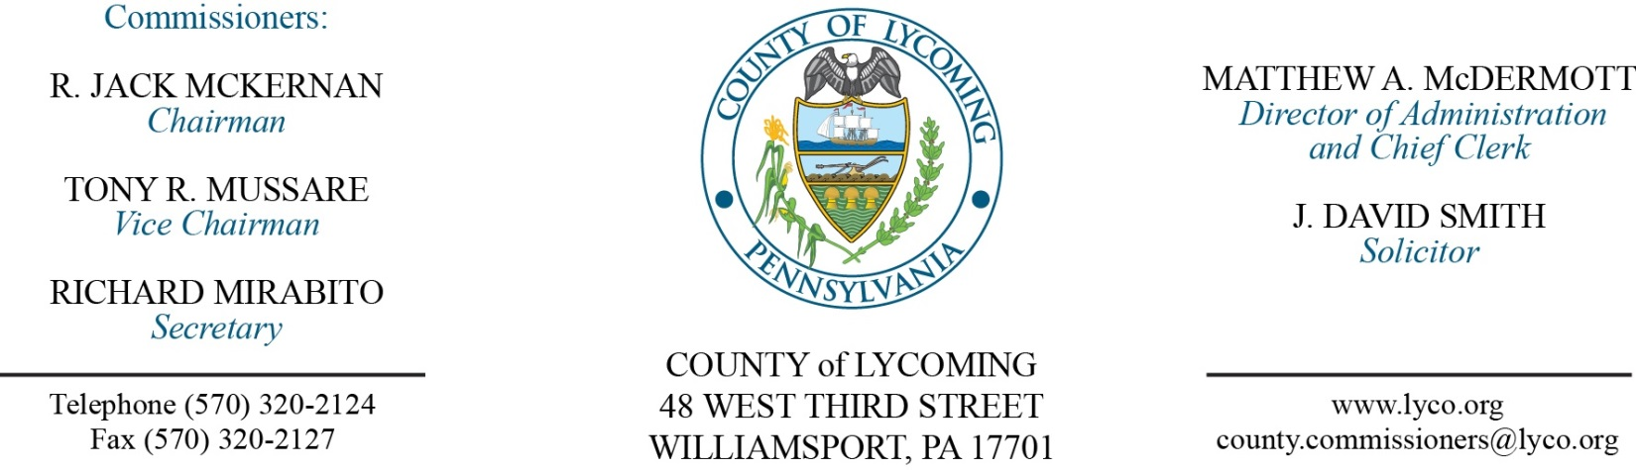
Commissioners’ Meeting Agenda
March 16, 2017

Opening Prayer

Pledge to the Flag

1.0 OPERATIONS

1.1 Convene Commissioners’ meeting.

1.2 Approve the minutes of the previous meetings.

1.3 Receive public comments (agenda items only).

2.0 ACTION ITEMS

2.1 Approve accounts payable cash requirement report through March 22, 2017 for payment on March 15, 2017 in the amount of $840,933.79 – Beth Johnston

Recess Commissioners’ Meeting

Tefra HEARING FOR GEISINGER

Jim Kull, Lead Treasury Analyst, Treasury Operations
Don Zaycosky, General Counsel
Kate Mullally, Director, Facilities Operations
Lorien Beishline, AVP, Clinical Operations
Mike Ferlazzo, Specialist II
Joe Stender, Specialist, Corporate Communications

Reconvene Commissioners’ Meeting

2.2 Adopt Resolution 2017-08 for Geisinger

2.3 Approve purchase of UPS from Schaedler Yesco in the amount of $14,803 off of COSTARS contract – John Yingling

2.4 Approve purchase of replacement generators for Pump Station and English Center from Generac in the total amount of $29,508 off of COSTARS contract – John Yingling

2.5 Approve constable agreement with Gilbert F. Stull for use of Police Frequency 1 – John Yingling

2.6 Approve grant receipt from PCCD for RASA/VOJO Victim Witness Services in the amount of $251,078 – Mya Toon

2.7 Approve quote from Cleveland Brothers Equipment Company, Inc., in the amount of $36,393.28 for the installation of a reconditioned transmission within the 2009 Caterpillar D8T Track Type Tractor – Michael Hnatin

2.8 Approve quote from Cleveland Brothers Equipment Company, Inc., in the amount of $27,989.91 for undercarriage system of a 2009 Caterpillar D8T Track Type Tractor – Michael Hnatin

2.9 Approve Professional Service Agreement with 2017 Goldman Associates, Inc. – Michael Hnatin

2.10 Approve DEP 903 Recycling Coordinator grant application in the amount of $38,664.54 – Lauren Strausser

2.11 Approve Policy 107 – Conflicts of Interest – of the County Policy and Procedures Manual – Ann Gehret/Roxanne Grieco

2.12 Approve the following personnel actions:

Pre Release – Mark J. Forward as full time replacement Resident
Supervisor I – Pay grade 6 - $16.59/hour effective 3/27/17.

Pre Release – James N. West as full time replacement Resident
Supervisor I – Pay grade 5 - $15.22/hour effective 3/20/17.

5.0 REPORTS/INFORMATION ITEMS

5.1 Lycoming County is requesting proposals for Zoning Hearing board Solicitor Services – Mya Toon

6.0 COMMISSIONER COMMENT:

7.0 PUBLIC COMMENT:

8.0 NEXT REGULARLY SCHEDULED MEETING: Planning Session on Tuesday, March 21, 2017.

9.0 ADJOURN COMMISSIONERS’ MEETING.

