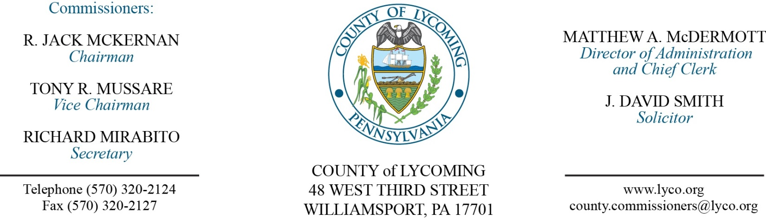
Commissioners’ Meeting Agenda
February 9, 2017

Opening Prayer

Pledge to the Flag

1.0 OPERATIONS

1.1 Convene Commissioners’ meeting.

1.2 Approve the minutes of the previous meetings.

1.3 Receive public comments (agenda items only).

2.0 ACTION ITEMS

2.1 Approve professional service agreement with EIHAB Human Services for the Juvenile Probation office for Shelter Care Services (Nancy Ackley)

2.2 Approve payment of invoice to Forensic Bioinformatic Services in the amount of $14,347.02. Previously tabled at the 1/26/17 public meeting for lack of information. (William Miele)

2.3 Approve ESRI GIS Renewal contract for 2017. (Karl Demi)

2.4 Approve 2017 MS ISAC membership contract (Karl Demi)

2.5 Approve Keymark Onbase renewal contract for 2017. (Karl Demi)

2.6 Approve purchase of 2017 Ford Explorer from Apple Automotive off of PA State CoStars in the amount of $30,858.00. (Mya Toon)

2.7 Approve Infocon Corporations contract (Mya Toon)

2.8 Approve Amendment to the Lycoming County Emergency Communication Towers Redevelopment Assistance Capital Project. (Mya Toon)

2.9 Approve USACE contract for a floodplain management study for Muncy. (Josh Schnitzlein)

2.10 Approve Amendment to Agreement with Girio Agency. (Josh Schnitzlein)

2.11 Approve Barbour Nutrient Trading Agreement
Approve Styer Nutrient Trading Agreement Approve Gavitt Nutrient Trading Agreement
Approve Vandine Nutrient Trading Agreement
Approve Tebbs-JRT Nutrient Trading Agreement
Approve Snyder Nutrient Trading Agreement
Approve Reitz Nutrient Trading Agreement
Approve Mowery Nutrient Trading Agreement
Approve Morrison Nutrient Trading Agreement
Approve Koons Nutrient Trading Agreement
Approve Jarrett Nutrient Trading Agreement
Approve Harvey Nutrient Trading Agreement
Approve Fogelman Nutrient Trading Agreement
Approve Evan Brown Nutrient Trading Agreement
Approve Ernie Brown Nutrient Trading Agreement
Approve Schrack Nutrient Trading Agreement
Approve Rogers Nutrient Trading Agreement
Approve London Nutrient Trading Agreement
Approve Lambert Nutrient Trading Agreement
Approve Dincher Nutrient Trading Agreement
Approve Bishcroft Nutrient Trading Agreement
Approve Buddendorf-McCoy Nutrient Trading Agreement
Approve Worthington Nutrient Trading Agreement
Approve Ulmer Nutrient Trading Agreement
Approve Sherman Nutrient Trading Agreement
Approve Plaxton Nutrient Trading Agreement
Approve Knepp Nutrient Trading Agreement
Approve Bosch Nutrient Trading Agreement(Josh Billings)

2.12 Approve Amendment to Agreement No-1 to 2016 RTGMSPA with Deacon Equipment Company Inc. (Mya Toon)

2.13 Approve Freeburg Boro, Snyder County DORA contract. (Mya Toon)

2.14 Approve the following personnel actions: (Roxanne Grieco)

PRC – Approve Rachel L. Black – Part Time Replacement Female Resident Supervisor – Paygrade 5 - $14.14 per hour – effective 2/20/17.

Prison – Approve Hunter B. Lomison – Full Time Replacement Correctional Office Relief – COI - $15.77 per hour – effective 2/13/17.

Prison – Approve Riley Francis Donahoe – Full Time Replacement Correctional Officer Relief – COI - $15.77 per hour – effective 2/13/17.

Prison – Approve New Position of Nathan D. Hill – Full Time, Promotion Bail Prelease Officer - $22.91 per hour – effective 2/26/17.

DA – Approve Danielle A. Ehrgood – Full Time Replacement Clerk III – Paygrade 4 - $13.95 per hour – effective 2/13/17.

Soil Conservation – Approve Kellen E. Krape – Full Time Replacement, Promotion – Paygrade 8 - $38,548.49 annually – effective 2/26/17.

APO – Approve New Positon of Vicki L. Kling – Full Time Promotion Administrative Case Officer – Paygrade 6 - $15.57 per hour – effective 3/12/17.

5.0 REPORTS/INFORMATIONAL ITEMS

5.1 Compensation for Tax Collectors will be voted on Tuesday, February 14, 2017

Office | 2018 | 2019 | 2020 | 2021
Tax Collectors | $2.50/bill | $2.50/bill | $2.50/bill | $2.50/bill

5.2 Compensation for Sheriff will be advertised and voted on ten days after advertisement. This will be an evening meeting to be scheduled.

6.0 COMMISSIONER COMMENT:

7.0 PUBLIC COMMENT:

8.0 NEXT REGULARLY SCHEDULED MEETING: Planning Session on Tuesday, February 14, 2017.

9.0 ADJOURN COMMISSIONERS’ MEETING.

