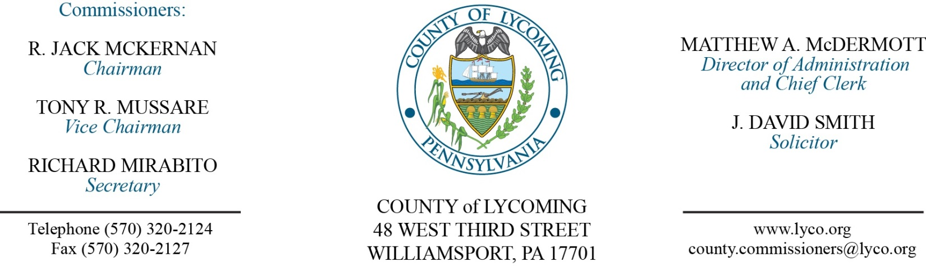
Commissioners’ Meeting Agenda
January 19, 2017

Opening Prayer

Pledge to the Flag

1.0 OPERATIONS

1.1 Convene Commissioners’ meeting.

1.2 Approve the minutes of the previous meetings.

1.3 Receive public comments (agenda items only).

2.0 ACTION ITEMS

2.1 Approve 2017 County Fund Certification for Ag Land Preservation in the amount of $50,000. (Mark Davidson)

2.2 Award Flood Mitigation Acquisition Demolition bid to Altoona Contracting Excavating Demolition Services. (Mya Toon)

2.3 Approve grant and monitoring contract with CAPPA in the amount of $35,000. (Mya Toon)

2.4 Approve agreement with the following for drop off recycling services: (Mya Toon)
Milton Borough Spring Township Penn Township Franklin Township.

2.5 Approve memorandum of understanding Lycoming County Conservation District and the Participants of the Lycoming County MS4 Coalition. (Kaelyn Koser)

2.6 Approve operational funding requirements for White Deer Gold Course up to $100,000 (Commissioner(s)

5.0 REPORTS/INFORMATION ITEMS

5.1 Lycoming county RMS is requesting bids for Aggregate Products, Concrete Product, Equipment Tires and Tire Repair, and Rental Equipment. (Mya Toon)

5.2 Present 2015 GFOA award to fiscal services. (Matt McDermott)

6.0 COMMISSIONER COMMENT:

7.0 PUBLIC COMMENT:

8.0 NEXT REGULARLY SCHEDULED MEETING: Planning Session on Tuesday, January 24, 2017. No meetings January 31 & February 1.

9.0 ADJOURN COMMISSIONERS’ MEETING.

